 | Document # | Date effective
 | LAT-TD-03631-02 | 31 JAN 2005
 | Author(s) | Supersedes
 | Dave Nelson
 | Subsystem/Office
Document Title
Tower Electronics Module (TEM) /Tower Electronics Module Power Supply (TPS) Thermal Vacuum Test Procedure

Change History Log
Revision | Effective Date | Description of Changes
01 | 20 July 2004 | Initial version
02 | 31 Jan 2005 | Chamber DAQ software changes and test profile changes

1. SCOPE 2
2. DEFINITIONS AND ACRONYMS 2
2.1 Definitions 2
2.2 Acronyms 2
3. REFERENCES 2
3.1 Applicable Documents 2
4. REQUIREMENTS 2
4.1 General 2
4.1.1 Test Personnel and Descriptions 2
4.2 Test Readiness Review (TRR) and Post Test Review (PTR) 2
4.3 Environmental Conditions 2
4.4 Contamination Control 2
4.5 Handling and Transportation 2
4.6 ESD 2
4.7 Mate/Demate Connectors 2
4.8 Test Equipment 2
4.9 Test Data and Review 2
4.10 Flight Hardware Log Book 2
4.11 Nonconforming Test Data, Equipment and Software 2
4.12 Redlining and Blacklining Documents 2
4.13 Quality Assurance 2
4.13.1 Product Assurance Requirements 2
4.14 Warnings, Cautions, and Notes 2
4.15 Testing Safety 2
4.16 SLAC Safety, ES & H Manual 2
5. PROCEDURE 2
5.1 Test Procedure Instructions/Information 2
5.1.1 Test Prerequisites 2
5.1.2 Test Sequence 2
5.1.3 Test Equipment 2
5.1.4 Test Fixtures 2
5.1.5 User Interface 2
5.1.6 Participant List 2
5.2 Test Setup and Validation 2
5.2.1 Open Chamber 2
5.2.2 Inspection of Chamber 2
5.2.3 Installation of the TEM Test Board and TEM Load Board 2
5.2.4 Setup of the Test Equipment and Test Cable 2
5.2.5 Test Setup of the Golden TEM/TPS Assembly 2
5.2.6 Validation of the Golden TEM/TPS Assembly 2
5.2.7 Test setup of the Flight TEM/TPS Assembly 2
5.2.8 Validation of the Golden TEM/TPS Assembly 2
5.2.9 Close Chamber 2
5.2.10 Boot Up DAS Software 2
5.2.11 Depressurization (Pump Down) 2
5.3 Thermal Vacuum Test 2
5.3.1 Test Definitions 2
5.3.2 Qualification Start Test 2
5.3.3 Qualification Test for Cycle 1 2
5.3.4 Qualification Test for Cycle 2-11 2
5.3.5 Qualification Test for Cycle 12 2
5.3.6 Shutdown Cycle of the Qualification Test 2
5.3.7 Acceptance Start Test 2
5.3.8 Acceptance Test for Cycle 1 2
5.3.9 Acceptance Test for Cycle 2-3 2
5.3.10 Acceptance Test for Cycle 4 2
5.3.11 Shutdown Cycle of the Acceptance Test 2
5.4 Chamber Shutdown 2
5.4.1 Pressurization (Venting) 2
5.4.2 Opening Chamber 2
5.4.3 Collecting Test Data Sheets 2
Appendix A (Data Sheets and Covers) 2
Appendix B (Connector Mate/Demate Log) 2

SCOPE
The purpose of this test is to verify workmanship, functionality and thermal design of the Tower Electronics Module (TEM)/ Tower Electronics and Module Power Supply (TPS) in a thermal-vacuum (TV) environment. System performance testing will be characterized at thermal extremes. This test procedure details the sequence and the methods to be followed in performing the TV testing of the TEM/TPS in accordance with the LAT T & DF Test Plan, LAT-TD-00296. The TV test results will be recorded within this document.

DEFINITIONS AND ACRONYMS
The following terms, abbreviations, and acronyms are used in this document:

Definitions
A, An | Analog
D, Dg | Digital
F | Functional
Hz | Hertz, unit of frequency
MHz | Megahertz
Ω | ohm, unit of electrical resistance
s, sec | seconds
V | Volt
W | Watt

Acronyms
AIDS | Assembly and Inspection Data Sheet
BOB | Break-Out-Box
CAL | Calorimeter
CPT | Comprehensive Performance Test
EGSE | Electrical Ground Support Equipment
ETech | Electrical Technician Electrical Ground Support Equipment
GASU | Global trigger Anti-collision Spacecraft Unit
LPT | Limited Performance Test
MTech | Mechanical Technician
PTR | Post Test Review
QAE | Quality Assurance Engineer
TC | Test Conductor
TD | Test Director
TEM | Tower Electronics Module
TKR | Tracker
TPS | Tower Power Supply
TRR | Test Readiness Review
UUT | Unit Under Test

REFERENCES
The following documents are referenced within this document:

Applicable Documents
Document Number | Description
SPECIFICATIONS
LAT-TD-00778 | LAT Environmental Specification
PLANS
LAT-MD-00039 | Performance Assurance Implementation Plan
LAT-MD-00078 | GLAST LAT System Safety Program Plan
LAT-MD-00404 | LAT Contamination Control Plan
LAT-MD-00408 | LAT Program Instrument Performance Verification Plan
LAT-TD-00296 | T & DF Test Plan
OTHER
LAT-MD-00091 | GLAST Quality Manual
LAT-MD-00471 | Control of Nonconforming Product
LAT-MD-00472 | Corrective and Preventative Action
LAT-MD-00473 | Handling, Storage, Packing, Preservation and Delivery
LAT-MD-02541 | Thermal Vacuum Chamber Operation Procedure
LAT-TD-04085 | TEM/TPS Performance Test

REQUIREMENTS
This section lists the requirements that shall be utilized during design, development, manufacture, assembly, testing and storage.

General
The Performance Assurance Implementation Plan, LAT-MD-00039 shall be utilized to verify that the products produced by the GLAST LAT project intended for design qualification, flight and critical ground support equipment usage meet the required levels of quality and functionality for their intended purposes.
This document shall follow the LAT Program Instrument Performance Verification Plan LAT-MD-00408 which details the LAT and its subsystem verification test flow.
The LAT T & DF Test Plan, LAT-TD-00296 shall be utilized to address the overall requirements at engineering model, qualification and production level phases. This document defines the time period from post circuit board fabrication until electronic box delivery to LAT Integration and Test.
Testing within this document shall conform to the requirements stated in LAT Performance and Operations Test Plan LAT-MD-02730 for all testing that relates to LAT I & T.

Test Personnel and Descriptions
Test personnel are described in GLAST LAT Integration and Test Subsystem Test Plan, LAT-MD-01376. The test team members are defined with the following responsibilities:

Test Readiness Review (TRR) and Post Test Review (PTR)
The TRR and PTR are organizational meetings that shall be held at the appropriate times to inform all parties about the testing that is to be accomplished and has been completed. The TRR and PTR meetings are defined in the GLAST LAT Integration and Test Subsystem Test Plan, LAT-MD-01376.

Environmental Conditions
Testing performed in accordance with this document shall conform to standard environmental test conditions unless specific test requirements within this document exist. Standard Environmental test conditions are as follows:
- Dynamic Mechanical Conditions: No load, at rest
- Temperature: 18.3 to 25.7.°C
- Atmospheric Pressure: Uncontrolled local conditions
- Humidity: 30% to 50% RH for testing when the Calorimeter or Engineering Model (EM) Calorimeters are present. For all other testing 30% to 60% RH is required.
This document shall follow the LAT Environmental Specification, LAT-SS-00778 for all testing where non standard environments are required. The Environmental Specification defines the thermal, vibration and on-orbit exposure design and test environments for the LAT instrument and its subsystems.

Contamination Control
The Contamination Control Plan defines the overall contamination control requirements necessary to establish hardware cleanliness for the GLAST LAT program. When work is performed at SLAC follow LAT-MD-01386. When work is performed elsewhere follow LAT-MD-00404.

Handling and Transportation
This document shall follow the requirements found in the Handling, Storage, Package, Preservation and Delivery document, LAT-MD-00473. This document establishes handling, storage, packaging and transportation practices adequate to maintain the safety, reliability and quality of SLAC LAT flight hardware items and achieve their damage free delivery to the place and time of ultimate use.

ESD
The CAL, TKR, T & DF Contamination Control Plan and the LAT Contamination Control Plan define the ESD requirements for the GLAST LAT program. When work is performed at SLAC follow LAT-MD-01386. When work is performed elsewhere follow LAT-MD-00404.

Mate/Demate Connectors
This document shall follow the requirements found in the Mate and Demate Workmanship Standard LAT-PS-04459. The mate/demate process shall be followed for each and every connector mate. This consists of a visual inspection of the interface, cleaning if required, and proper mating techniques.

Test Equipment
This document shall follow the requirements found in the LAT Program Instrument Performance Verification Plan, LAT-MD-00408, which defines calibration, accuracy, substitutions, etc. for the test equipment.

Test Data and Review
This document shall follow the requirements found in the LAT Program Instrument Performance Verification Plan, LAT-MD-00408, which defines the test data sheets and details the personnel that reviews test data. Test data shall be recorded on the data sheets that are found in Appendix A of this document. The data sheets and any supporting data shall use a cover sheet that is found in Appendix A of this document.

Flight Hardware Log Book
The LAT Program Instrument Performance Verification Plan, LAT-MD-00408 requires that a log of hardware installation, software installation, power ON and mates/demates to flight connectors shall be kept for each flight unit. The log book is part of the package that is deliverable to the customer.

Nonconforming Test Data, Equipment and Software
This document shall follow the requirements found in the Control of Nonconforming Product, LAT-MD-00471. This document establishes methods to identify and control nonconforming product developed by the LAT project team.

Redlining and Blacklining Documents
The users of this document shall follow the requirements found in the Redline/Blackline Engineering Documents, LAT-MD-03474.

Quality Assurance
This document shall follow the requirements found in the Corrective and Preventative Action document, LAT-MD-00472 and the GLAST Quality Manual, LAT-MD-00091 and LAT Program Instrument Performance Verification Plan, LAT-MD-00408.
The Corrective and Preventative Action document establishes the method to be used to initiate, implement, evaluate and record corrective and preventive actions. The GLAST Quality Manual defines the methods implemented by the GLAST LAT project to ensure consistent quality of all processes for procurement, design, development and production of flight hardware, flight software, calibration and all associated ground support equipment interfacing with flight hardware and software. The LAT Program Instrument Performance Verification Plan defines test configuration, data sheets and review of test results.

Product Assurance Requirements
The QAE shall witness the initial test setup and validation operations. In the event of a failure a Non Conformance Report (NCR) shall be written. The root cause and corrective action shall be identified and there shall be QAE approval before the operation is continued. Any deviation from this document requires approval from the QAE as well as the TC.

Warnings, Cautions, and Notes
The following SAFETY ALERTS are intended to create awareness of the potential safety hazards and the steps that must be taken to avoid accidents. These same alerts are used throughout this document to identify specific hazards that may endanger personnel and/or equipment.
Identification of every conceivable hazardous situation is impossible. Therefore, all personnel have the responsibility to diligently exercise safe practices whenever exposed to this equipment.
Indicates a potential hazardous situation which, if not avoided, could result in death or injury.
Indicates a potential hazardous situation which, if not avoided, could result in damage to equipment.
Indicates a notification of information that is important, but not hazard related.

Testing Safety
This document shall follow the requirements found in the GLAST LAT System Safety Program Plan, LAT-MD-00078. This document defines all phases of the LAT program including: design, development, fabrication, handling, transportation, storage, test, assembly and operation.

SLAC Safety, ES & H Manual
This document shall follow the requirements found in the SLAC Environment, Safety, and Health Manual, SLAC-I-720-0A29Z-001. This document defines the SLAC policy to support environmental protection, health, and safety in the workplace.
A hot work permit is required for work on or around open connectors/circuits having:
- Voltage greater than 50V (AC or DC)
AND
- Current supply capability greater than 5mA
OR any circuit having
- Energy storage greater than 10 Joules (E=1/2CV²)

PROCEDURE
The Thermal Vacuum Chamber Operation Procedure LAT- TD-02541 and TEM/TPS Performance Procedure LAT-TD-04085 are used in conjunction this test procedure. Refer to and review the GLAST Thermal Vacuum Chamber Operation Procedure LAT-TD-02541 and TEM/TPS Performance Procedure LAT-TD-04085 before proceeding with the following procedure.
This procedure is used for Performance Testing of the circuits of the TEM.
Unless otherwise noted use a DVM for all measurements.
When performing measurements with a DMM connect the negative lead first.

Test Procedure Instructions/Information
This section provides the general instructions and information that are used and required to perform this procedure, including: test parameters, sequence, equipment and test participants.

Test Prerequisites
- This section describes processes and procedures that must be completed prior to performing the tests in this document.

Test Sequence
This section describes the requirements of the event sequence for performing this procedure. Tests are to be performed in the order listed in this document unless otherwise specified. It is permissible for Assembly Instruction Data Sheets (AIDS) to be used to change the order of tests or select a single test paragraph to be performed. In that case, the data sheet for the test performed will be included in the end item data package linked to the AIDS step that required it. Test sequencing can also be changed in a TRR and black lined into the test procedure.

Test Equipment
The test equipment listed below is necessary for the tests described in this procedure. If additional equipment is used, add it to the table below with the signature of the TC and QAE, proceed with the test.

EGSE
To record the test equipment, cables, connector savers and software:
- Record the information for all equipment on the data sheet. See the list below for descriptions of the information to be recorded.
- Description and Manufacturer
- Model/LAT number
- Serial/Revision number
- Calibration due date (enter NA for non calibrated equipment)
- Validation completion date for all EGSE
The list below indicates the equipment that is used to perform this procedure:
Test Equipment Description, Manufacturer | Model/LAT Number
VME Crate, Dawn VME Products | 11-1011777-2119
VME, TST-STP Trans card | LAT-DS-00999
VME SBC MVME2304 card, Motorola | PN MVME2304-0123
VME LCB Mezzanine card | LAT-TD-00860
Software for the local PC | LATTE P04-04-01www-glast.slac.stanford.edu/IntegrationTest/ONLINE/updates/
Software for the local PC | TEMPROD V01-00-02
DC Power supply #1, BK Precision | BK 1697
DC Power supply #2, BK Precision | BK 1697
28 Volt supply cable | LAT-DS-03246
PS Control cable | LAT-DS-04831
TEM to GASU cable | LAT-DS-02106
LCB Transition board cable | LAT-DS-03247
TEM Test Board Assembly | LAT-DS-04465
TEM Test board cooling fan assembly | LAT-DS-03567
CAT5 Ethernet cable | TRD855PL-50
RS-232 Cable | TDC003-7 (RECO98M connectors)
Ground jumper, Banana, Pomona | B-12-0
PS extension cable | LAT-DS-04629
Digital Multimeter, Fluke/Meterman | 87-III/38XR
Connector Savers (28 pin), L Com | DGBH28MF
Connector Savers (51 pin), Glenair | MWDM2L-51USP1
Connector Savers (69 pin), SLAC | LAT-DS-04724
Connector Savers (78 pin), L Com | DGBH78MF
Breakout Box Assembly (BOB) (78 pin), SLAC | LAT-DS-03580
Breakout Cable (BOC), SLAC | LAT-DS-04273
Breakout Cable (BOC), SLAC | LAT-DS-04275
Load | LAT-DS-04822
Load | LAT-DS-04823
1 MHz Filter | LAT-DS-04767
Noise Measurement Adapter, 51-Pin, SLAC | LAT-DS-04821
Noise Measurement Adapter, 69-Pin, SLAC | LAT-DS-04820
True RMS Volt Meter, Agilent (HP) | 3400A
Delay Line, Lemo To Bnc 4N, from SLAC Stores | STORES ID #078697
Thermal Vacuum Chamber, SLAC | LAT-DS-01043
Acrylic base adhesive tape, Saint Gobain | K102
Thermo coupler wire (8), Omega | T Type
DAQ Module, Omega | OMB-DAQ-55
DAQ Module, Omega | OMB-DAQ-56
Adaptor 28 Volt supply cable | LAT-DS-05663
Adaptor PS Control cable | LAT-DS-05661
Adaptor TEM to GASU cable | LAT-DS-05662

Test Fixtures
Type | Description
Plate Adaptor LAT-DS-05656 | Secures the TEM/TPS unit to the hot/cold plate within the TV chamber

User Interface
Type | Description
DAS Software (SLAC) | Software- controls, monitors and records the environment conditions of the hardware and chamber.

Participant List
This section provides a data sheet to record test participants.
- Record all test participants in the data sheet.

Test Setup and Validation
The Thermal Vacuum Chamber Operation Procedure LAT- TD-02541 and TEM/TPS Performance Procedure LAT-TD-04085 are used in conjunction this test setup procedure. Refer to GLAST Thermal Vacuum Chamber Operation Procedure LAT-TD-02541 and TEM/TPS Performance Procedure LAT-TD-04085 before proceeding with the following procedure.
- Notify the QAE to witness test setup and validation. Record per the data sheet.

Open Chamber
- Open the thermal vacuum chamber. Refer to GLAST Thermal Vacuum Chamber Operation Procedure LAT-TD-02541 to open the thermal vacuum chamber.

Inspection of Chamber
When inspecting the chamber refer to GLAST Thermal Vacuum Chamber Operation Procedure LAT-TD-02541.
- Perform a visual inspection for of the chamber’s hot/cold plate equipment.
- At the hot/cold plate tubing connections check that there are no loose connections or indications of fluid leakage.
- On the Thermo Haake controller, check that the Nitrogen supply is connected to the bath lid.
- Check that the bath fluid levels are at the required level.
- Wipe down the inside of the chamber and hot/cold plate with wiping pads and isopropyl alcohol, wearing gloves.

Installation of the TEM Test Board and TEM Load Board
When working with the electronic equipment wear ESD wrist bands at all times.
- Install the TEM Test Board and TEM Load Board in the chamber. Refer to the TEM/TPS Performance Procedure LAT-TD-04085 and the Interconnect Diagram Figure.
- Install TPS plate adaptor to the hot/cold plate using 3/8" socket head cap screws (torque to 45 ft-lb) and 1/2" socket head cap screws (torque to110 ft-lb).
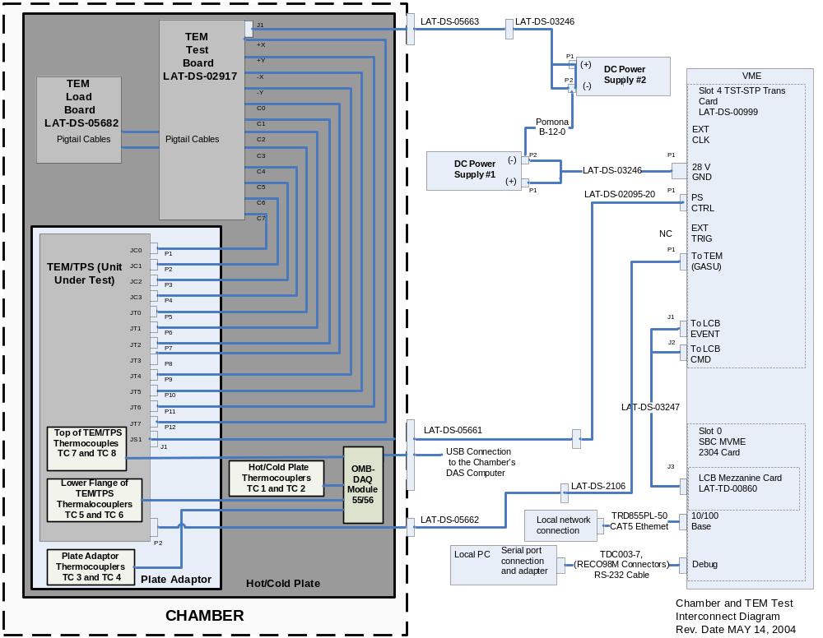
- Interconnect Diagram

Setup of the Test Equipment and Test Cable
- Setup the test cables, test cables adapter and power cables using the cable feed-through connectors of the TV chamber. Refer to the test setup within the TEM/TPS Performance Procedure LAT-TD-04085 and the Interconnect Diagram Figure.

Test Setup of the Golden TEM/TPS Assembly
- Place a golden TEM/TSP assembly on the TPS plate adaptor. This TEM/TPS is used to validate the TEM/TPS test setup.
- Connect test cables to the golden TEM/TPS. Refer to the test setup within the TEM/TPS Performance Procedure LAT-TD-04085 and the Interconnect Diagram Figure.

Validation of the Golden TEM/TPS Assembly
- Validate the TEM/TPS test setup by performing the Comprehensive Performance Test within the TEM/TPS Performance Procedure LAT-TD-04085. Attach to the Appendix A Cover. Record per the data sheet.
- Disconnect test cables from the golden TEM/TPS assembly.
- Remove the golden TEM/TPS assembly from the TPS plate adaptor.

Test setup of the Flight TEM/TPS Assembly
- Install a flight TEM/TSP assembly to the plate adaptor. This flight TEM/TSP assembly is the EUT to be used for qualification or acceptance testing. Torque to 20 ft-lb.
- Connect the test cables to the flight TEM/TPS assembly. Refer to the test setup within the TEM/TPS Performance Procedure LAT-TD-04085 and the Interconnect Diagram Figure.
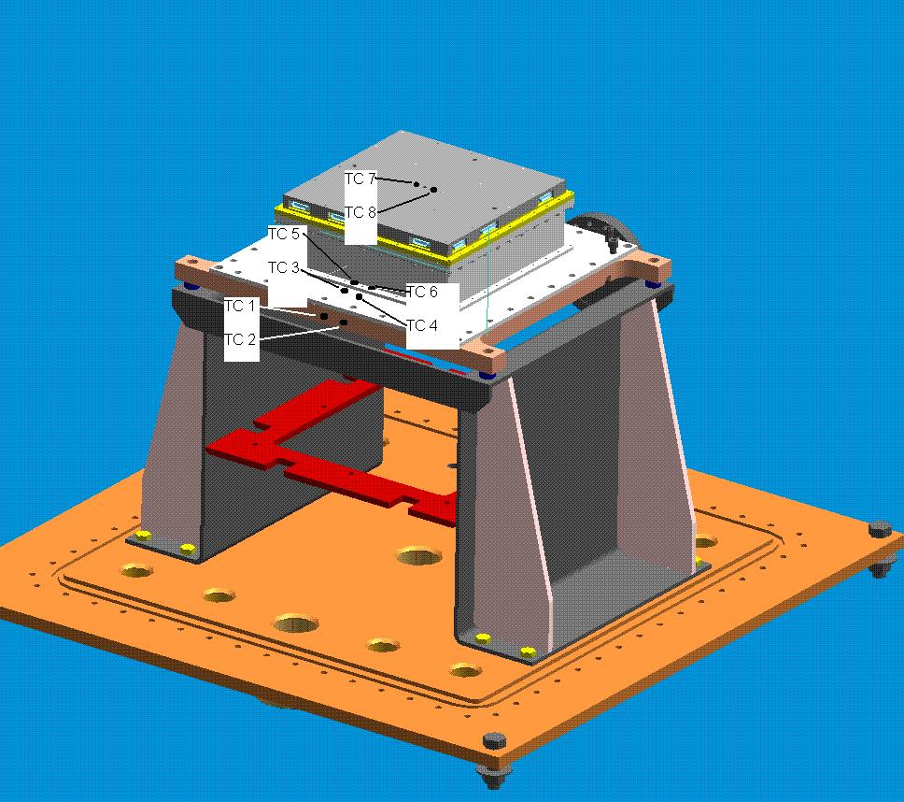
- Thermo Couplers TC1-TC8 Placements
- Secure eight thermo couplers (TC 1-TC 8) with acrylic base adhesive tape. Refer to the Thermo Couplers TC1-TC8 Placement Figure and Interconnect Diagram Figure.
- (Two) TC 1 and TC2 on the hot/cold plate.
- (Two) TC 3 and TC 4 on the plate adaptor.
- (Two) TC 5 and TC 6 on the bottom flange of the TEM/TPS.
- (Two) TC 7 and TC 8 on the top of the TEM/TPS Assembly.

Validation of the Golden TEM/TPS Assembly
- Validate the TEM/TPS test setup by performing the Comprehensive Performance Test within the TEM/TPS Performance Procedure LAT-TD-04085. Attach to the Appendix A Cover. Record per the data sheet.

Close Chamber
- Close the thermal vacuum chamber. Refer to GLAST Thermal Vacuum Chamber Operation Procedure LAT-TD-02541 to close the thermal vacuum chamber.

Boot Up DAS Software
- Using the DAS computer system to boot up of the DAS software. Refer to GLAST Thermal Vacuum Chamber Operation Procedure LAT-TD-02541.

Depressurization (Pump Down)
- Pump down the thermal vacuum chamber. Refer to GLAST Thermal Vacuum Chamber Operation Procedure LAT-TD-02541 to pump down the thermal vacuum chamber.

Thermal Vacuum Test
The thermal vacuum test satisfies the requirements for qualification and acceptance testing as verification for the TEM/TPS as specified in the LAT Environmental Specification LAT-SS-00778 and LAT Instrument Performance Verification Plan LAT-MD-00408.
The Thermal Vacuum Chamber Operation Procedure LAT- TD-02541 and TEM/TPS Performance Procedure LAT-TD-04085 are used in conjunction with this test procedure. Refer to these documents before proceeding with the following procedure.

Test Definitions

Timeline
The Test Timeline Figures below represent the qualification and acceptance test timelines. These timelines show when to open and close the chamber, test setup and shut down, test setup validation, and performance tests will take place. Deviations from these timelines shall be permitted at the discretion of the Test Director.

Cycles
Each thermal test shall be subject to a specified number of thermal cycles. Each cycle shall include a specified number of hour soaks at the specified high and low plateau temperature. A hot and cold survival soak shall be accomplished during the first cycle. Also an operational startup at the beginning of the transition to the test temperatures shall be accomplished during the first cycle.

Thermal
The thermal test will be conducted at the specified qualification and acceptance temperature ranges. During Ramp-Up or Ramp-Down of the temperature, the hot/cold plate will be adjusted to maintain a specified temperature per hour ramp. Throughout the test, the test temperatures shall not exceed the temperatures specified during hot soak and cold soak.

Vacuum
The thermal vacuum test of the TEM/TPS will be subject to the specified vacuum pressure (torr).

Performance
During the test, the TEM/TPS shall undergo both Comprehensive and Limited Performance Testing. These tests as shown in the Test Timeline Figures and are identified in the following sections.
- Comprehensive Performance Testing (C) shall provide verification of the full electrical function of the TEM/TPS electronics.
- Limited Performance Testing (L) shall provide verification of selected elements of the electrical function of the TEM/TPS electronics.
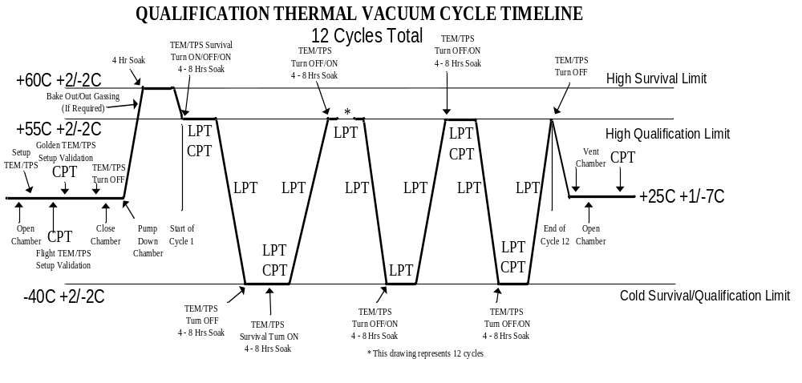
- Qualification Thermal Vacuum Cycle Timeline

Qualification Start Test
When perform the following test refer to the Qualification Thermal Vacuum Cycle Timeline Figure.
- Notify the QAE to witness the qualification test. Record per the data sheet.

Start of the Qualification Hot Survival Temperature Limit Test
- Verify the TEM/TPS is powered OFF. Record per the data sheet.
- On the TV Chamber Main Panel, click on "Start TEM Qualification T/V Cycle" button. Refer to the TV Chamber Main Panel Figure.
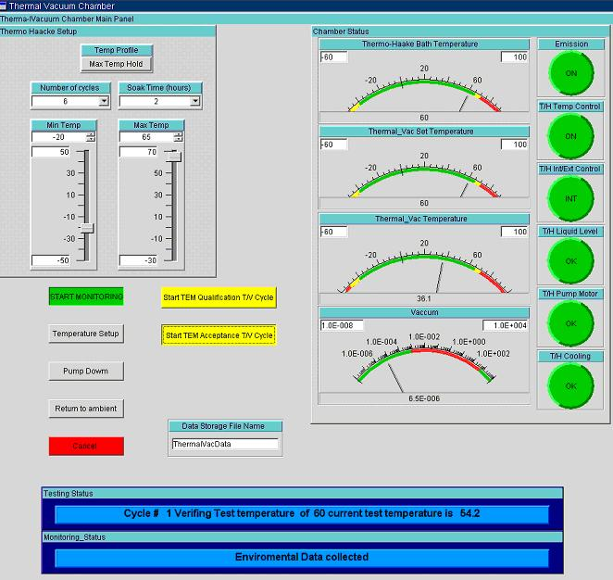
- TV Chamber Main Panel
- Message Windows
- Monitor the message windows at the bottom of the TV Chamber Main Panel for the start of the qualification hot survival temperature. Refer to the Message Windows Figure.
- Review the recorded environmental profiles (CVS files). Verify the following:
- Pressure is less than 10e-5 Torr. Record per the data sheet.
- Temperature at the top of the TEM/TPS (thermo couplers TC 7 and TC 8) is +60 degrees C +2/-2C. Record per the data sheet.
- A maximum of 20 degrees C /hour temperature up/down ramp. Record per the data sheet.
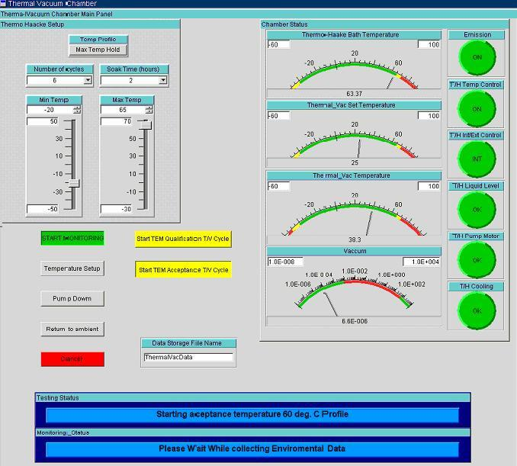
- Soaking at the Hot Survival Temperature

Soaking at Qualification Hot Survival Temperature Limit Test
- Monitor the message windows for soaking at the qualification hot survival temperature and soak time. Refer to the Soaking at the Hot Survival Temperature Figure.
- Review the recorded environmental profiles (CVS file). Verify the following:
- The TEM/TPS soaked for 4 hours. Record per the data sheet.
- Pressure is less than 10e-5 Torr. Record per the data sheet.
- Temperature at the top of the TEM/TPS (thermo couplers TC 7 and TC 8) is +60 degrees C +2/-2C. Record per the data sheet.
- A maximum of 20 degrees C /hour temperature up/down ramp. Record per the data sheet.
- Temperature at the top of the TEM/TPS is at less than 3 deg C/hour rate of change. Record per the data sheet.

Transition to Qualification High Temperature Limit
- Monitor the message windows for the start of the qualification hot temperature.
- Review the recorded environmental profiles (CVS files). Verify the following:
- Temperature at the top of the TEM/TPS (thermo couplers TC 5 and TC 6) is +55 degrees C +2/-2C. Record per the data sheet.
- A maximum of 20 degrees C /hour temperature up/down ramp. Record per the data sheet.
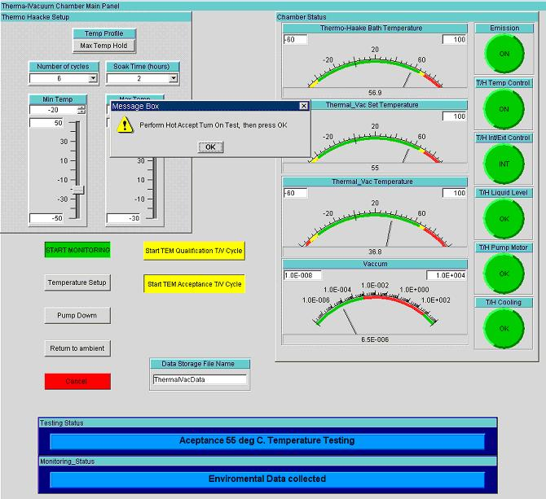
- Turn ON Test Popup Window

Qualification Test for Cycle 1

Hot Qualification Turn ON Test for First Cycle
- Popup window "Perform Hot Qualification Turn ON Test, then press OK" appears.
- Perform the following:
- Turn the TEM/TPS power to ON. Wait for 1 minute. Record per the data sheet.
- Turn the TEM/TPS power to OFF. Wait for 1 minute. Record per the data sheet.
- Turn the TEM/TPS power to ON. Record per the data sheet.
- Click on “OK” button.

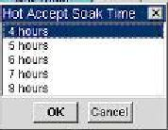
- Soak Time Hour Selection

Soak Time Selection at Qualification High Temperature Limit for First Cycle
- Popup window "Hot Qualification Soak Time" appears. Refer to the Soak Time Hour Selection Figure.
- Select the soak time hours (4 though 8) (4 hours typical).
- Click on “OK” button. This starts the soak time.

Soaking at Qualification High Temperature Limit Test for First Cycle
- Monitor the message windows for soaking at the qualification hot survival temperature and soak time.
- Review the recorded environmental profiles (CVS file). Verify the following:
- The TEM/TPS soaked for minimum of 4 hours to a maximum of 8 hours. Record per the data sheet.
- Pressure is less than 10e-5 Torr. Record per the data sheet.
- Temperature at the top of the TEM/TPS (thermo couplers TC 5 and TC6) is +55 degrees C +2/-2C. Record per the data sheet.
- A maximum of 20 degrees C /hur temperature up/down ramp. Record per the data sheet.
- Temperature at the top of the TEM/TPS is at less than 3 deg C/hour rate of change. Record per the data sheet.
- During the soak perform a continuous Limit Performance Test. Refer to the TEM/TPS Performance Procedure LAT-TD-04085. Record per the data sheet.

End of Soak CPT Test at Qualification High Temperature Limit for the First Cycle
- Perform one Comprehensive Performance Test. Refer to the TEM/TPS Performance Procedure LAT-TD-04085. Record per the data sheet.

Start of the Qualification Cold Survival Temperature Limit Test for First Cycle
- Monitor the message windows for the start of the qualification hot temperature.
- Review the recorded environmental profiles (CVS files). Verify the following:
- Temperature at the top of the TEM/TPS (thermo couplers TC 7 and TC 8) is -40 degrees C +2/-2C. Record per the data sheet.
- A maximum of 20 degrees C /hour temperature up/down ramp. Record per the data sheet.

Qualification Cold Survival Temperature Limit Turn OFF Test for First Cycle
- Popup window "Perform Cold Qualification Turn OFF Test, then press OK" appears.
- Perform the following:
- Turn the TEM/TPS power to OFF. Record per the data sheet.
- Click on “OK” button.

Soak Time Selection at Qualification Cold Survival Temperature Limit for First Cycle
- Popup window "Cold Qualification Soak Time" appears. Refer to the Soak Time Hour Selection Figure.
- Perform the following:
- Select the soak time hours (4 though 8) 4 hours is typical.
- Click on “OK” button. This starts the soak time.

Soaking at Qualification Cold Survival Temperature Limit Test for First Cycle
- Monitor the message windows for soaking at the qualification cold survival temperature and soak time.
- Review the recorded environmental profiles (CVS file). Verify the following:
- The TEM/TPS soaked for minimum of 4 hours to a maximum of 8 hours. Record per the data sheet.
- Pressure is less than 10e-5 Torr. Record per the data sheet.
- Temperature at the top of the TEM/TPS (thermo couplers TC 7 and TC8) is -40 degrees C +2/-2C. Record per the data sheet.
- A maximum of 20 degrees C /hour temperature up/down ramp. Record per the data sheet.
- Temperature at the top of the TEM/TPS is at less than 3 deg C/hour rate of change. Record per the data sheet.

Cold Qualification Turn ON Test for First Cycle
- Popup window "Perform Cold Qualification Turn ON Test, then press OK" appears.
- Perform the following:
- Turn the TEM/TPS power to ON. Wait for 1 minute. Record per the data sheet.
- Turn the TEM/TPS power to OFF. Wait for 1 minute. Record per the data sheet.
- Turn the TEM/TPS power to ON. Record per the data sheet.
- Click on “OK” button.

Soak Time Selection at Cold Qualification Temperature Limit for First Cycle
- Popup window "Cold Qualification Soak Time" appears. Refer to the Soak Time Hour Selection Figure.
- Select the soak time hours (4 though 8) (4 hours typical).
- Click on “OK” button. This starts the soak time.

Soaking at Qualification Low Temperature Limit Test for First Cycle
- Monitor the message windows for soaking at the qualification low temperature and soak time.
- Review the recorded environmental profiles (CVS file). Verify the following:
- The TEM/TPS soaked for minimum of 4 hours to a maximum of 8 hours. Record per the data sheet.
- Pressure is less than 10e-5 Torr. Record per the data sheet.
- Temperature at the top of the TEM/TPS (thermo couplers TC 5 and TC6) is -40 degrees C +2/-2C. Record per the data sheet.
- A maximum of 20 degrees C /hour temperature up/down ramp. Record per the data sheet.
- Temperature at the top of the TEM/TPS is at less than 3 deg C/hour rate of change. Record per the data sheet.
- During the soak perform a continuous Limit Performance Test. Refer to the TEM/TPS Performance Procedure LAT-TD-04085. Record per the data sheet.

End of Soak CPT Test at Qualification Low Temperature Limit for the First Cycle
- Perform one Comprehensive Performance Test. Refer to the TEM/TPS Performance Procedure LAT-TD-04085. Record per the data sheet.

Last Qualification High Temperature Limit Test for First Cycle
- Monitor the message windows for the start of the qualification high temperature.
- Review the recorded environmental profiles (CVS files). Verify the following:
- Temperature at the top of the TEM/TPS (thermo couplers TC 7 and TC 8) is +55 degrees C +2/-2C. Record per the data sheet.
- A maximum of 20 degrees C /hour temperature up/down ramp. Record per the data sheet.
- During this transition perform a continuous Limit Performance Test. Refer to the TEM/TPS Performance Procedure LAT-TD-04085. Record per the data sheet.

Qualification Test for Cycle 2-11

Qualification High Temperature Limit Turn ON Test for Cycle 2-11
- This test starts cycles 2-11.
- Popup window "Perform High Qualification Turn ON Test, then press OK" appears.
- Perform the following:
- Turn the TEM/TPS power to OFF. Wait for 1 minute. Record per the data sheet.
- Turn the TEM/TPS power to ON. Record per the data sheet.
- Click on “OK” button.

Soak Time Selection at High Qualification Temperature Limit for Cycle 2-11
- Popup window "High Qualification Soak Time" appears. Refer to the Soak Time Hour Selection Figure.
- Perform the following:
- Select the soak time hours (4 though 8) 4 hours is typical.
- Click on “OK” button. This starts the soak time.

Soaking at Qualification High Temperature Limit Test for Cycle 2-11
- Monitor the message windows for soaking at the qualification high temperature and soak time.
- Review the recorded environmental profiles (CVS file). Verify the following:
- The TEM/TPS soaked for minimum of 4 hours to a maximum of 8 hours. Record per the data sheet.
- Pressure is less than 10e-5 Torr. Record per the data sheet.
- Temperature at the top of the TEM/TPS (thermo couplers TC 5 and TC6) is +55 degrees C +2/-2C. Record per the data sheet.
- A maximum of 20 degrees C /hour temperature up/down ramp. Record per the data sheet.
- Temperature at the top of the TEM/TPS is at less than 3 deg C/hour rate of change. Record per the data sheet.
- During the soak perform a continuous Limit Performance Test. Refer to the TEM/TPS Performance Procedure LAT-TD-04085. Record per the data sheet.

End of Soak LPT Test at Qualification High Temperature Limit for Cycle 2-11
- Perform one last Limited Performance Test. Refer to the TEM/TPS Performance Procedure LAT-TD-04085. Record per the data sheet.

Start of the Qualification Low Temperature Limit Test for Cycle 2-11
- Monitor the message windows for the start of the qualification low temperature.
- Review the recorded environmental profiles (CVS files). Verify the following:
- Temperature at the top of the TEM/TPS (thermo couplers TC 7 and TC 8) is -40 degrees C +2/-2C. Record per the data sheet.
- A maximum of 20 degrees C /hour temperature up/down ramp. Record per the data sheet.
- During this transition perform a continuous Limit Performance Test. Refer to the TEM/TPS Performance Procedure LAT-TD-04085. Record per the data sheet.

Qualification Low Temperature Limit Turn ON Test for Cycle 2-11
- Popup window "Perform Low Qualification Turn ON Test, then press OK" appears.
- Perform the following:
- Turn the TEM/TPS power to OFF. Wait for 1 minute. Record per the data sheet.
- Turn the TEM/TPS power to ON. Record per the data sheet.
- Click on “OK” button.

Soak Time Selection at Low Qualification Temperature Limit for Cycle 2-11
- Popup window "Cold Qualification Soak Time" appears. Refer to the Soak Time Hour Selection Figure.
- Perform the following:
- Select the soak time hours (4 though 8) 4 hours is typical.
- Click on “OK” button. This starts the soak time.

Soaking at Qualification Low Temperature Limit Test for Cycle 2-11
- Monitor the message windows for soaking at the qualification low temperature and soak time.
- Review the recorded environmental profiles (CVS file). Verify the following:
- The TEM/TPS soaked for minimum of 4 hours to a maximum of 8 hours. Record per the data sheet.
- Pressure is less than 10e-5 Torr. Record per the data sheet.
- Temperature at the top of the TEM/TPS (thermo couplers TC 5 and TC6) is -40 degrees C +2/-2C. Record per the data sheet.
- A maximum of 20 degrees C /hour temperature up/down ramp. Record per the data sheet.
- Temperature at the top of the TEM/TPS is at less than 3 deg C/hour rate of change. Record per the data sheet.
- During the soak perform a continuous Limit Performance Test. Refer to the TEM/TPS Performance Procedure LAT-TD-04085. Record per the data sheet.

End of Soak LPT Test at Qualification Low Temperature Limit for Cycle 2-11
- Perform one Limited Performance Test. Refer to the TEM/TPS Performance Procedure LAT-TD-04085. Record per the data sheet.

Last Qualification High Temperature Limit Test for Cycle 2-12
- Monitor the message windows for the start of the qualification high temperature.
- Review the recorded environmental profiles (CVS files). Verify the following:
- Temperature at the top of the TEM/TPS (thermo couplers TC 7 and TC 8) is +55 degrees C +2/-2C. Record per the data sheet.
- A maximum of 20 degrees C /hour temperature up/down ramp. Record per the data sheet.
- During this transition perform a continuous Limit Performance Test. Refer to the TEM/TPS Performance Procedure LAT-TD-04085. Record per the data sheet.

Qualification Test for Cycle 12

Qualification High Temperature Limit Turn ON Test for Cycle 12
- This test starts cycles 12.
- Popup window "Perform High Qualification Turn ON Test, then press OK" appears.
- Perform the following:
- Turn the TEM/TPS power to OFF. Wait for 1 minute. Record per the data sheet.
- Turn the TEM/TPS power to ON. Record per the data sheet.
- Click on “OK” button.

Soak Time Selection at High Qualification Temperature Limit for Cycle 12
- Popup window "High Qualification Soak Time" appears. Refer to the Soak Time Hour Selection Figure.
- Perform the following:
- Select the soak time hours (4 though 8) 4 hours is typical.
- Click on “OK” button. This starts the soak time.

Soaking at Qualification High Temperature Limit Test for Cycle 12
- Monitor the message windows for soaking at the qualification high temperature and soak time.
- Review the recorded environmental profiles (CVS file). Verify the following:
- The TEM/TPS soaked for minimum of 4 hours to a maximum of 8 hours. Record per the data sheet.
- Pressure is less than 10e-5 Torr. Record per the data sheet.
- Temperature at the top of the TEM/TPS (thermo couplers TC 5 and TC6) is +55 degrees C +2/-2C. Record per the data sheet.
- A maximum of 20 degrees C /hour temperature up/down ramp. Record per the data sheet.
- Temperature at the top of the TEM/TPS is at less than 3 deg C/hour rate of change. Record per the data sheet.
- During the soak perform a continuous Limit Performance Test. Refer to the TEM/TPS Performance Procedure LAT-TD-04085. Record per the data sheet.

End of Soak LPT Test at Qualification High Temperature Limit for Cycle 12
- Perform one last Limited Performance Test. Refer to the TEM/TPS Performance Procedure LAT-TD-04085. Record per the data sheet.

Start of the Qualification Low Temperature Limit Test for Cycle 12
- Monitor the message windows for the start of the qualification low temperature.
- Review the recorded environmental profiles (CVS files). Verify the following:
- Temperature at the top of the TEM/TPS (thermo couplers TC 7 and TC 8) is -40 degrees C +2/-2C. Record per the data sheet.
- A maximum of 20 degrees C /hour temperature up/down ramp. Record per the data sheet.
- During this transition perform a continuous Limit Performance Test. Refer to the TEM/TPS Performance Procedure LAT-TD-04085. Record per the data sheet.

Qualification Low Temperature Limit Turn ON Test for Cycle 12
- Popup window "Perform Low Qualification Turn ON Test, then press OK" appears.
- Perform the following:
- Turn the TEM/TPS power to OFF. Wait for 1 minute. Record per the data sheet.
- Turn the TEM/TPS power to ON. Record per the data sheet.
- Click on “OK” button.

Soak Time Selection at Low Qualification Temperature Limit for Cycle 12
- Popup window "Cold Qualification Soak Time" appears. Refer to the Soak Time Hour Selection Figure.
- Perform the following:
- Select the soak time hours (4 though 8) 4 hours is typical.
- Click on “OK” button. This starts the soak time.

Soaking at Qualification Low Temperature Limit Test for Cycle 12
- Monitor the message windows for soaking at the qualification low temperature and soak time.
- Review the recorded environmental profiles (CVS file). Verify the following:
- The TEM/TPS soaked for minimum of 4 hours to a maximum of 8 hours. Record per the data sheet.
- Pressure is less than 10e-5 Torr. Record per the data sheet.
- Temperature at the top of the TEM/TPS (thermo couplers TC 5 and TC6) is -40 degrees C +2/-2C. Record per the data sheet.
- A maximum of 20 degrees C /hour temperature up/down ramp. Record per the data sheet.
- Temperature at the top of the TEM/TPS is at less than 3 deg C/hour rate of change. Record per the data sheet.
- During the soak perform a continuous Limit Performance Test. Refer to the TEM/TPS Performance Procedure LAT-TD-04085. Record per the data sheet.

End of Soak LPT Test at Qualification Low Temperature Limit for Cycle 12
- During the soak perform one Comprehensive Performance Test. Refer to the TEM/TPS Performance Procedure LAT-TD-04085. Record per the data sheet.

Last Qualification High Temperature Limit Test for Cycle 12
- Monitor the message windows for the start of the qualification high temperature.
- Review the recorded environmental profiles (CVS files). Verify the following:
- Temperature at the top of the TEM/TPS (thermo couplers TC 7 and TC 8) is +55 degrees C +2/-2C. Record per the data sheet.
- A maximum of 20 degrees C /hour temperature up/down ramp. Record per the data sheet.
- During this transition perform a continuous Limit Performance Test. Refer to the TEM/TPS Performance Procedure LAT-TD-04085. Record per the data sheet.

Shutdown Cycle of the Qualification Test

Start of Shutdown Cycle of the Qualification Test
- Popup window "Perform Qualification Turn OFF Test, then press OK" appears.
- Perform the following:
- Turn the TEM/TPS power to OFF. Record per the data sheet.
- Click on “OK” button.
- Monitor the message windows for the start of the shutdown of the qualification test. Refer to the Message Windows Figure.
- Review the recorded environmental profiles (CVS files). Verify the following:
- Temperature at the top of the TEM/TPS (thermo couplers TC 5 and TC 6 indicate +25 degree +1/-7 C. Record per the data sheet.
- This cycle shall have a maximum of 20 deg C /hour up/down ramp. Record per the data sheet.
- Proceed to the section Shutdown of Chamber within this test procedure.

Acceptance Start Test
When perform the following test refer to the Acceptance Thermal Vacuum Cycle Timeline Figure.
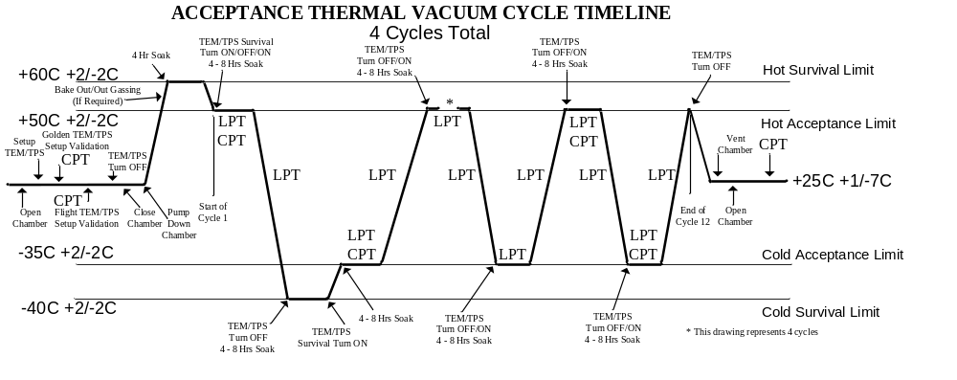
- Acceptance Thermal Vacuum Cycle Timeline
- Notify the QAE to witness the acceptance test. Record per the data sheet.

Start of the Acceptance Hot Survival Temperature Limit Test for First Cycle
- Verify the TEM/TPS is powered OFF. Record per the data sheet.
- On the TV Chamber Main Panel, click on "Start TEM Acceptance T/V Cycle" button. Refer to the TV Chamber Main Panel Figure.
- TV Chamber Main Panel
- Message Windows
- Monitor the message windows at the bottom of the TV Chamber Main Panel for the start of the Acceptance hot survival temperature. Refer to the Message Windows Figure.
- Review the recorded environmental profiles (CVS files). Verify the following:
- Pressure is less than 10e-5 Torr. Record per the data sheet.
- Temperature at the top of the TEM/TPS (thermo couplers TC 7 and TC 8) is +60 degrees C +2/-2C. Record per the data sheet.
- A maximum of 20 degrees C /hour temperature up/down ramp. Record per the data sheet.
- Soaking at the Hot Survival Temperature

Soaking at Acceptance Hot Survival Temperature Limit Test
- Monitor the message windows for soaking at the acceptance hot survival temperature and soak time. Refer to the Soaking at the Hot Survival Temperature Figure.
- .Review the recorded environmental profiles (CVS file). Verify the following:
- The TEM/TPS soaked for 4 hours. Record per the data sheet.
- Pressure is less than 10e-5 Torr. Record per the data sheet.
- Temperature at the top of the TEM/TPS (thermo couplers TC 7 and TC 8) is +60 degrees C +2/-2C. Record per the data sheet.
- A maximum of 20 degrees C /hour temperature up/down ramp. Record per the data sheet.
- Temperature at the top of the TEM/TPS is at less than 3 deg C/hour rate of change. Record per the data sheet.

Transition to Acceptance High Temperature Limit Test Cycle
- Monitor the message windows for the start of the acceptance high temperature.
- Review the recorded environmental profiles (CVS files). Verify the following:
- Temperature at the top of the TEM/TPS (thermo couplers TC 5 and TC 6) is +50 degrees C +2/-2C. Record per the data sheet.
- A maximum of 20 degrees C /hour temperature up/down ramp. Record per the data sheet.
- Turn ON Test Popup Window

Acceptance Test for Cycle 1

Hot Acceptance Turn ON Test for First Cycle
- Popup window "Perform Hot Acceptance Turn ON Test, then press OK" appears.
- Perform the following:
- Turn the TEM/TPS power to ON. Wait for 1 minute. Record per the data sheet.
- Turn the TEM/TPS power to OFF. Wait for 1 minute. Record per the data sheet.
- Turn the TEM/TPS power to ON. Record per the data sheet.
- Click on “OK” button.
- Soak Time Hour Selection

Soak Time Selection at Acceptance High Temperature Limit for First Cycle
- Popup window "Hot Acceptance Soak Time" appears. Refer to the Soak Time Hour Selection Figure.
- Select the soak time hours (4 though 8) (4 hours typical).
- Click on “OK” button. This starts the soak time.

Soaking at Acceptance High Temperature Limit Test for First Cycle
- Monitor the message windows for soaking at the acceptance hot survival temperature and soak time.
- Review the recorded environmental profiles (CVS file). Verify the following:
- The TEM/TPS soaked for minimum of 4 hours to a maximum of 8 hours. Record per the data sheet.
- Pressure is less than 10e-5 Torr. Record per the data sheet.
- Temperature at the top of the TEM/TPS (thermo couplers TC 5 and TC6) is +50 degrees C +2/-2C. Record per the data sheet.
- A maximum of 20 degrees C /hour temperature up/down ramp. Record per the data sheet.
- Temperature at the top of the TEM/TPS is at less than 3 deg C/hour rate of change. Record per the data sheet.
- During the soak perform a continuous Limit Performance Test. Refer to the TEM/TPS Performance Procedure LAT-TD-04085. Record per the data sheet.

End of Soak CPT Test at Acceptance High Temperature Limit for the First Cycle
- Perform one Comprehensive Performance Test. Refer to the TEM/TPS Performance Procedure LAT-TD-04085. Record per the data sheet.

Start of the Acceptance Cold Survival Temperature Limit Test for First Cycle
- Monitor the message windows for the start of the acceptance hot temperature.
- Review the recorded environmental profiles (CVS files). Verify the following:
- Temperature at the top of the TEM/TPS (thermo couplers TC 7 and TC 8) is -40 degrees C +2/-2C. Record per the data sheet.
- A maximum of 20 degrees C /hour temperature up/down ramp. Record per the data sheet.

Acceptance Cold Survival Temperature Limit Turn OFF Test for First Cycle
- Popup window "Perform Cold Acceptance Turn OFF Test, then press OK" appears.
- Perform the following:
- Turn the TEM/TPS power to OFF. Record per the data sheet.
- Click on “OK” button.

Soak Time Selection at Acceptance Cold Survival Temperature Limit for First Cycle
- Popup window "Cold Acceptance Soak Time" appears. Refer to the Soak Time Hour Selection Figure.
- Perform the following:
- Select the soak time hours (4 though 8) 4 hours is typical.
- Click on “OK” button. This starts the soak time.

Soaking at Acceptance Cold Survival Temperature Limit Test for First Cycle
- Monitor the message windows for soaking at the acceptance cold survival temperature and soak time.
- Review the recorded environmental profiles (CVS file). Verify the following:
- The TEM/TPS soaked for minimum of 4 hours to a maximum of 8 hours. Record per the data sheet.
- Pressure is less than 10e-5 Torr. Record per the data sheet.
- Temperature at the top of the TEM/TPS (thermo couplers TC 7 and TC8) is -40 degrees C +2/-2C. Record per the data sheet.
- A maximum of 20 degrees C /hour temperature up/down ramp. Record per the data sheet.
- Temperature at the top of the TEM/TPS is at less than 3 deg C/hour rate of change. Record per the data sheet.

Cold Acceptance Turn ON Test for First Cycle
- Popup window "Perform Cold Acceptance Turn ON Test, then press OK" appears.
- Perform the following:
- Turn the TEM/TPS power to ON. Wait for 1 minute. Record per the data sheet.
- Click on “OK” button.

Transition to Acceptance Low Temperature Limit Test Cycle
- Monitor the message windows for the start of the acceptance low temperature.
- Review the recorded environmental profiles (CVS files). Verify the following:
- Temperature at the top of the TEM/TPS (thermo couplers TC 5 and TC 6) is -35 degrees C +2/-2C. Record per the data sheet.
- A maximum of 20 degrees C /hour temperature up/down ramp. Record per the data sheet.
- During this transition perform a continuous Limit Performance Test. Refer to the TEM/TPS Performance Procedure LAT-TD-04085. Record per the data sheet.

Soak Time Selection at Cold Acceptance Temperature Limit for First Cycle
- Popup window "Cold Acceptance Soak Time" appears. Refer to the Soak Time Hour Selection Figure.
- Select the soak time hours (4 though 8) (4 hours typical).
- Click on “OK” button. This starts the soak time.

Soaking at Acceptance Low Temperature Limit Test for First Cycle
- Monitor the message windows for soaking at the acceptance low temperature and soak time.
- Review the recorded environmental profiles (CVS file). Verify the following:
- The TEM/TPS soaked for minimum of 4 hours to a maximum of 8 hours. Record per the data sheet.
- Pressure is less than 10e-5 Torr. Record per the data sheet.
- Temperature at the top of the TEM/TPS (thermo couplers TC 5 and TC6) is -35 degrees C +2/-2C. Record per the data sheet.
- A maximum of 20 degrees C /hour temperature up/down ramp. Record per the data sheet.
- Temperature at the top of the TEM/TPS is at less than 3 deg C/hour rate of change. Record per the data sheet.
- During the soak perform a continuous Limit Performance Test. Refer to the TEM/TPS Performance Procedure LAT-TD-04085. Record per the data sheet.

End of Soak CPT Test at Acceptance Low Temperature Limit for the First Cycle
- Perform one Comprehensive Performance Test. Refer to the TEM/TPS Performance Procedure LAT-TD-04085. Record per the data sheet.

Last Acceptance High Temperature Limit Test for First Cycle
- Monitor the message windows for the start of the acceptance high temperature.
- Review the recorded environmental profiles (CVS files). Verify the following:
- Temperature at the top of the TEM/TPS (thermo couplers TC 7 and TC 8) is +50 degrees C +2/-2C. Record per the data sheet.
- A maximum of 20 degrees C /hour temperature up/down ramp. Record per the data sheet.
- During this transition perform a continuous Limit Performance Test. Refer to the TEM/TPS Performance Procedure LAT-TD-04085. Record per the data sheet.

Acceptance Test for Cycle 2-3

Acceptance High Temperature Limit Turn ON Test for Cycle 2-3
- This test starts cycles 2-3.
- Popup window "Perform High Acceptance Turn ON Test, then press OK" appears.
- Perform the following:
- Turn the TEM/TPS power to OFF. Wait for 1 minute. Record per the data sheet.
- Turn the TEM/TPS power to ON. Record per the data sheet.
- Click on “OK” button.

Soak Time Selection at High Acceptance Temperature Limit for Cycle 2-3
- Popup window "High Acceptance Soak Time" appears. Refer to the Soak Time Hour Selection Figure.
- Perform the following:
- Select the soak time hours (4 though 8) 4 hours is typical.
- Click on “OK” button. This starts the soak time.

Soaking at Acceptance High Temperature Limit Test for Cycle 2-3
- Monitor the message windows for soaking at the acceptance high temperature and soak time.
- Review the recorded environmental profiles (CVS file). Verify the following:
- The TEM/TPS soaked for minimum of 4 hours to a maximum of 8 hours. Record per the data sheet.
- Pressure is less than 10e-5 Torr. Record per the data sheet.
- Temperature at the top of the TEM/TPS (thermo couplers TC 5 and TC6) is +50 degrees C +2/-2C. Record per the data sheet.
- A maximum of 20 degrees C /hour temperature up/down ramp. Record per the data sheet.
- Temperature at the top of the TEM/TPS is at less than 3 deg C/hour rate of change. Record per the data sheet.
- During the soak perform a continuous Limit Performance Test. Refer to the TEM/TPS Performance Procedure LAT-TD-04085. Record per the data sheet.

End of Soak LPT Test at Acceptance High Temperature Limit for Cycle 2-3
- Perform one last Limited Performance Test. Refer to the TEM/TPS Performance Procedure LAT-TD-04085. Record per the data sheet.

Start of the Acceptance Low Temperature Limit Test for Cycle 2-3
- Monitor the message windows for the start of the acceptance low temperature.
- Review the recorded environmental profiles (CVS files). Verify the following:
- Temperature at the top of the TEM/TPS (thermo couplers TC 7 and TC 8) is -35 degrees C +2/-2C. Record per the data sheet.
- A maximum of 20 degrees C /hour temperature up/down ramp. Record per the data sheet.
- During this transition perform a continuous Limit Performance Test. Refer to the TEM/TPS Performance Procedure LAT-TD-04085. Record per the data sheet.

Acceptance Low Temperature Limit Turn ON Test for Cycle 2-3
- Popup window "Perform Low Acceptance Turn ON Test, then press OK" appears.
- Perform the following:
- Turn the TEM/TPS power to OFF. Wait for 1 minute. Record per the data sheet.
- Turn the TEM/TPS power to ON. Record per the data sheet.
- Click on “OK” button.

Soak Time Selection at Low Acceptance Temperature Limit for Cycle 2-3
- Popup window "Cold Acceptance Soak Time" appears. Refer to the Soak Time Hour Selection Figure.
- Perform the following:
- Select the soak time hours (4 though 8) 4 hours is typical.
- Click on “OK” button. This starts the soak time.

Soaking at Acceptance Low Temperature Limit Test for Cycle 2-3
- Monitor the message windows for soaking at the acceptance low temperature and soak time.
- Review the recorded environmental profiles (CVS file). Verify the following:
- The TEM/TPS soaked for minimum of 4 hours to a maximum of 8 hours. Record per the data sheet.
- Pressure is less than 10e-5 Torr. Record per the data sheet.
- Temperature at the top of the TEM/TPS (thermo couplers TC 5 and TC6) is -35 degrees C +2/-2C. Record per the data sheet.
- A maximum of 20 degrees C /hour temperature up/down ramp. Record per the data sheet.
- Temperature at the top of the TEM/TPS is at less than 3 deg C/hour rate of change. Record per the data sheet.
- During the soak perform a continuous Limit Performance Test. Refer to the TEM/TPS Performance Procedure LAT-TD-04085. Record per the data sheet.

End of Soak LPT Test at Acceptance Low Temperature Limit for Cycle 2-3
- Perform one Comprehensive Performance Test. Refer to the TEM/TPS Performance Procedure LAT-TD-04085. Record per the data sheet.

Last Acceptance High Temperature Limit Test for Cycle 2-12
- Monitor the message windows for the start of the acceptance high temperature.
- Review the recorded environmental profiles (CVS files). Verify the following:
- Temperature at the top of the TEM/TPS (thermo couplers TC 7 and TC 8) is +50 degrees C +2/-2C. Record per the data sheet.
- A maximum of 20 degrees C /hour temperature up/down ramp. Record per the data sheet.
- During this transition perform a continuous Limit Performance Test. Refer to the TEM/TPS Performance Procedure LAT-TD-04085. Record per the data sheet.

Acceptance Test for Cycle 4

Acceptance High Temperature Limit Turn ON Test for Cycle 4
- This test starts cycles 4.
- Popup window "Perform High Acceptance Turn ON Test, then press OK" appears.
- Perform the following:
- Turn the TEM/TPS power to OFF. Wait for 1 minute. Record per the data sheet.
- Turn the TEM/TPS power to ON. Record per the data sheet.
- Click on “OK” button.

Soak Time Selection at High Acceptance Temperature Limit for Cycle 4
- Popup window "High Acceptance Soak Time" appears. Refer to the Soak Time Hour Selection Figure.
- Perform the following:
- Select the soak time hours (4 though 8) 4 hours is typical.
- Click on “OK” button. This starts the soak time.

Soaking at Acceptance High Temperature Limit Test for Cycle 4
- Monitor the message windows for soaking at the acceptance high temperature and soak time.
- Review the recorded environmental profiles (CVS file). Verify the following:
- The TEM/TPS soaked for minimum of 4 hours to a maximum of 8 hours. Record per the data sheet.
- Pressure is less than 10e-5 Torr. Record per the data sheet.
- Temperature at the top of the TEM/TPS (thermo couplers TC 5 and TC6) is +50 degrees C +2/-2C. Record per the data sheet.
- A maximum of 20 degrees C /hour temperature up/down ramp. Record per the data sheet.
- Temperature at the top of the TEM/TPS is at less than 3 deg C/hour rate of change. Record per the data sheet.
- During the soak perform a continuous Limit Performance Test. Refer to the TEM/TPS Performance Procedure LAT-TD-04085. Record per the data sheet.

End of Soak LPT Test at Acceptance High Temperature Limit for Cycle 4
- Perform one last Limited Performance Test. Refer to the TEM/TPS Performance Procedure LAT-TD-04085. Record per the data sheet.

Start of the Acceptance Low Temperature Limit Test for Cycle 4
- Monitor the message windows for the start of the acceptance low temperature.
- Review the recorded environmental profiles (CVS files). Verify the following:
- Temperature at the top of the TEM/TPS (thermo couplers TC 7 and TC 8) is -35 degrees C +2/-2C. Record per the data sheet.
- A maximum of 20 degrees C /hour temperature up/down ramp. Record per the data sheet.
- During this transition perform a continuous Limit Performance Test. Refer to the TEM/TPS Performance Procedure LAT-TD-04085. Record per the data sheet.

Acceptance Low Temperature Limit Turn ON Test for Cycle 4
- Popup window "Perform Low Acceptance Turn ON Test, then press OK" appears.
- Perform the following:
- Turn the TEM/TPS power to OFF. Wait for 1 minute. Record per the data sheet.
- Turn the TEM/TPS power to ON. Record per the data sheet.
- Click on “OK” button.

Soak Time Selection at Low Acceptance Temperature Limit for Cycle 4
- Popup window "Cold Acceptance Soak Time" appears. Refer to the Soak Time Hour Selection Figure.
- Perform the following:
- Select the soak time hours (4 though 8) 4 hours is typical.
- Click on “OK” button. This starts the soak time.

Soaking at Acceptance Low Temperature Limit Test for Cycle 4
- Monitor the message windows for soaking at the acceptance low temperature and soak time.
- Review the recorded environmental profiles (CVS file). Verify the following:
- The TEM/TPS soaked for minimum of 4 hours to a maximum of 8 hours. Record per the data sheet.
- Pressure is less than 10e-5 Torr. Record per the data sheet.
- Temperature at the top of the TEM/TPS (thermo couplers TC 5 and TC6) is -35 degrees C +2/-2C. Record per the data sheet.
- A maximum of 20 degrees C /hour temperature up/down ramp. Record per the data sheet.
- Temperature at the top of the TEM/TPS is at less than 3 deg C/hour rate of change. Record per the data sheet.
- During the soak perform a continuous Limit Performance Test. Refer to the TEM/TPS Performance Procedure LAT-TD-04085. Record per the data sheet.

End of Soak LPT Test at Acceptance Low Temperature Limit for Cycle 4
- During the soak perform one Comprehensive Performance Test. Refer to the TEM/TPS Performance Procedure LAT-TD-04085. Record per the data sheet.

Last Acceptance High Temperature Limit Test for Cycle 4
- Monitor the message windows for the start of the acceptance high temperature.
- Review the recorded environmental profiles (CVS files). Verify the following:
- Temperature at the top of the TEM/TPS (thermo couplers TC 7 and TC 8) is +50 degrees C +2/-2C. Record per the data sheet.
- A maximum of 20 degrees C /hour temperature up/down ramp. Record per the data sheet.
- During this transition perform a continuous Limit Performance Test. Refer to the TEM/TPS Performance Procedure LAT-TD-04085. Record per the data sheet.

Shutdown Cycle of the Acceptance Test

Start of Shutdown Cycle of the Acceptance Test
- Popup window "Perform Acceptance Turn OFF Test, then press OK" appears.
- Perform the following:
- Turn the TEM/TPS power to OFF. Record per the data sheet.
- Click on “OK” button.
- Monitor the message windows for the start of the shutdown of the Acceptance test. Refer to the Message Windows Figure.
- Review the recorded environmental profiles (CVS files). Verify the following:
- Temperature at the top of the TEM/TPS (thermo couplers TC 5 and TC 6 indicate +25 degree +1/-7 C. Record per the data sheet.
- This cycle shall have a maximum of 20 deg C /hour up/down ramp. Record per the data sheet.
- Proceed to the section Shutdown of Chamber within this test procedure.

Chamber Shutdown
This section describes the procedure to shutdown the chamber by pressurization (venting), performing a comprehensive performance test, collecting test data, shutdown of the TEM/TPS and test equipment, and opening and closing the chamber.

Pressurization (Venting)
- Vent the thermal vacuum chamber. Refer to GLAST Thermal Vacuum Chamber Operation Procedure LAT-TD-02541 to vent the thermal vacuum chamber.
- Verify the chamber pressure is at ambient pressure 760 Torr. Record per the data sheet.
- Verify the chamber temperature is at ambient temperature (+25 C +2/-2C). Record per the data sheet.

Opening Chamber
This section describes the procedure to lift the chamber so that the TEM/TPS unit can be removed from the chamber.
The chamber must be at ambient temperature before the lid is lifted. This is to prevent condensation on the TEM/TPS or hot/cold plate when the chamber is opened to the ambient environment.
- Open the thermal vacuum chamber. Refer to GLAST Thermal Vacuum Chamber Operation Procedure LAT-TD-02541 to open the thermal vacuum chamber.
- Perform the Comprehensive Performance Test within the TEM/TPS Performance Procedure LAT-TD-04085. Record per the data sheet.
- Review and save the recorded environmental profiles (CVS files).

Collecting Test Data Sheets
- Save and attach TEM/TPS Thermal Vacuum Test Data Sheets to Appendix A Cover. Record per the data sheet.
- Save and print the recorded data, attach them to the Appendix A Cover. Record per the data sheet.
Appendix A (Data Sheets and Covers)
COVER SHEET

Program: GLAST
Procedure Number: LAT-TD-03631
Procedure Title: TEM/TPS Thermal Vacuum Test Procedure
Paragraph Number: 5.4
Paragraph Title: Thermal Vacuum Test
Unit S/N:

TEST READINESS REVIEW COMPLETED AND APPROVED BY THE FOLLOWING:
Test Director: Date:
Quality Assurance: Date:
Test Conductor: Date:

REVIEWED AND APPROVED BY THE FOLLOWING:
Test Director: Date:
Quality Assurance: Date:
Test Conductor: Date:

TEST DATA SHEET |  |  | Unit S/N: |  | Date/Temperature:
Title: 5.1.3 Test Equipment |  |  | Operator: |  | QA:
Para./  Step | Test Equipment Description, Manufacturer | Model/LAT  Number |  | Serial/Rev.  Number |  | *Cal./Val. Date
5.1.3.1 - 1 | Record Model/LAT number, Serial/Revision number, Calibration due dates and Validation date for all equipment used in this procedure:
 | VME Crate, Dawn VME Products | 11-1011777-2119 VME64x (series 767)
 | VME, TST-STP Trans card | LAT-DS-00999
 | VME SBC MVME2304 card, Motorola | PN MVME2304-0123
 | VME LCB Mezzanine card | LAT-TD-00860
 | Software for the local PC | LATTE P04-04-01  www-glast.slac.stanford.edu/IntegrationTest/ONLINE/updates/
 | Software for the local PC | TEMPROD V00-00-00
 | DC Power supply #1, BK Precision | BK 1697
 | DC Power supply #2, BK Precision | BK 1697
 | 28 Volt supply cable | LAT-DS-03246
 | PS Control cable | LAT-DS-04831
 | TEM to GASU cable | LAT-DS-02106
 | LCB Transition board cable | LAT-DS-03247
 | TEM Test Board Assembly | LAT-DS-04465
 | TEM Test board cooling fan assembly | LAT-DS-03567
 | CAT5 Ethernet cable | TRD855PL-50
 | RS-232 Cable | TDC003-7 (RECO98M connectors)
 | Ground jumper, Banana, Pomona | B-12-0
 | PS extension cable | LAT-DS-04629
 | Digital Multimeter, Fluke/Meterman | 87-III/38XR
 | Connector Savers (28 pin), L Com | DGBH28MF
 | Connector Savers (51 pin), Glenair | MWDM2L-51USP1
 | Connector Savers (69 pin), SLAC | LAT-DS-04724
 | Connector Savers (78 pin), L Com | DGBH78MF
 | Breakout Box Assembly (BOB) (78 pin), SLAC | LAT-DS-03580
 | Breakout Cable (BOC), SLAC | LAT-DS-04273
 | Breakout Cable (BOC), SLAC | LAT-DS-04275
 | Load | LAT-DS-04822
 | Load | LAT-DS-04823
 | 1 MHz Filter | LAT-DS-04767
 | Noise Measurement Adapter, 51-Pin, SLAC | LAT-DS-04821
 | Noise Measurement Adapter, 69-Pin, SLAC | LAT-DS-04820
 | True RMS Volt Meter, Agilent (HP) | 3400A
 | Delay Line, Lemo To Bnc 4N, from SLAC Stores | STORES ID #078697
 | Thermal Vacuum Chamber, SLAC | LAT-DS-01043
 | Acrylic base adhesive tape, Saint Gobain | K102
 | Thermo coupler wire (8), Omega | T Type
 | DAQ Module, Omega | OMB-DAQ-55
 | DAQ Module, Omega | OMB-DAQ-56
- This column is used to enter the date that equipment is validated, when validated equipment is recorded in this data sheet.

TEST DATA SHEET |  |  | Unit S/N: |  | Date/Temperature:
Title: 5.1.3 Test Equipment |  |  | Operator: |  | QA:
Para./  Step | Test Equipment Description, Manufacturer | Model/LAT  Number |  | Serial/Rev.  Number |  | *Cal./Val. Date
5.1.3.1 - 1 | Record Model/LAT number, Serial/Revision number, Calibration due dates and Validation date for all equipment used in this procedure:
 | Adaptor 28 Volt supply cable | LAT-DS-05663
 | Adaptor PS Control cable | LAT-DS-05661
 | Adaptor TEM to GASU cable | LAT-DS-05662
 | Adaptor 28 Volt supply cable | LAT-DS-05663
- This column is used to enter the date that equipment is validated, when validated equipment is recorded in this data sheet.

TEST DATA SHEET |  |  | Unit S/N: |  | Date/Temperature:
Title: 5.1.4 Participant List |  |  | Operator: |  | QA:
Para./  Step | Title | Print Name |  | Signature
5.1.4 - 1 | Record names of all personnel that take part in the test/operation:

TEST DATA SHEET |  |  | Start Time:  End Time: |  |  | Date/Shift/  Temperature:  Unit S/N:
Title: TEM/TPS Thermal Vacuum Test |  |  | Operator: |  |  | QA:
Step |  | Description |  | Limits | Unit |  | Data
Test Setup
5.2 -1 | QAE notified to witness test setup |  |  |  | Yes/No
TEM/TPS Test Setup Validation
5.2.6 -1 | Perform the Comprehensive Performance Test within the TEM/TPS Performance Procedure LAT-TD-04085 |  |  |  | Yes/No
5.2.8 -1 | Perform the Comprehensive Performance Test within the TEM/TPS Performance Procedure LAT-TD-04085 |  |  |  | Yes/No
Start Qualification Test
5.3.2 Qualification Test
-1 |  | QAE notified to witness the qualification test |  |  | Yes/No
5.3.2.1 Start of Qualification Test
-1 |  | Verify the TEM/TPS is still turned on. |  |  | Yes/No
4 - a |  | Verify the pressure of the chamber. |  | 10e-5 | Torr
4 - b |  | Verify temperature per hour ramp rate. |  | >20 | Celsius per hour
4 - c |  | Verify the temperature of the hot soak. |  | +60 (+2/-2) | Celsius
Start Qualification Test
5.3.2.2 Qualification Soak
2 - a |  | Verify the soak of each cycle. |  | =>4 | Hours
2 - b |  | Verify during cycle the pressure of the chamber. |  | 10e-5 | Torr
2 - c |  | Verify the temperature of the cycle |  | +60 (+2/-2) | Celsius
2 - d |  | Verify temperature per hour ramp rate |  | >20 | Celsius per hour
2 - e |  | Verify during the cycle the temperature stability |  | <3 deg | Celsius per hour rate of change
Start Qualification Test
5.3.2.3 Transition Qualification
2 - a |  | Verify the temperature of the cycle |  | +55 (+2/-2) | Celsius
2 - b |  | Verify temperature per hour ramp rate |  | >20 | Celsius per hour

TEST DATA SHEET |  | Unit S/N: |  |  | Date:
Title: TEM/TPS Thermal Vacuum Test |  | Operator: |  |  | QA:
Step | Description |  | Limits | Unit |  | Operator
Qualification Test Cycle 1
5.3.3.1 Qualification Soak
2 - a | Turn the TEM/TPS power to ON. |  | ON | ON/OFF
2 - b | Turn the TEM/TPS power to OFF. |  | OFF | ON/OFF
2 - c | Turn the TEM/TPS power to ON. |  | ON | ON/OFF
Qualification Test Cycle 1
5.3.3.3 Qualification Soak
2 - a | Verify the soak of each cycle. |  | 4-8 | Hours
2 - b | Verify during cycle the pressure of the chamber. |  | 10e-5 | Torr
2 - c | Verify the temperature of the cycle |  | +55 (+2/-2) | Celsius
2 - d | Verify temperature per hour ramp rate |  | >20 | Celsius per hour
2 - e | Verify during the cycle the temperature stability |  | <3 deg | Celsius per hour rate of change
2 - f | Perform one Limited Performance Test within the TEM/TPS Performance Procedure LAT-TD-04085 |  | OK | OK/NG
Qualification Test Cycle 1
5.3.3.4 CPT Test
-1 | Perform one Comprehensive Performance Test within the TEM/TPS Performance Procedure LAT-TD-04085 |  | OK | OK/NG
Qualification Test Cycle 1
5.3.3.5 Start Qualification
2 - a | Verify the temperature of the cycle |  | -40 (+2/-2) | Celsius
2 - b | Verify temperature per hour ramp rate |  | >20 | Celsius per hour
Qualification Test Cycle 1
5.3.3.6 Qualification Turn OFF
2 - a | Turn the TEM/TPS power to OFF. |  | OFF | ON/OFF

TEST DATA SHEET |  | Unit S/N: |  |  | Date:
Title: TEM/TPS Thermal Vacuum Test |  | Operator: |  |  | QA:
Step | Description |  | Limits | Unit |  | Operator
Qualification Test Cycle 1
5.3.3.8 Qualification Soak
2 - a | Verify the soak of each cycle. |  | 4-8 | Hours
2 - b | Verify during cycle the pressure of the chamber. |  | 10e-5 | Torr
2 - c | Verify the temperature of the cycle |  | -40 (+2/-2) | Celsius
2 - d | Verify temperature per hour ramp rate |  | >20 | Celsius per hour
2 - e | Verify during the cycle the temperature stability |  | <3 deg | Celsius per hour rate of change
Qualification Test Cycle 1
5.3.3.9 Qualification Turn ON
2 - a | Turn the TEM/TPS power to ON. |  | ON | ON/OFF
2 - b | Turn the TEM/TPS power to OFF. |  | OFF | ON/OFF
2 - c | Turn the TEM/TPS power to ON. |  | ON | ON/OFF

TEST DATA SHEET |  | Unit S/N: |  |  | Date:
Title: TEM/TPS Thermal Vacuum Test |  | Operator: |  |  | QA:
Step | Description |  | Limits | Unit |  | Operator
Qualification Test Cycle 1
5.3.3.11 Qualification Soak
2 - a | Verify the soak of each cycle. |  | 4-8 | Hours
2 - b | Verify during cycle the pressure of the chamber. |  | 10e-5 | Torr
2 - c | Verify the temperature of the cycle |  | -40 (+2/-2) | Celsius
2 - d | Verify temperature per hour ramp rate |  | >20 | Celsius per hour
2 - e | Verify during the cycle the temperature stability |  | <3 deg | Celsius per hour rate of change
2 - f | Perform the continue Limited Performance Test within the TEM/TPS Performance Procedure LAT-TD-04085 |  | OK | OK/NG
Qualification Test Cycle 1
5.3.3.12 CPT Test
-1 | Perform one Comprehensive Performance Test within the TEM/TPS Performance Procedure LAT-TD-04085 |  | OK | OK/NG
Qualification Test Cycle 1
5.3.3.13 End of Qualification
2 - a | Verify the temperature of the cycle |  | +55 (+2/-2) | Celsius
2 - b | Verify temperature per hour ramp rate |  | >20 | Celsius per hour
2 - c | Perform the continue Limited Performance Test within the TEM/TPS Performance Procedure LAT-TD-04085 |  | OK | OK/NG

TEST DATA SHEET |  | Unit S/N: |  |  | Date:
Title: TEM/TPS Thermal Vacuum Test |  | Operator: |  |  | QA:
Step | Description |  | Limits | Unit |  | Operator
Qualification Test Cycle 2-11
5.3.4.1 Qualification Turn ON
3 - a | Turn the TEM/TPS power to OFF. |  | OFF | ON/OFF
3 - b | Turn the TEM/TPS power to ON. |  | ON | ON/OFF
Qualification Test Cycle 2-11
5.3.4.3 Qualification Soak
2 - a | Verify the soak of each cycle. |  | 4-8 | Hours
2 - b | Verify during cycle the pressure of the chamber. |  | 10e-5 | Torr
2 - c | Verify the temperature of the cycle |  | +55 (+2/-2) | Celsius
2 - d | Verify temperature per hour ramp rate |  | >20 | Celsius per hour
2 - e | Verify during the cycle the temperature stability |  | <3 deg | Celsius per hour rate of change
2 - f | Perform the continue Limited Performance Test within the TEM/TPS Performance Procedure LAT-TD-04085 |  | OK | OK/NG
Qualification Test Cycle 2-11
5.3.4.4 LPT Test
-1 | Perform one Limited Performance Test within the TEM/TPS Performance Procedure LAT-TD-04085 |  | OK | OK/NG
Qualification Test Cycle 2-11
5.3.4.5 End of Qualification
2 - a | Verify the temperature of the cycle |  | -40 (+2/-2) | Celsius
2 - b | Verify temperature per hour ramp rate |  | >20 | Celsius per hour
2 - c | Perform the continue Limited Performance Test within the TEM/TPS Performance Procedure LAT-TD-04085 |  | OK | OK/NG

TEST DATA SHEET |  | Unit S/N: |  |  | Date:
Title: TEM/TPS Thermal Vacuum Test |  | Operator: |  |  | QA:
Step | Description |  | Limits | Unit |  | Operator
Qualification Test Cycle 2-11
5.3.4.6 Qualification Turn ON
2 - a | Turn the TEM/TPS power to OFF. |  | OFF | ON/OFF
2 - b | Turn the TEM/TPS power to ON. |  | ON | ON/OFF
Qualification Test Cycle 2-11
5.3.4.8 Qualification Soak
2 - a | Verify the soak of each cycle. |  | 4-8 | Hours
2 - b | Verify during cycle the pressure of the chamber. |  | 10e-5 | Torr
2 - c | Verify the temperature of the cycle |  | -40 (+2/-2) | Celsius
2 - d | Verify temperature per hour ramp rate |  | >20 | Celsius per hour
2 - e | Verify during the cycle the temperature stability |  | <3 deg | Celsius per hour rate of change
2 - f | Perform the continue Limited Performance Test within the TEM/TPS Performance Procedure LAT-TD-04085 |  | OK | OK/NG
Qualification Test Cycle 2-11
5.3.4.9 LPT Test
-1 | Perform one Limited Performance Test within the TEM/TPS Performance Procedure LAT-TD-04085 |  | OK | OK/NG
Qualification Test Cycle 2-11
5.3.4.10 End of Qualification
2 - a | Verify the temperature of the cycle |  | +55 (+2/-2) | Celsius
2 - b | Verify temperature per hour ramp rate |  | >20 | Celsius per hour
2 - c | Perform the continue Limited Performance Test within the TEM/TPS Performance Procedure LAT-TD-04085 |  | OK | OK/NG

TEST DATA SHEET |  | Unit S/N: |  |  | Date:
Title: TEM/TPS Thermal Vacuum Test |  | Operator: |  |  | QA:
Step | Description |  | Limits | Unit |  | Operator
Qualification Test Cycle 12
5.3.5.1 Qualification Turn ON
3 - a | Turn the TEM/TPS power to OFF. |  | OFF | ON/OFF
3 - b | Turn the TEM/TPS power to ON. |  | ON | ON/OFF
Qualification Test Cycle 12
5.3.5.3 Qualification Soak
2 - a | Verify the soak of each cycle. |  | 4-8 | Hours
2 - b | Verify during cycle the pressure of the chamber. |  | 10e-5 | Torr
2 - c | Verify the temperature of the cycle |  | +55 (+2/-2) | Celsius
2 - d | Verify temperature per hour ramp rate |  | >20 | Celsius per hour
2 - e | Verify during the cycle the temperature stability |  | <3 deg | Celsius per hour rate of change
2 - f | Perform the continue Limited Performance Test within the TEM/TPS Performance Procedure LAT-TD-04085 |  | OK | OK/NG
Qualification Test Cycle 12
5.3.5.4 LPT Test
-1 | Perform one Limited Performance Test within the TEM/TPS Performance Procedure LAT-TD-04085 |  | OK | OK/NG
Qualification Test Cycle 12
5.3.5.5 End of Qualification
2 - a | Verify the temperature of the cycle |  | -40 (+2/-2) | Celsius
2 - b | Verify temperature per hour ramp rate |  | >20 | Celsius per hour
2 - c | Perform the continue Limited Performance Test within the TEM/TPS Performance Procedure LAT-TD-04085 |  | OK | OK/NG
Qualification Test Cycle 12
5.3.5.6 Qualification Turn ON
2 - a | Turn the TEM/TPS power to OFF. |  | OFF | ON/OFF
2 - b | Turn the TEM/TPS power to ON. |  | ON | ON/OFF

TEST DATA SHEET |  | Unit S/N: |  |  | Date:
Title: TEM/TPS Thermal Vacuum Test |  | Operator: |  |  | QA:
Step | Description |  | Limits | Unit |  | Operator
Qualification Test Cycle 12
5.3.5.8 Qualification Soak
2 - a | Verify the soak of each cycle. |  | 4-8 | Hours
2 - b | Verify during cycle the pressure of the chamber. |  | 10e-5 | Torr
2 - c | Verify the temperature of the cycle |  | -40 (+2/-2) | Celsius
2 - d | Verify temperature per hour ramp rate |  | >20 | Celsius per hour
2 - e | Verify during the cycle the temperature stability |  | <3 deg | Celsius per hour rate of change
2 - f | Perform the continue Limited Performance Test within the TEM/TPS Performance Procedure LAT-TD-04085 |  | OK | OK/NG
Qualification Test Cycle 12
5.3.5.9 LPT Test
-1 | Perform one Limited Performance Test within the TEM/TPS Performance Procedure LAT-TD-04085 |  | OK | OK/NG
Qualification Test Cycle 12
5.3.5.10 End of Qualification
2 - a | Verify the temperature of the cycle |  | +55 (+2/-2) | Celsius
2 - b | Verify temperature per hour ramp rate |  | >20 | Celsius per hour
2 - c | Perform the continue Limited Performance Test within the TEM/TPS Performance Procedure LAT-TD-04085 |  | OK | OK/NG

TEST DATA SHEET |  | Unit S/N: |  |  | Date:
Title: TEM/TPS Thermal Vacuum Test |  | Operator: |  |  | QA:
Step | Description |  | Limits | Unit |  | Operator
Qualification Shutdown
5.3.6.1 Qualification Soak
2 - a | Turn the TEM/TPS power to OFF. |  | OFF | ON/OFF
4 - a | Verify the temperature of the cycle |  | +25 (+1/-7) | Celsius
-5 | Verify temperature per hour ramp rate |  | >20 | Celsius per hour

TEST DATA SHEET |  | Unit S/N: |  |  | Date:
Title: TEM/TPS Thermal Vacuum Test |  | Operator: |  |  | QA:
Step | Description |  | Limits | Unit |  | Data
Start Acceptance Test
5.3.7 Qualification Test
-1 | QAE notified to witness the Acceptance test |  | YES | YES/NO
5.3.7.1 Start of Acceptance Test
-1 | Verify the TEM/TPS is turned OFF. |  | OFF | OFF/ON
4 - a | Verify the pressure of the chamber. |  | 10e-5 | Torr
4 - b | Verify temperature per hour ramp rate. |  | >20 | Celsius per hour
4 - c | Verify the temperature of the hot soak. |  | +60 (+2/-2) | Celsius
Start Acceptance Test
5.3.7.2 Acceptance Soak
2 - a | Verify the soak of each cycle. |  | =>4 | Hours
2 - b | Verify during cycle the pressure of the chamber. |  | 10e-5 | Torr
2 - c | Verify the temperature of the cycle |  | +60 (+2/-2) | Celsius
2 - d | Verify temperature per hour ramp rate |  | >20 | Celsius per hour
2 - e | Verify during the cycle the temperature stability |  | <3 deg | Celsius per hour rate of change
Start Acceptance Test
5.3.7.3 Transition Acceptance:
2 - a | Verify the temperature of the cycle |  | +55 (+2/-2) | Celsius
2 - b | Verify temperature per hour ramp rate |  | >20 | Celsius per hour

TEST DATA SHEET |  | Unit S/N: |  |  | Date:
Title: TEM/TPS Thermal Vacuum Test |  | Operator: |  |  | QA:
Step | Description |  | Limits | Unit |  | Operator
Acceptance Test Cycle 1
5.3.8.1 Acceptance Soak
2 - a | Turn the TEM/TPS power to ON. |  | ON | ON/OFF
2 - b | Turn the TEM/TPS power to OFF. |  | OFF | ON/OFF
2 - c | Turn the TEM/TPS power to ON. |  | ON | ON/OFF
Acceptance Test Cycle 1
5.3.8.3 Acceptance Soak
2 - a | Verify the soak of each cycle. |  | 4-8 | Hours
2 - b | Verify during cycle the pressure of the chamber. |  | 10e-5 | Torr
2 - c | Verify the temperature of the cycle |  | +55 (+2/-2) | Celsius
2 - d | Verify temperature per hour ramp rate |  | >20 | Celsius per hour
2 - e | Verify during the cycle the temperature stability |  | <3 deg | Celsius per hour rate of change
2 - f | Perform one Limited Performance Test within the TEM/TPS Performance Procedure LAT-TD-04085 |  | OK | OK/NG
Acceptance Test Cycle 1
5.3.8.4 CPT Test
-1 | Perform one Comprehensive Performance Test within the TEM/TPS Performance Procedure LAT-TD-04085 |  | OK | OK/NG
Acceptance Test Cycle 1
5.3.8.5 Start Acceptance
2 - a | Verify the temperature of the cycle |  | -40 (+2/-2) | Celsius
2 - b | Verify temperature per hour ramp rate |  | >20 | Celsius per hour
Acceptance Test Cycle 1
5.3.8.6 Acceptance Turn OFF
2 - a | Turn the TEM/TPS power to OFF. |  | OFF | ON/OFF

TEST DATA SHEET |  | Unit S/N: |  |  | Date:
Title: TEM/TPS Thermal Vacuum Test |  | Operator: |  |  | QA:
Step | Description |  | Limits | Unit |  | Operator
Acceptance Test Cycle 1
5.3.8.8 Acceptance Soak
2 - a | Verify the soak of each cycle. |  | 4-8 | Hours
2 - b | Verify during cycle the pressure of the chamber. |  | 10e-5 | Torr
2 - c | Verify the temperature of the cycle |  | -40 (+2/-2) | Celsius
2 - d | Verify temperature per hour ramp rate |  | >20 | Celsius per hour
2 - e | Verify during the cycle the temperature stability |  | <3 deg | Celsius per hour rate of change
Acceptance Test Cycle 1
5.3.8.9 Acceptance Turn ON
2 - a | Turn the TEM/TPS power to ON. |  | ON | ON/OFF
Acceptance Test Cycle 1
5.3.8..10 Start Acceptance:
2 - a | Verify the temperature of the cycle |  | -35 (+2/-2) | Celsius
2 - b | Verify temperature per hour ramp rate |  | >20 | Celsius per hour
2 - c | Perform the continue Limited Performance Test within the TEM/TPS Performance Procedure LAT-TD-04085 |  | OK | OK/NG

TEST DATA SHEET |  | Unit S/N: |  |  | Date:
Title: TEM/TPS Thermal Vacuum Test |  | Operator: |  |  | QA:
Step | Description |  | Limits | Unit |  | Operator
Acceptance Test Cycle 1
5.3.7.12 Acceptance Soak
2 - a | Verify the soak of each cycle. |  | 4-8 | Hours
2 - b | Verify during cycle the pressure of the chamber. |  | 10e-5 | Torr
2 - c | Verify the temperature of the cycle |  | -35 (+2/-2) | Celsius
2 - d | Verify temperature per hour ramp rate |  | >20 | Celsius per hour
2 - e | Verify during the cycle the temperature stability |  | <3 deg | Celsius per hour rate of change
2 - f | Perform the continue Limited Performance Test within the TEM/TPS Performance Procedure LAT-TD-04085 |  | OK | OK/NG
Acceptance Test Cycle 1
5.3.8.13 CPT Test
-1 | Perform one Comprehensive Performance Test within the TEM/TPS Performance Procedure LAT-TD-04085 |  | OK | OK/NG
Acceptance Test Cycle 1
5.3.8.14 End of Acceptance
2 - a | Verify the temperature of the cycle |  | +50 (+2/-2) | Celsius
2 - b | Verify temperature per hour ramp rate |  | >20 | Celsius per hour
2 - c | Perform the continue Limited Performance Test within the TEM/TPS Performance Procedure LAT-TD-04085 |  | OK | OK/NG

TEST DATA SHEET |  | Unit S/N: |  |  | Date:
Title: TEM/TPS Thermal Vacuum Test |  | Operator: |  |  | QA:
Step | Description |  | Limits | Unit |  | Operator
Acceptance Test Cycle 2-3
5.3.9.1 Acceptance Turn ON
3 - a | Turn the TEM/TPS power to OFF. |  | OFF | ON/OFF
3 - b | Turn the TEM/TPS power to ON. |  | ON | ON/OFF
Acceptance Test Cycle 2-3
5.3.9.3 Acceptance Soak
2 - a | Verify the soak of each cycle. |  | 4-8 | Hours
2 - b | Verify during cycle the pressure of the chamber. |  | 10e-5 | Torr
2 - c | Verify the temperature of the cycle |  | +55 (+2/-2) | Celsius
2 - d | Verify temperature per hour ramp rate |  | >20 | Celsius per hour
2 - e | Verify during the cycle the temperature stability |  | <3 deg | Celsius per hour rate of change
2 - f | Perform the continue Limited Performance Test within the TEM/TPS Performance Procedure LAT-TD-04085 |  | OK | OK/NG
Acceptance Test Cycle 2-3
5.3.9.4 LPT Test
-1 | Perform one Limited Performance Test within the TEM/TPS Performance Procedure LAT-TD-04085 |  | OK | OK/NG
Acceptance Test Cycle 2-3
5.3.9.5 End of Acceptance
2 - a | Verify the temperature of the cycle |  | -40 (+2/-2) | Celsius
2 - b | Verify temperature per hour ramp rate |  | >20 | Celsius per hour
2 - c | Perform the continue Limited Performance Test within the TEM/TPS Performance Procedure LAT-TD-04085 |  | OK | OK/NG

TEST DATA SHEET |  | Unit S/N: |  |  | Date:
Title: TEM/TPS Thermal Vacuum Test |  | Operator: |  |  | QA:
Step | Description |  | Limits | Unit |  | Operator
Acceptance Test Cycle 2-3
5.3.9.6 Acceptance Turn ON
3 - a | Turn the TEM/TPS power to OFF. |  | OFF | ON/OFF
3 - b | Turn the TEM/TPS power to ON. |  | ON | ON/OFF
Acceptance Test Cycle 2-3
5.3.9.8 Acceptance Soak
2 - a | Verify the soak of each cycle. |  | 4-8 | Hours
2 - b | Verify during cycle the pressure of the chamber. |  | 10e-5 | Torr
2 - c | Verify the temperature of the cycle |  | -40 (+2/-2) | Celsius
2 - d | Verify temperature per hour ramp rate |  | >20 | Celsius per hour
2 - e | Verify during the cycle the temperature stability |  | <3 deg | Celsius per hour rate of change
2 - f | Perform the continue Limited Performance Test within the TEM/TPS Performance Procedure LAT-TD-04085 |  | OK | OK/NG
Acceptance Test Cycle 2-3
5.3.9.9 LPT Test
-1 | Perform one Limited Performance Test within the TEM/TPS Performance Procedure LAT-TD-04085 |  | OK | OK/NG
Acceptance Test Cycle 2-3
5.3.9.10 End of Acceptance
2 - a | Verify the temperature of the cycle |  | +55 (+2/-2) | Celsius
2 - b | Verify temperature per hour ramp rate |  | >20 | Celsius per hour
2 - c | Perform the continue Limited Performance Test within the TEM/TPS Performance Procedure LAT-TD-04085 |  | OK | OK/NG

TEST DATA SHEET |  | Unit S/N: |  |  | Date:
Title: TEM/TPS Thermal Vacuum Test |  | Operator: |  |  | QA:
Step | Description |  | Limits | Unit |  | Operator
Acceptance Test Cycle 4
5.3.10.1 Acceptance Turn ON
3 - a | Turn the TEM/TPS power to OFF. |  | OFF | ON/OFF
3 - b | Turn the TEM/TPS power to ON. |  | ON | ON/OFF
Acceptance Test Cycle 4
5.3.10.3 Acceptance Soak
2 - a | Verify the soak of each cycle. |  | 4-8 | Hours
2 - b | Verify during cycle the pressure of the chamber. |  | 10e-5 | Torr
2 - c | Verify the temperature of the cycle |  | +55 (+2/-2) | Celsius
2 - d | Verify temperature per hour ramp rate |  | >20 | Celsius per hour
2 - e | Verify during the cycle the temperature stability |  | <3 deg | Celsius per hour rate of change
2 - f | Perform the continue Limited Performance Test within the TEM/TPS Performance Procedure LAT-TD-04085 |  | OK | OK/NG
Acceptance Test Cycle 4
5.3.10.4 LPT Test
-1 | Perform one Limited Performance Test within the TEM/TPS Performance Procedure LAT-TD-04085 |  | OK | OK/NG
Acceptance Test Cycle 4
5.3.10.5 End of Acceptance
2 - a | Verify the temperature of the cycle |  | -40 (+2/-2) | Celsius
2 - b | Verify temperature per hour ramp rate |  | >20 | Celsius per hour
2 - c | Perform the continue Limited Performance Test within the TEM/TPS Performance Procedure LAT-TD-04085 |  | OK | OK/NG
Acceptance Test Cycle 4
5.3.10.6 Acceptance Turn ON
2 - a | Turn the TEM/TPS power to OFF. |  | OFF | ON/OFF
2 - b | Turn the TEM/TPS power to ON. |  | ON | ON/OFF

TEST DATA SHEET |  | Unit S/N: |  |  | Date:
Title: TEM/TPS Thermal Vacuum Test |  | Operator: |  |  | QA:
Step | Description |  | Limits | Unit |  | Operator
Acceptance Test Cycle 4
5.3.10.8 Acceptance Soak
2 - a | Verify the soak of each cycle. |  | 4-8 | Hours
2 - b | Verify during cycle the pressure of the chamber. |  | 10e-5 | Torr
2 - c | Verify the temperature of the cycle |  | -40 (+2/-2) | Celsius
2 - d | Verify temperature per hour ramp rate |  | >20 | Celsius per hour
2 - e | Verify during the cycle the temperature stability |  | <3 deg | Celsius per hour rate of change
2 - f | Perform the continue Limited Performance Test within the TEM/TPS Performance Procedure LAT-TD-04085 |  | OK | OK/NG
Acceptance Test Cycle 4
5.3.10.9 LPT Test
-1 | Perform one Limited Performance Test within the TEM/TPS Performance Procedure LAT-TD-04085 |  | OK | OK/NG
Acceptance Test Cycle 4
5.3.10.10 End of Acceptance
2 - a | Verify the temperature of the cycle |  | +55 (+2/-2) | Celsius
2 - b | Verify temperature per hour ramp rate |  | >20 | Celsius per hour
2 - c | Perform the continue Limited Performance Test within the TEM/TPS Performance Procedure LAT-TD-04085 |  | OK | OK/NG
Acceptance Shutdown
5.3.11.1 Acceptance shutdown
2 - a | Turn the TEM/TPS power to OFF. |  | OFF | ON/OFF
4 - a | Verify the temperature of the cycle |  | +25 (+1/-7) | Celsius
-5 | Verify temperature per hour ramp rate |  | >20 | Celsius per hour

TEST DATA SHEET |  | Unit S/N: |  |  | Date:
Title: TEM/TPS Thermal Vacuum Test |  | Operator: |  |  | QA:
Step | Description |  | Limits | Unit |  | Operator
Chamber Shutdown
5.4 Chamber Shutdown
5.4.1 - 2 | Verify the pressure of the chamber. |  | 760 | Torr
5.4.1 - 3 | Verify the temperature of the TEM/TPS. |  | +25 (+2/-2) | Celsius
5.4.2 -2 | Perform the Comprehensive Performance Test within the TEM/TPS Performance Procedure LAT-TD-04085. |  | OK | OK/NG
5.4.3 Collecting Data Sheets
-1 | Save and attach TEM/TPS Thermal Vacuum Test Data Sheets |  |  | Yes/No
-2 | Save, print, and attach Recorded Profiles |  |  | Yes/No

Appendix B (Connector Mate/Demate Log)

The Excel Mate/Demate log form that is below is the actual Excel file imported into this word document. You can copy and paste it into a folder and then open it as an Excel worksheet.


