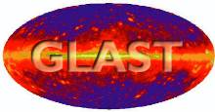 | Document # | Date Effective
 | LAT-MD-01196-03
 | Author(s)
 | John Ku
GLAST LAT System Test Plan | Martin Nordby
GLAST LAT System Test Plan | Subsystem/Office
GLAST LAT System Test Plan | Design Engineering
Document Title
LAT Dynamics Test Plan

- Change History Log
Revision | Effective Date | Description of Changes
01 | 22 Mar 03 | Initial release. No changes from D5 draft
02 | 2 May 03 | Added Section 11 on Sine Burst testing  Added LPT after Y-direction sine vibe (omitted in earlier rev)
03 |  | Multiple revisions to reflect re-baseline and agreements made; added mass properties test

- Contents
1. Change History Log 1
2. Contents 1
3. Abstract 3
4. Definitions 3
4.1. Acronyms 3
4.2. Definitions 3
5. Applicable Documents 4
6. Goals of the LAT Dynamics Testing Program 5
6.1. Objectives 5
6.2. Success Criteria 5
6.3. Test Flow 6
7. LAT Dynamics Requirements and Verification Method 6
8. Sinusoidal Sweep Vibration 6
8.1. Test Goals 6
8.2. Description of Test 7
8.3. Test Limitations 15
9. Modal Survey Test (Contingency Only) 16
9.1. Test Goals 16
9.2. Description of Test 17
9.3. Test Limitations 18
10. Acoustic Testing 19
10.1. Test Goals 19
10.2. Description of Test 20
10.3. Test Limitations 22
11. Mass Properties 23
11.1. Test Goals 23
11.2. Description of Test 24
11.3. Test Limitations 26
12. Activities Involving Verification By Analysis 26
13. Data Collection and Test Records 26
13.1. Test Data and Data Evaluation 26
13.2. Disposition of Test Records 27
13.3. Problem / Failure Reporting 27
14. Test Accommodations 27
14.1. Requirements on Subsystems 27
14.2. Requirements on GSE and Test Set-Up 28
14.3. Requirements on Facilities 30
15. Appendices 31
15.1. Instrumentation List 31

- Abstract
This document describes the dynamics tests planned to flight-qualify the fully integrated LAT instrument assembly. It includes discussion on required test configurations and objectives, test criteria, expected results and test sequences.

- Definitions
  - Acronyms
ACD Anticoincidence Detector
ASD Acceleration Spectral Density
CAL Calorimeter
CCP Contamination Control Plan (LAT-MD-00404)
CLA Coupled Loads Analysis
ECLA Early Coupled Loads Analysis (CLA results from September 2003)
EGSE Electrical Ground Support Equipment
FDLC2 Flight Design Loads Cycle 2 (CLA results from December 2004)
GEVS “General Environmental Verification Specification for STS & ELV Payloads, Subsystems, and Components”
ICD Interface Control Documents between the LAT and LAT subsystems.
IRD “GLAST LAT—Spacecraft Interface Requirements Document” (433-IRD-0001)
LAT Large Area Telescope
LCS LAT Coordinate System
LIP LAT Interface Plane. The theoretical plane defined by the bottom surface of the Grid.
LPS “LAT Performance Specification” (LAT-SS-00010)
LV Launch Vehicle
GLAST Gamma-ray Large Area Space Telescope
GPR Grid Perimeter Ring
MAR “Mission Assurance Requirements for the GLAST LAT” (433-MAR-0001)
MGSE Mechanical Ground Support Equipment
MSS “Mission System Specification” (433-SPEC-0001)
NRL Naval Research Lab, Building A59 Payload Checkout Facility
PPG “Delta II Payload Planners Guide” (MDC 00H0016)
SC Spacecraft
SPS “Spacecraft Performance Specification” (433-SPEC-0003)
STE Special Test Equipment
TBD To Be Determined
TBR To Be Resolved
TCS Thermal Control System
TIP Test Interface Plate MGSE
TKR Tracker

  - Definitions
Arc-min, arc-minute: 1/60 of a degree
Arc-sec, arc-second, a-sec: 1/60 of an arc-minute or 1/3600 of a degree
cm: centimeter
g: unit of gravitational acceleration, g = 9.81 m/s^2
kg: kilogram
LCS, LAT Coordinate System: Defined in LAT-TD-00035
m: meter
Max: Maximum
Min: Minimum
s, sec: seconds

- Applicable Documents
433-IRD-0001, “Large Area Telescope (LAT) Instrument—Spacecraft Interface Requirements Document”, May, 2002.
433-SPEC-0001, “GLAST Mission System Specification”, May, 2002
433-MAR-0001, “Mission Assurance Requirements (MAR) for the Gamma-Ray Large Area Telescope (GLAST) Large Area Telescope (LAT)”, June 9, 2000
LAT-MD-00408-01, “LAT Program Instrument Performance Verification Plan,” Sep 2002.
LAT-SS-00010, “GLAST LAT Performance Specification”, August 2000
LAT-SS-00778-01, “LAT Environmental Specification”, February, 2003.
LAT-TD-00035-3, “LAT Coordinate and Numbering System,” February, 2003.
LAT-MD-02717, “LAT Environmental Test Sequence”
LAT-MD-01533, “LAT EGSE Plan”
LAT-MD-00649, “LAT Transportation and Handling Plan”
LAT-MD-00404, “LAT Contamination Control Plan”
LAT-TD-00890, “LAT Instrumentation Plan”

Reference Documents
X. Swales memo on SC Acoustic STE
- Goals of the LAT Dynamics Testing Program
  - Objectives
The dynamic test program for the LAT instrument is intended to verify that the LAT can sustain launch and deployment into orbit. Specifically, the objectives of the testing program are to:
- Verify the strength of the LAT and subsystem interfaces under proto-flight qualification (PFQ) level loading and duration in their flight configuration.
- Measure primary natural frequencies and identify primary modes of the LAT in launch configuration.
- Determine the transmissibility and response level for sinusoidal vibration input.
- Validate the accuracy of the LAT Finite Element Analysis (FEA) and Statistical Energy Analysis (SEA) models, and correlate model predictions with test results. Mass property determination is a critical part of this objective. As a contingency, a modal survey may be performed if mode identification indicates the first LAT fundamental mode is < 50 Hz.
- Verify the workmanship and processes used in the manufacture and assembly of the LAT
The specific tests planned as part of this program are described in detail in the sections below.

  - Success Criteria
The outcome of the tests will be measured by the following success criteria.
- No failure or damage to the LAT assembly as determined by physical inspection.
- No significant changes to the dynamic signature as determined by the pre and post low-level vibration inputs.
- No significant degradation of instrument or system performance as determined by electrical performance test.
- The dynamic performance of the LAT meets all mass and frequency requirements.
Furthermore, the dynamic test program will be deemed successful if it produces data that accurately represents the LAT’s structural dynamic properties as configured in the test setup. This data will be used to refine and validate FEM and acoustic models of the LAT. This correlation is an important aspect of the test program.

  - Test Flow
Figure 1, below, shows the tests to be performed, the order of testing, and the Integration and Test (I&T) activities surrounding the dynamics tests.

Modal Survey
Sine Vibe
EMI/EMC
C
L
Install Radiators
Acoustic
L
T-Cycle
T-Bal
Remove Radiators
Weight, CG
Ship to GD
C
L
L
M
Receive, Unpack
C
L
L
Aliveness
Limited Performance
Comprehensive Performance
Muon Survey
C
A
M
L
L
Pack LAT
A
L
Final CPT
C
Reference CPT
(done at SLAC)
Figure 1: LAT Dynamics Test Sequence

- LAT Dynamics Requirements and Verification Method
The requirements for dynamics testing are set forth in 433-MAR-0001, “Mission Assurance Requirements (MAR) for the Gamma-Ray Large Area Telescope (GLAST) Large Area Telescope (LAT).” Test environments for the LAT originate from a few sources, and are collected in LAT-SS-00778, “LAT Environmental Parameters Specification”. This document specifies the load environments during launch and sets the levels to which the LAT must be tested.
The details of LAT and subsystem verification test flow are controlled by LAT-MD-00408, the “LAT Program Instrument Performance Verification Plan.” This document specifies the dynamics testing being performed at the subsystem and instrument levels, and clearly defines the verification process.
The LAT assembly will be tested in various environments to verify that it can sustain the launch environment and to validate analytical models of the LAT. To this end, the LAT will be subjected to a Sinusoidal Vibration, Acoustic, and Mass Properties test. If the sine vibration test results indicate the need, a modal survey test will be used to refine and verify the analytical model of the LAT structure.
- Sinusoidal Sweep Vibration
  - Test Goals

Test Objectives
The LAT will be subjected to sine sweep vibration to accomplish three objectives:
1. High-level sine sweep will, along with static loads testing, verify the LAT’s ability to survive the low frequency launch environment.
2. Provide a workmanship test for hardware such as wiring harnesses, MLI, and cable support and strain-relief, which will not have been fully verified at the subsystem level.
3. Low-level signature sweep from 5 to 150 Hz (sweep up and down) will serve to identify fundamental mode frequencies, transfer functions and confirm approximate mode shapes.

Test Entry Criteria
The sine vibe dynamic test is the first environmental test to be performed after arrival to NRL and the subsequent CPT. Criteria which must be met before this test can be executed are:
- LAT mechanical integration is complete—all visual, dimensional, and torque testing has been complete, and all travelers verified to be complete. The LAT is in its flight configuration, except as detailed in Section 8.3, below.
- All subsystem units/modules function—each subsystem has passed its CPT following removal from the shipping container. Any performance discrepancies have been clearly documented.
- Ensure all E-GSE needed is installed and functioning. After moving and attaching the LAT to the vibration test equipment, ensure each subsystem has passed its LPT. All E-GSE cable harnesses have been removed from the LAT prior to test.
- All test instrumentation is in place and functioning—instrumentation has been verified to be securely mounted in the correct locations and oriented in the correct direction, as defined in the test procedure, and electronics are working correctly, and reading out signals. Cable harnesses for this instrumentation are connected and properly restrained for the test.
- Pretest analysis which provides predictions for Fn and Q for significant modes at all test accelerometers

Expected Results
The raw data resulting from the sine vibe tests include time-histories of load, acceleration, displacement and strain data obtained during test. The raw data will be used to determine the following:
- Low level signature sine sweep will be performed to generate amplitude spectra and transfer functions for each response channel. Based on this data, a fundamental frequency determination effort will be performed and if the results of this reveal that rigid-base LAT fundamental is > 50 Hz, then a modal survey test will not be required (Section 9.0). This information (i.e., Fn and Q) will also serve to establish notching parameters used during the high-level (i.e., Proto-flight) sine sweeps.
- High-level sine sweep amplitude spectra for each response channel. This data will identify peak accelerations at interfaces of specific components and other significant locations on the instrument.

Test Exit Criteria
Following the sine vibration test, an LPT will be performed. Prior to breaking test configuration, the following criteria must be met:
- Visual inspection of the LAT indicates that there is no visible damage to the LAT
- Successful completion of the LPT verifies that all components and subsystems function properly after testing
- Rough analysis of test data shows that all recorded data is useable for analysis purposes
- Comparison of pre-test and post-test modal signatures match to within 5 %, or at the discretion of the test director, showing that modal frequencies have not changed significantly as a result of the test.

  - Description of Test

Test Configuration
The LAT is fully integrated for the sine vibration test, except that the Radiators are not installed. The LAT is mounted to the Test Interface Plate STE using the test flexures. The Test Interface Plate, in turn, is mounted to the vibration table.
The LAT is tested in all three axes, X, Y, and Z independently. To accomplish this, the STE is unbolted from the vibration table and re-configured between tests. Note that the LAT bolted connection to the STE does not need to be disassembled as part of the re-configuration.
The LAT is powered off during sinusoidal vibration testing, and the E-GSE cable harnesses removed. Only cable harness supporting the sine vibe test instrumentation are in place, and these are suitably strain-relieved and supported to accommodate the expected range of motion of the test table and the acceleration during testing.

Test Instrumentation
Instrumentation for the sine vibration test consists of accelerometers mounted to the LAT and test stand. Pretest analysis will serve to determine optimum accelerometer locations. See Appendix Section 15.1 for a complete list and detailed description of the instrumentation and location. Figures 5 through 7, below, shows schematically the location of accelerometers for this test.
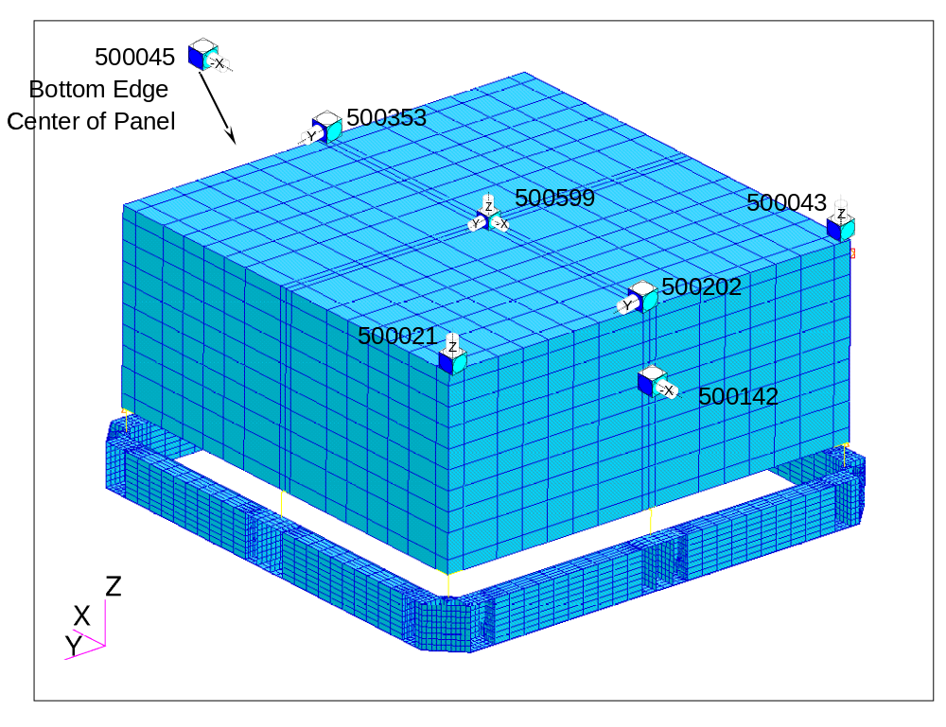
Figure 2: Accelerometers on the ACD for Sine Vibe and Acoustic Testing
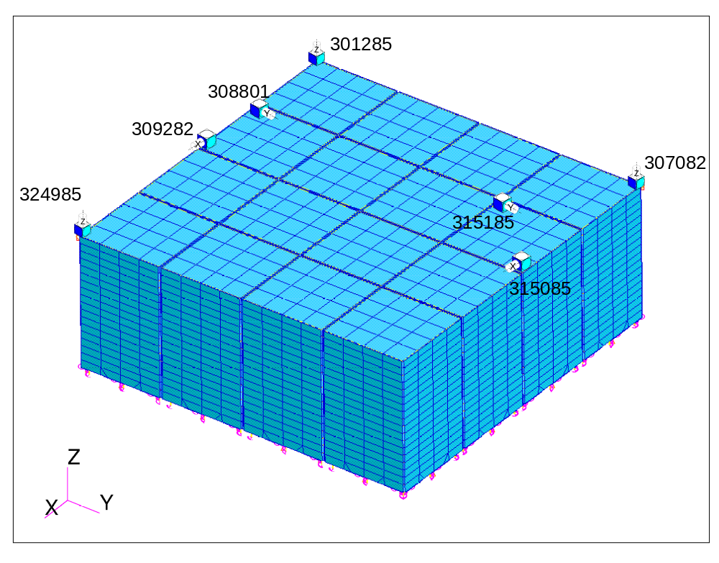
Figure 3: Accelerometers on the TKR for Sine Vibe and Acoustic Testing
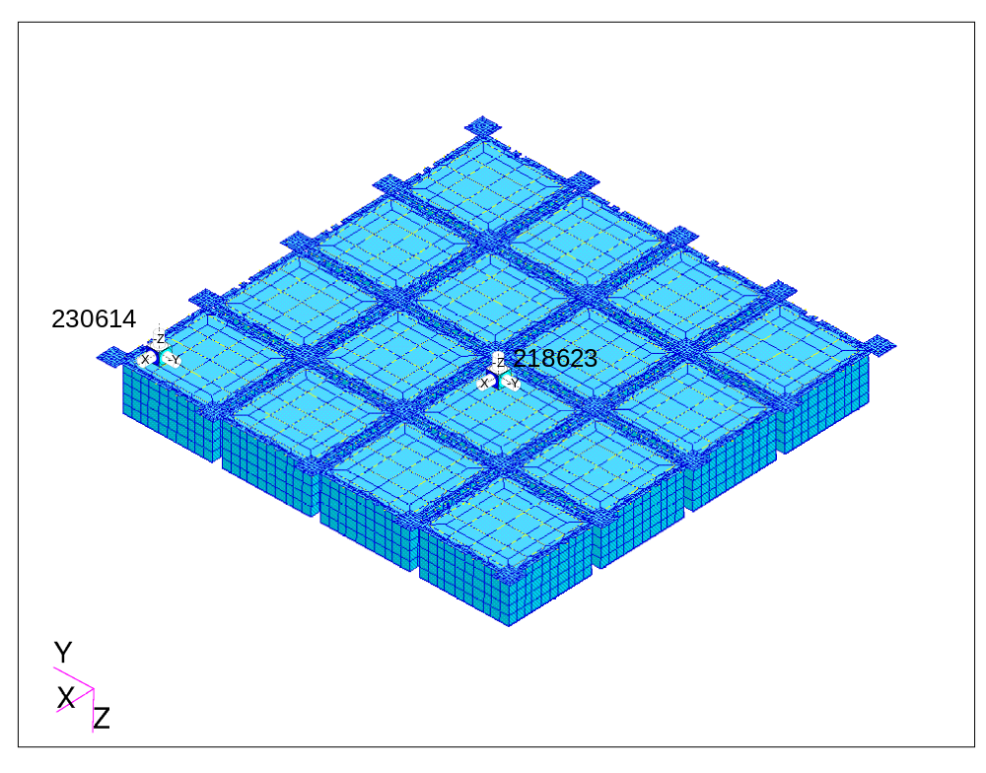
Figure 4: Accelerometers on the CAL for Sine Vibe and Acoustic Testing

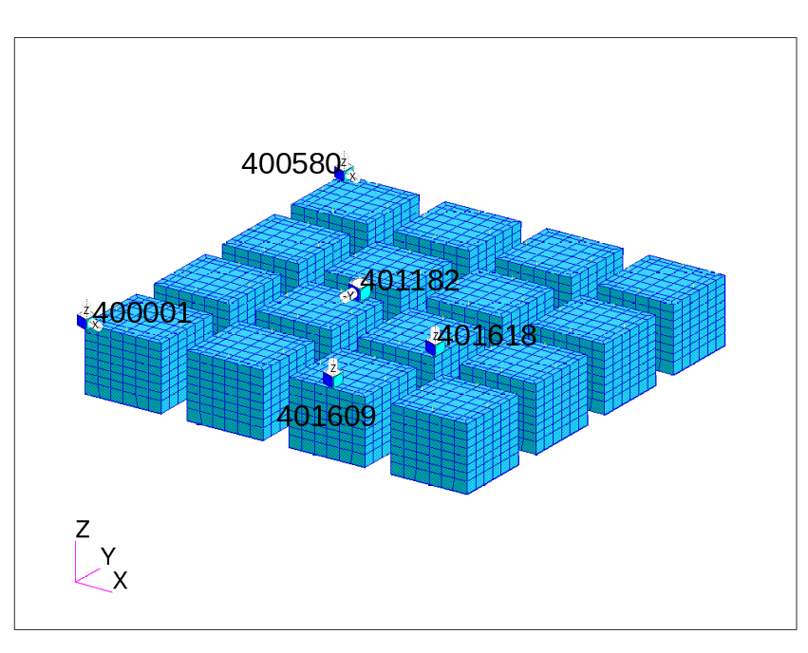
Figure 5: Accelerometers on the EBOX for Sine Vibe and Acoustic Testing

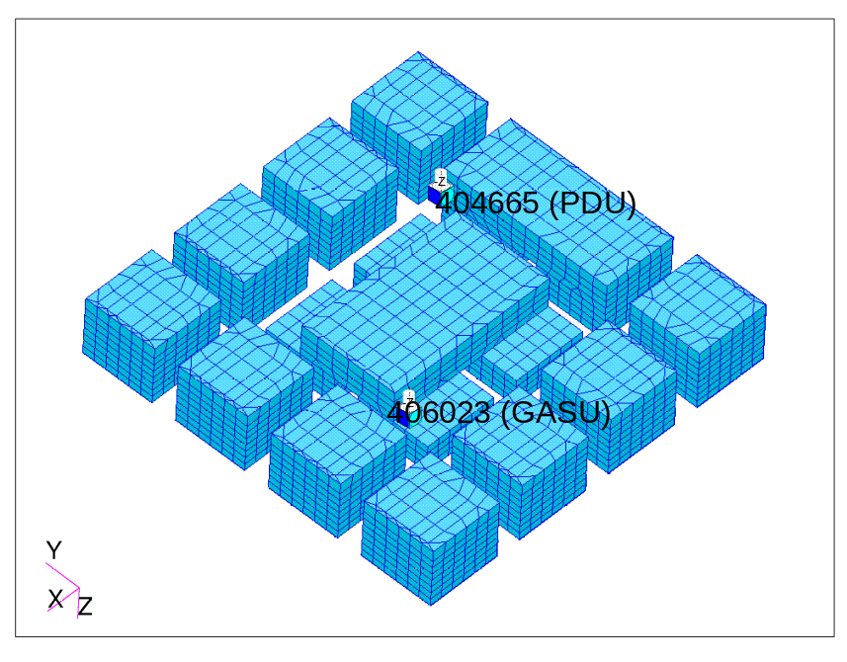
Figure 6: Accelerometers on the EBOX for Sine Vibe and Acoustic Testing

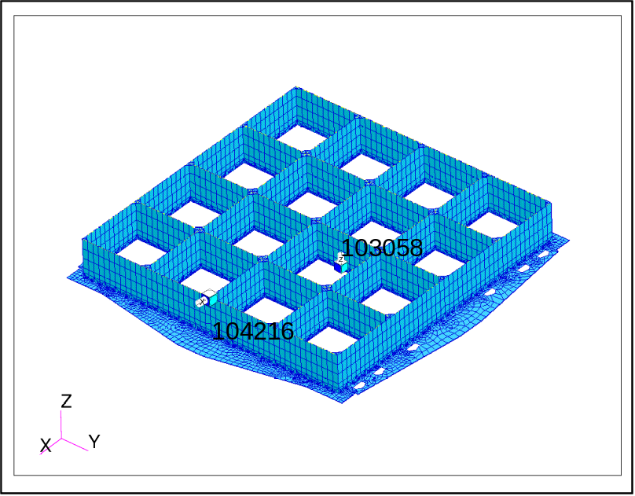
Figure 7: Accelerometers on the Grid for Sine Vibe and Acoustic Testing

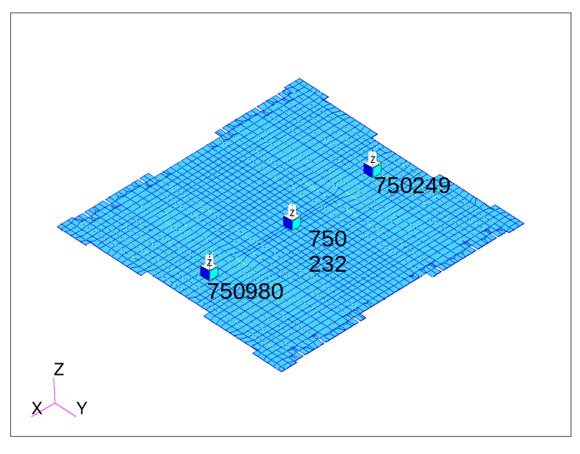
Figure 8: Accelerometers on the XLAT for Sine Vibe and Acoustic Testing

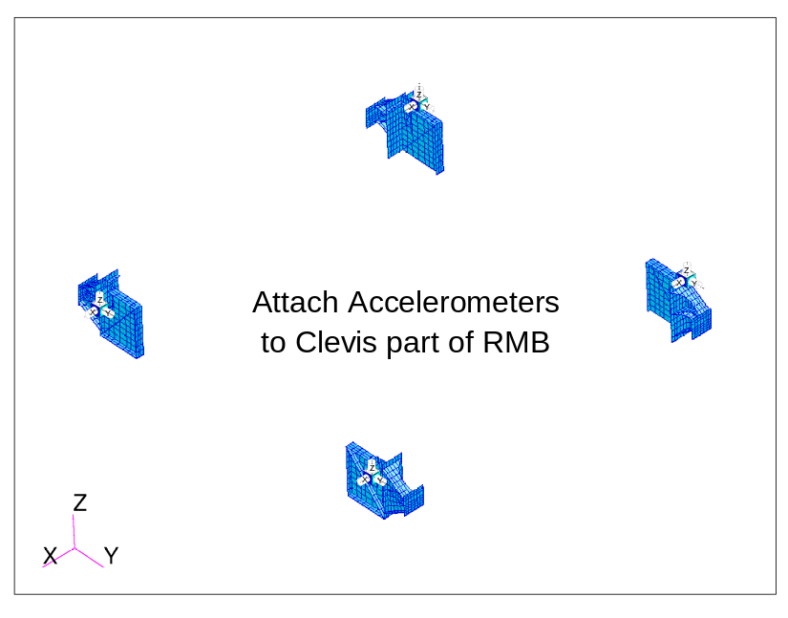
Figure 9: Accelerometers on the RMB for Sine Vibe and Acoustic Testing

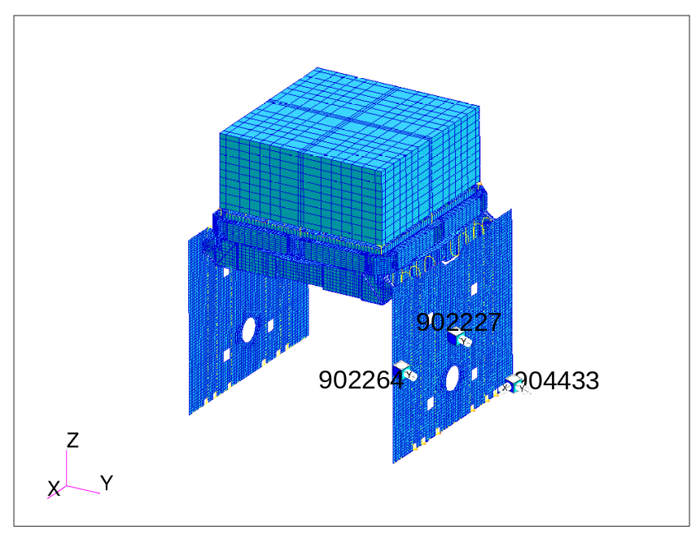
Figure 10: Accelerometers on the Radiators for Acoustic Testing

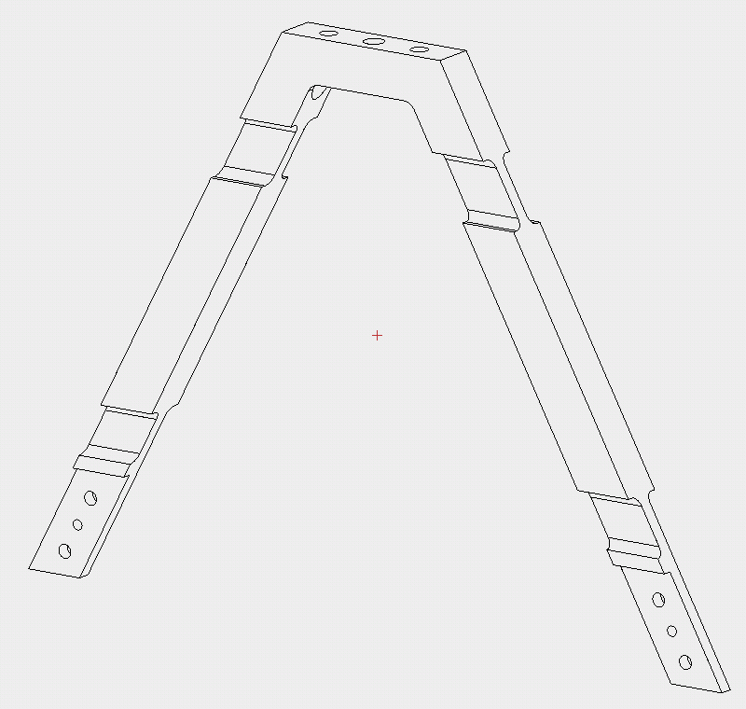
Figure 11: Four Strain Gauges on each Flexure for Sine Vibe and Acoustic Testing

Detailed Test Sequence
The sine sweep test is performed in the following sequence, with the minimum number of steps shown.
Z-Direction Sine Vibe:
- Instrumentation check—low-level vibration to verify that all instrumentation are operational and taking useful data.
- Low-level signature sine sweep vibration over the frequency range 5-150 Hz (sweep up and down), using an input of 0.15 G at 2 octaves/minute. Low-level random vibration may also be applied if this assists in obtaining improved data. The simple mode identification effort and verification of notch criteria will be performed at this time by comparing test data with pretest analysis predictions.
- Half-level sine sweep vibration over the frequency range 5-50 Hz. Using half-level results, update estimates of response Q and re-assess notching requirements for Protoflight-level sweep.
- Proto-flight level sine sweep vibration over the frequency range 5-50 Hz.
- Low-level signature sine sweep vibration over the frequency range 5-150 Hz, using an input of 0.15 G at 2 octaves/minute.
- Limited Performance Test—re-connect E-GSE cable harnesses and execute LPT while still on vibe test stand.
X-Direction Sine Vibe:
- Low-level signature sine sweep vibration over the frequency range 5-150 Hz (sweep up and down), using an input of 0.15 G at 2 octaves/minute. Low-level random vibration may also be applied if this assists in obtaining improved data. The simple mode identification effort and verification of notch criteria will be performed at this time by comparing test data with pretest analysis predictions.
- Half-level sine sweep vibration over the frequency range 5-50 Hz. Using half-level results, update estimates of response Q and re-assess notching requirements for Protoflight-level sweep.
- Proto-flight level sine sweep vibration over the frequency range 5-50 Hz
- Low-level signature sine sweep vibration over the frequency range 5-150 Hz, using an input of 0.15 G at 2 octaves/minute.
- Limited Performance Test—re-connect E-GSE cable harnesses and execute LPT while still on vibe test stand.
Y-Direction Sine Vibe:
- Low-level signature sine sweep vibration over the frequency range 5-150 Hz (sweep up and down), using an input of 0.15 G at 2 octaves/minute. Low-level random vibration may also be applied if this assists in obtaining improved data. The simple mode identification effort and verification of notch criteria will be performed at this time by comparing test data with pretest analysis predictions.
- Half-level sine sweep vibration over the frequency range 5-50 Hz. Using half-level results, update estimates of response Q and re-assess notching requirements for Protoflight-level sweep.
- Proto-flight level sine sweep vibration over the frequency range 5-50 Hz
- Low-level signature sine sweep vibration over the frequency range 5-150 Hz, using an input of 0.15 G at 2 octaves/minute.
- Limited Performance Test—re-connect E-GSE cable harnesses and execute LPT while still on vibe test stand.

Environmental Test Limits
Sinusoidal vibration levels are published in LAT-SS-00778, the “LAT Environmental Specification.” And are reproduced below for reference. Notching predictions are used to control the vibration inputs to prevent damage to the LAT assembly at resonant frequencies. These levels, as well as any special considerations for the STE being used, are shown in the test procedure.
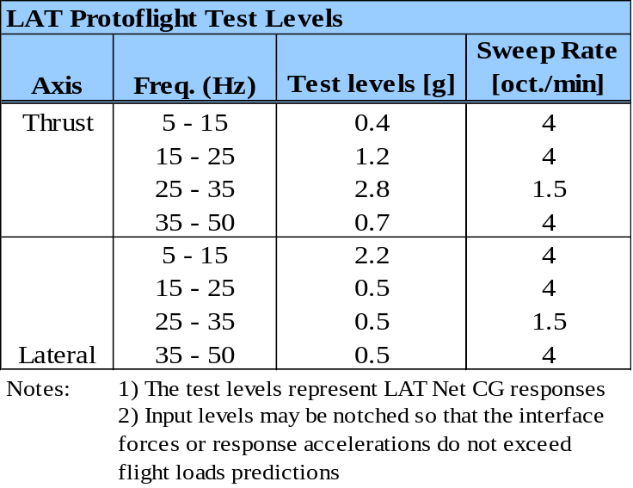
Table 1: LAT Protoflight Sine Vibration Levels

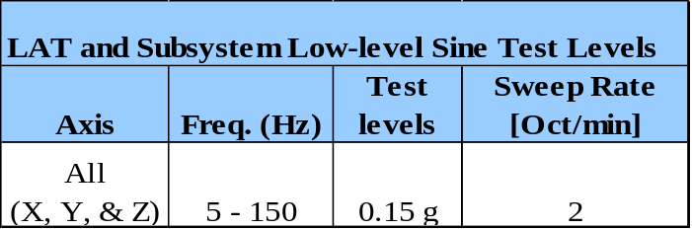
Table 2: LAT Low-level Sine Vibration Levels

  - Test Limitations

Deviations From Flight Configuration
The Radiators are not integrated to the LAT for this test. Thus, structural interactions between the Radiators and the Grid are not captured in the test results. In addition to the Radiators not being present, there are coverplates to constrain the down spout heat pipes (DSHPs) and X-LAT heat pipes (XLHPs) to prevent relative motion to the Grid.
The LAT is mounted to STE using test flexures which simulate the flight connection to the SC. The STE and test flexures will be included in the pre-test FEA analysis, so its impact on the response of the LAT will be understood.
Since the Radiators and SC are not included in this test, not all flight cable harnesses and supports will be integrated for this test. Thus, these cables and their associated support brackets will not be adequately verified by this test. Workmanship for these flight connections and harnesses will be accomplished with the Observatory level sine vibration test.

Verification Limitations
The structural connection of the Radiators to the Radiator Mount Brackets is not verified by this test, since the Radiators are not integrated. However, the Grid Static Load Test ensures that the Radiator Mount Brackets are strength-verified by the time of this test. Thus, the risk of this incomplete verification at the instrument level is minimal.
The second area of incomplete verification has to do with the Radiator interaction with the Grid. During dynamic motion of the LAT, the relative motion between a Radiator and the Grid introduces forces and stresses into both the bolted structural joint and the VCHP heat pipe bolted joints. The dynamic behavior of both of these regions needs to be verified. To mitigate against the lack of verification during the LAT sine vibe test, the Radiators are individually sine vibe tested, using STE which simulates the Grid structural and heat pipe connection. This ensures that the design is fully qualified, and will serve as a risk-reduction verification of the bolted joints. The workmanship verification of the flight Radiator connections to the Grid will be fully verified during the Observatory sine vibe and acoustic tests.

- Modal Survey Test (Contingency Only)
  - Test Goals

Test Objectives
This test will only be performed if the fundamental frequency determination effort performed as part of the sine vibration test indicates that the LAT rigid-mounted frequency will fall below 50 Hz (this does not include flexure modes wherein the LAT is essentially moving as rigid-body). In this case, a modal survey test of the LAT while mounted in the sine vibration equipment will be performed to measure its three primary modes (frequency, shape and damping). Primary modes of the LAT structure include the drumhead (Z-axis), and both lateral axis modes.
Test results will be used to evaluate the predicted modes in the LAT (in flight configuration), and used to correlate the structural finite element model, as needed.

Test Entry Criteria
This test will be performed after LAT sine vibration testing has been completed. The following criteria must be met before this test can be started:
- LAT integration on the sine vibe tests stand is complete—all visual, dimensional, and torque testing has been complete, and all travelers verified to be complete. The LAT is in its flight configuration, except as detailed in Section 9.3, below.
- All subsystem units/modules function—each subsystem has passed at least a limited performance test (LPT).
- Ensure all E-GSE needed is installed and functioning. After moving and orienting the LAT in the acoustic test chamber, ensure each subsystem has passed its LPT. All E-GSE cable harnesses have been removed from the LAT prior to test.
- All accelerometers, microphones, and other test instrumentation are in place and functioning—instrumentation has been verified to be securely mounted in the correct locations and oriented in the correct direction, as defined in the test procedure, and electronics are working correctly and reading out signals. Cable harnesses for this instrumentation are connected and properly restrained for the test.

Expected Results
The modal survey test of the LAT involves a measurement of frequency response functions at predetermined locations. Results are the output of the accelerometers and subsequent data reduction as both plots and in Universal File Format datafiles:
- Acceleration data in the form of frequency response functions of sufficient statistical quality.
- Modal frequencies (eigenvalues) and estimates of percent critical damping on per mode basis.
- Mode shape coefficients (eigenvectors) as obtained through appropriate curve-fitting routines.

Test Exit Criteria
Prior to breaking test configuration, the following criteria must be met:
• Visual inspection of the LAT does not reveal any visible damage
• Limited Performance Test (LPT) of the LAT verifies that all subsystems function properly
• Review of test data indicates that all recorded data is useable for analysis purposes

  - Description of Test

Test Configuration
The LAT is fully integrated for the sine vibration test, except that the Radiators are not installed. The LAT is mounted to the Test Interface Plate STE using the test flexures. The Test Interface Plate, in turn, is mounted to the vibration table.
The LAT is oriented with the +Z-axis point vertically up. If needed, the LAT modes may be excited by narrow-band random input by means of one (or more) stingers, which connect modal shaker(s) to the LAT. Stinger attach points will be located under the LAT and at corner Radiator Mount Brackets.
The LAT is tested in all three axes, X, Y, and Z independently. To accomplish this, the STE is unbolted from the vibration table and re-configured between tests. Note that the LAT bolted connection to the STE does not need to be disassembled as part of the re-configuration.
The LAT is powered off during testing, and the E-GSE cable harnesses removed. Only cable harness supporting the sine vibe test instrumentation are in place, and these are suitably strain-relieved and supported to accommodate the expected range of motion of the test table and the acceleration during testing.

Test Instrumentation
Instrumentation for the modal survey consists of the same set of accelerometers mounted to the LAT and supporting fixture during the sine vibe test, shown in figures 2 through 10. Selection of accelerometer locations will correspond to that of a NASTRAN ASET, which has been verified to adequately represent modes of the full FEM (i.e., NASTRAN GSET). This verification is demonstrated by cross-orthogonality and self-orthogonality matrices that are within 5% of the identity matrix. See Appendix Section 15.1 for a complete list.

Test Sequence
The modal survey involves exciting the LAT in differing locations and directions to excite particular modes of the LAT. The instrumentation described above, along with locations and orientations of the excitations described here, are intended to excite the three primary LAT modes shown in Table 3. The predicted modes will be updated as part of the pre-test analysis.

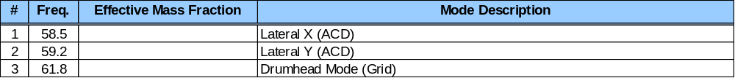Table 3: LAT Modal Frequencies and Shapes
The sequence is as follows:
- Following the sine vibe test sequence, post-process low-level sine sweep data and obtain mode shape information.
- Perform mode shape correlation with analytical model.
- Ensure cross-orthogonality is within 5% of the identity matrix, or modify math model as appropriate.

Environmental Test Limits
This is a very low amplitude test, and no test limits are defined. The post CDR modal analysis will define the initial magnitude and orientations of the set of excitations induced upon the LAT. Input excitation levels may require adjustment as the test progresses, based on the response of the test article and whether non-linearity is observed during the data acquisition process.

  - Test Limitations

Deviations From Flight Configuration
The Radiators will not be integrated to the LAT for this test. Thus, mode shapes and frequencies associated with the Radiators will not be accurately captured in the test results. The test FEA model will be used to determine the extent to which this affects the primary modes of the LAT.
The LAT is mounted to STE using test flexures which simulate the flight connection to the SC. The STE and test flexures will be included in the pre-test FEA analysis, so its impact on the response of the LAT will be understood. Additionally, since the Radiators and SC are not included in this test, not all flight cable harnesses and supports will be integrated for this test.

Verification Limitations
This test should measure LAT modal frequencies and mode shapes with a reasonably high degree of accuracy, including cross-orthogonality checks of the derived mode shapes.

- Acoustic Testing
  - Test Goals

Test Objectives
The LAT will be subjected to a proto-flight acoustic environment for 60 seconds to accomplish three objectives. First, this test is intended to verify the LAT’s ability to survive the acoustic launch environment. Second, it acts as a workmanship test for LAT hardware, especially that hardware which responds to acoustic loading. Third, the acoustic test is used to validate the acoustic analysis. This is important to do, since this analysis was used to produce subsystem random vibration test levels.

Test Entry Criteria
The LAT acoustic test is performed immediately following the LAT sine vibe test (or modal survey test, however it may be) and the subsequent LPT. Criteria which must be met before this test can be executed are:
- LAT integration on the acoustic test stand is complete—visual inspection verifies that all the LAT has been re-configured correctly. All travelers verified to be complete. The LAT is in its flight configuration, except as detailed in Section 10.3, below.
- All subsystem units/modules function—each subsystem has passed its LPT following EMI/EMC testing. Any performance discrepancies have been clearly documented.
- Ensure all E-GSE needed is installed and functioning. After moving and orienting the LAT in the acoustic test chamber, ensure each subsystem has passed its LPT. All E-GSE cable harnesses have been removed from the LAT prior to test.
- All accelerometers, microphones, and other test instrumentation are in place and functioning—instrumentation has been verified to be securely mounted in the correct locations and oriented in the correct direction, as defined in the test procedure, and electronics are working correctly and reading out signals. Cable harnesses for this instrumentation are connected and properly restrained for the test.

Expected Results
The raw data resulting from the acoustic tests include microphone sound pressure levels, accelerometer responses and strain gage data. The raw data is used to determine the following:
- Acceleration spectral density plots obtained from LAT accelerometer responses.
- Strain spectral density plots obtained from LAT strain gauge responses.
- One-third octave sound pressure level plots of individual microphones and test chamber microphone average.

Test Exit Criteria
Following the acoustic test, an LPT will be performed. The criteria for declaring a successful completion of the acoustic test are:
- Visual inspection of the LAT—indicating that there is no visible damage to the LAT
- Successful completion of the LPT—verifying that all components and subsystems function properly after testing.
- Preliminary analysis of test data—verify that all recorded data is useable for analysis purposes
- No significant mode shifts—pre- and post-test signatures match within 5% showing modal frequencies have not changed as a result of testing.

  - Description of Test

Test Configuration
The LAT is fully integrated, including the Radiators. It is mounted to STE using the flight-configuration bolted joint. The STE only approximates the SC flexures and a portion of the spacecraft geometry (SC Top deck construction mimicked) as determined necessary to minimize inducing non-flight (excessive) vibration response on the LAT. Reference [X] provides more details.
The radiator panels will be close to the floor, but this has been deemed acceptable. The STE will be centered in the acoustic chamber, rotated to an angle of approximately 20-30 degrees, as measured between the Radiator surface and chamber sidewall. Additionally, there will be a plastic sheet placed under the STE to help identify any items that may come loose as a result of the acoustic vibration.
The LAT is powered off during acoustic testing, and the GSE cable harnesses removed. Only cable harnesses supporting the acoustic test instrumentation are in place, and these are suitably strain-relieved and supported to accommodate the acoustic loads during testing.

Test Instrumentation
Instrumentation for the acoustic test consists of microphones and accelerometers mounted to the LAT. See Appendix Section Error: Reference source not found for a complete list and detailed description of the instrumentation and locations. Figure 12, below, shows schematically the orientation of the LAT and locations of microphones for this test. Accelerometers from the sine vibration test are used for this test as well.

M1, ACD Mid-pnl
M2, ACD Mid-pnl
M3, ACD Mid-pnl
M4, ACD Mid-pnl
M5, RAD Mid-pnl
M6, RAD Mid-pnl
~36”
Acoustic Chamber
M7, monitor only
LAT
Figure 12: LAT Orientation and Microphone Placement in Acoustic Chamber

Test Sequence
The test follows the sequence, below, which is detailed in the test procedure.

- Instrumentation check—low-level acoustic to verify that all instrumentation is operational and taking useful data
- Pre-test signature run at -6dB for 30 seconds.
- Half-level acoustic run at -3dB for 30 seconds. Record data and continue directly to the next level (do not ramp down sound pressure).
- Proto-flight level acoustic run—ramp up SPL to qualification levels and maintain at this level for 60 seconds
- Ramp down SPL and turn off
- Post-test signature run at -6dB for 30 seconds. Compare these results with Pre-test data to verify any mode shifts are within +/- 5%
- Limited Performance Test—re-connect EGSE cable harnesses and execute LPT while still on acoustic test stand

Environmental Test Limits
Acoustic test levels are published in LAT-SS-00778-01-D1, the “LAT Environmental Specification.” and reproduced below for reference. These levels, as well as any special considerations for the STE being used, will be clearly shown in the test procedure.

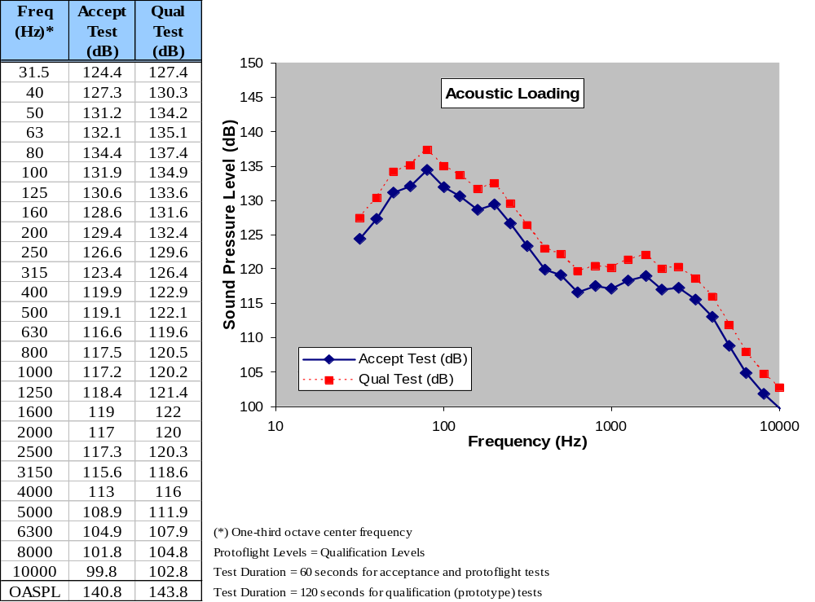
Figure 13: LAT Acoustic Sound Pressure Levels

  - Test Limitations

Deviations From Flight Configuration
The LAT is mounted to STE, which is intended to simulate the influence of the SC volume and geometric proximity on acoustic pressures immediately adjacent to significant LAT surfaces, such as the Radiators and XLAT plate.
SC-LAT cabling is not connected for this test, so these connections, the cable harnesses, and the attachment methods are not verified as part of this test. These will be verified at the Observatory acoustic test.

Verification Limitations
SC-LAT cabling is not connected for this test, so these connections, the cable harnesses, and the attachment methods are not verified as part of this test. These will be verified at the Observatory acoustic test. Furthermore, not having these cables will slightly alter the loading on the EMI Skirt and cable bulkhead connectors. This is expected to have little effect on the overall response of the LAT, so this adds little risk to the verification program. In any event, this risk is fully retired at Observatory acoustic testing, where the entire LAT, with all cable connections, will be tested to proto-flight qualification levels.

- Mass Properties
It is just as important to verify mass properties as it is to match frequencies to ensure a valid math model for use in the final launch vehicle to observatory coupled loads analysis. Validating both mass and stiffness ensures that model modifications are performed correctly and preserve the true dynamic behavior of the structure.
  - Test Goals

Test Objectives
The primary objective of this test is to measure and/or calculate the overall mass and CG of the fully integrated LAT, to verify that it meets the IRD [x] requirements of:
- Mass is less than 3000 kg
- Z-cg is a maximum of 185mm above the LAT Interface Plane (LIP)
- X-cg and Y-cg are within 20mm of LAT Coordinate System (LCS) Z-axis
A secondary objective is to verify measured mass properties match well when compared with the math model mass matrix. Due to the complexity of measuring moments of inertia, only mass and CG properties will be validated. Differences will be reconciled by updating the math model to reflect measured values. Since structural dynamics is intimately tied with mass and stiffness, mass property updates are important to preserve the true dynamic behavior of the LAT.
Because of the difficult involved in measuring Zcg, this requirement will be verified through calculations, based on measurements of all LAT constituents. From the Xcg and Ycg measurements and comparison with calculated values, an appropriate confidence level can be established and applied to the Zcg calculations.

Test Entry Criteria
The LAT mass properties test is performed following the LAT thermal vacuum test and the subsequent CPT and removal of the radiators. Criteria which must be met before this test can be executed are:
- LAT Radiators have been removed and the LAT, Flexures and TIP have been moved into the mass properties test area—visual inspection verifies that all the LAT has been re-configured correctly. All travelers verified to be complete. The LAT is in its flight configuration, except as detailed in Section 10.3, below.
- All subsystem units/modules function—each subsystem has passed its CPT following TVAC. Any performance discrepancies have been clearly documented.
- All non-fly-away accelerometers and other test instrumentation, cables and harnesses are removed.

Expected Results
The raw data resulting from the mass property test include the force output from the three force gauges. The raw data is used to determine the following:
- Overall mass of the LAT instrument, plus any accompanying non-flight hardware such as the mounting base, flexures and TIP MGSE
- From the force gauge readouts, a sum of moments will reveal Xcg and Ycg.
- Based on calculated error bars from Xcg and Ycg, calculate Zcg.

Test Exit Criteria
Following the mass properties test, an aliveness will be performed. The criteria for declaring a successful completion of the mass properties test are:
- Visual inspection of the LAT—indicating that there is no visible damage to the LAT
- Successful completion of the aliveness test—verifying that all components and subsystems are still properly interconnected.
- Preliminary analysis of test data—verify that all recorded data is useable for analysis purposes

  - Description of Test

Test Configuration
The LAT is fully integrated, excluding the Radiators. It is mounted to STE using the flight-configuration bolted joint. The STE provides a stable platform on which to set down the LAT instrument.
The LAT is powered off during mass property testing, and the GSE cable harnesses removed.

Test Instrumentation
Instrumentation for the mass property test consists of three load cells (force gauges) mounted to a level and stable platform. Figures TBD, below, shows schematically the location of instrumentation for this test. The load cells (red circles) are precisely positioned at the apexes of an isosceles triangle. The

h
a
a
LAT_{cg}
F₁
F₂
F₃
x
y
W_{tot}=F₁+F₂+F₃
X_{cg}= (F₂-F₃)*a/W_{tot}
Y_{cg}= F₁*h/W_{tot}
Figure 14: LAT Acoustic Sound Pressure Levels

Test Sequence
The test follows the sequence, below, which is detailed in the test procedure.

- Instrumentation check—use dummy masses to verify that all instrumentation is operational and taking useful data
- Align LAT on test platform
- Measure overall mass and centers of gravity
- Rotate LAT 90 degrees and align to test platform
- Measure overall mass and centers of gravity
- Aliveness Test—execute aliveness test after LAT has been packed in shipping container

Environmental Test Limits
Any special considerations for the STE being used, will be clearly shown in the test procedure.

  - Test Limitations

Deviations From Flight Configuration
The Radiators are not integrated to the LAT for this test. Thus, structural interactions between the Radiators and the Grid are not captured in the test results. In addition to the Radiators not being present, there are coverplates to constrain the down spout heat pipes (DSHPs) and X-LAT heat pipes (XLHPs) to prevent relative motion to the Grid.
The LAT is mounted to STE using test flexures which simulate the flight connection to the SC. The STE and test flexures will be included in the pre-test FEA analysis, so its impact on the response of the LAT will be understood.
Since the Radiators and SC are not included in this test, not all flight cable harnesses and supports will be integrated for this test. Thus, these cables and their associated support brackets will not be adequately verified by this test. Workmanship for these flight connections and harnesses will be accomplished with the Observatory level sine vibration test.

Verification Limitations
Because the flight radiators will not be installed during this test, their component measured mass and centers of gravity will be accounted for in the overall calculations. Similarly, STE (flexures and TIP) will be subtracted from the overall calculations. Finally, because of the logistical difficulty in measuring Zcg, this value will be calculated based on the aggregate of constituent measurements, taking into account an appropriate confidence level.

- Activities Involving Verification By Analysis
No verification by analysis is planned at the LAT level of integration. All verification activities involve direct test and measurement of the flight LAT hardware.
However, analysis is used in three areas that touch on LAT verification activities: generating pre-test predictions for test planning purposes, post-processing of test results, and analysis of STE and simulators that depart from flight configuration. All of these analysis activities are directly validated by test results.

- Data Collection and Test Records
  - Test Data and Data Evaluation
During the above mentioned tests test data will be collected in accordance with LAT-MD-00408. Raw data will be evaluated during execution of the test by the on-site test manager and LAT structural engineer. Follow-on analysis and data reduction will be used to close out the verification activities associated with the test. Results of this evaluation will be published in test reports and put under configuration control.

  - Disposition of Test Records
The disposition of test records will be in accordance with LAT-MD-00408. Raw data will be stored along with test procedures and travelers as part of the test data files. Test reports and analyses will be stored in the LAT document control system.

  - Problem / Failure Reporting
Any problems during testing or non-conformance in either workmanship, or performance of the test specimen will be recorded using standard non-conformance reporting techniques. Reporting will be accomplished using either the LAT NCR/PFR online reporting system or a similar system at NRL.

- Test Accommodations
  - Requirements on Subsystems
Select subsystems and components will need to accommodate certain configurations or equipment during various tests. This section discusses requirements that each subsystem will need to accommodate during testing.

Mechanical Systems
VCHP closeout plates will be needed for use whenever radiators are not present.
Cut-outs in Grid flanges to accommodate accelerometer cables from the TKR. Two (TBR) cut-outs are needed, one in the +X/+Y corner (TBR) and one in the –X/-Y corner of the Grid. Each cut-out shall be TBD mm², and allow free passage of the cables past the ACD and below the bottom of the Grid.
Accommodation for mounting accelerometers on the Grid, as described in the instrumentation section for each test. This includes access to apply and remove accelerometers, as well as a suitably large footprint to bond/epoxy them in place.

Electronics
Accommodation for mounting accelerometers as described in the instrumentation section for each test. This includes access to apply and remove accelerometers, as well as a suitably large footprint to epoxy them in place.

Tracker
Accommodation for mounting accelerometers as described in the instrumentation section for each test. This includes access to apply and remove accelerometers, as well as a suitably large footprint to epoxy them in place. All accelerometers on the TKR are fly-away, so the TKR shall provide locations for restraining cables across the top surfaces of all TKR modules, as well as down the sidewalls at the outer corners of modules in Bays 0 and 11.

Calorimeter
Accommodation for mounting accelerometers as described in the instrumentation section for each test. This includes access to apply and remove accelerometers, as well as a suitably large footprint to epoxy them in place. All accelerometers on the Calorimeter are fly-away, so the Calorimeter shall provide locations for restraining cables, as well as routing down the edges of modules which have an accelerometer on the top surface.

Anticoincidence Detector
Accommodation for mounting accelerometers as described in the instrumentation section for each test. This includes access to apply and remove accelerometers, as well as a suitably large footprint to epoxy them in place.
Provision to route accelerometer cabling to test one central location on the ACD on the +X/+Y (TBR) corner of the ACD.

  - Requirements on GSE and Test Set-Up
All ground support equipment will meet the specifications and requirements outlined below.

MGSE
All MGSE will be built to released drawings.
All MGSE used on the LAT program will be mechanically certified for its purpose and will be subject to periodic re-evaluation as determined by design and safety engineering.
SC test flexures are not designed using MGSE Safety Factors and therefore must have be carefully evaluated for positive stress and buckling margins for all loading cases.
Personnel operating and using MGSE will be trained and certified for the operating this equipment.

Sine Vibe Test Fixture
Support the LAT without Radiators.
The sine vibration test fixture will include the SC test flexures, on which the LAT will be mounted.
The sine vibration test fixture must be drilled with appropriate hole pattern to allow mounting to test lab shaker and slip table . The minimum natural frequency of the test fixture, with mounted LAT, shall exceed 100 Hz.

Acoustic Test Stand
Support the LAT and Radiators while mounted onto the Special Test Equipment (STE)
The STE (i.e. acoustic test stand) will include SC test flexures, on which the LAT will be mounted. In addition to supporting the LAT and its own weight in the desired test orientation(s), the STE simulates a portion of the spacecraft geometry as determined necessary to minimize inducing non-flight (excessive) vibration response on the LAT and simulates the stiffness of the SC interface by incorporating the SC test flexures.

EGSE
All EGSE will be certified for use on flight hardware by means of a released test procedure.
EGSE will be subjected to acceptance test procedures when built and after any break of internal configuration.
EGSE will be subjected to validation tests after any break of electrical configuration and prior to first use in a configuration.
Data acquisition hardware shall be capable of simultaneous acquisition of all signals from the instrumentation listed in the Appendix. The minimum sampling rates are described in each test instrumentation section.
Test instrumentation shall include cable harnesses from the LAT test plug on the EMI Skirt to the acquisition hardware. This shall include all feedthroughs or penetrations needed to accommodate the test chambers.
Systems which control the test levels and durations shall be capable of receiving force or acceleration feedback signals from accelerometers on the LAT. The systems shall be able to accommodate up to TBD number of feedback signal.

Equipment Calibration
All measurement equipment must be in a calibration and maintenance program. All equipment used for testing of flight hardware shall be in current calibration and shall be noted external to the equipment by a tag or sticker. All equipment, fixtures and facilities must show conformance to necessary test requirements prior to conducting tests on qualification or flight hardware. All items used in performance of a test must be capable of maintaining the test conditions for the duration of the test. Performance of a test facility or piece of test equipment must be demonstrated prior to use with flight hardware.

Measurements
All measurements to flight hardware will be made with tools and equipment which are under calibration control and in their current calibration cycle.

Measurement Accuracy
Measurement accuracy unless otherwise noted will be per will be per section 1.14 of the General Environmental Verification Specification for STS and ELV, GEVS-SE.

Equipment Substitutions
Where necessary, equipment which has been specified in a test procedure will be substituted with another piece of equipment of equal or better performance. These substitutions are permitted deviations from test plans provided the changes are identified to and concurred with by subsystem engineering management.

  - Requirements on Facilities

Sine Vibration Table
The facility shall have a shaker and slip-table of sufficient size to apply specified input accelerations to the LAT and associated fixturing. Closed-loop control of sine sweep testing shall also be provided, along with required instrumentation and data analysis capable of providing time history, amplitude spectra, and frequency response function plots.

Modal Survey
The facility shall have seismic mass to permit isolation of the test item and appropriate fixturing and instrumentation to enable characterization of listed mode shapes. The test lab shall also provide analysis software capable of extracting FRFs and curve-fitting routines for determining mode shapes.

Acoustic Chamber
The facility shall have reverberant acoustic chamber of sufficient capacity to generate uniform sound-field at the specified sound pressure levels. The average sound field around the LAT will measured by at least four microphones and additional instrumentation shall be provided as specified herein. The facility shall also be capable of producing one-third octave SPL and acceleration spectral density plots. In order to verify that no structural changes have occurred post-test, a modal hammer and FRF analyzer shall be available to allow measurement of primary mode frequencies.

- Appendices
  - Instrumentation List


