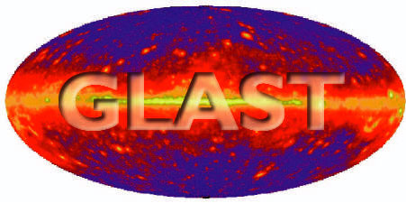 | Document # | Date
 | LAT-TD-00440-07 | 27-Oct-2004
 | Author(s)
 | Gary Godfrey
GLAST LAT System Specification
GLAST LAT System Specification | Subsystem/Office
GLAST LAT System Specification | Integration and Test
Document Title
Particle Beam Test Plan

Gamma-ray Large Area Space Telescope (GLAST)

Large Area Telescope (LAT)

Integration & Test Subsystem

Particle Test Plan

Change History Log
Revision | Effective Date | Description of Changes
-01 | 12/21/01 | Initial release. Preliminary draft.
-02 | 4/15/02 | Replaced coherent and channeling beams with a Photon Tagger in ESA. Corrected config of EM tracker. Changed LAT (mistake) to CU tested in beam. New ESA Fig 3. Removed airplane details and pointed at LAT-TD-00550.
-03 | 6/3/02 | Added multiple positrons/pulse to calibrate CsI at up to 300 GeV.
-04 | 3/5/03 | Changed 30 GeV positrons to 28 GeV positrons, 20-400 MeV tagged γ to 20-1500 MeV, updated Table 1 to LAT-00010-02. Changed Pb Glass to BGO. Elaborated on bremsstrahlung beam strategy.
-05 | 4/28/03 | Changed lowest tagged photon energy from 20 MeV to 100 MeV. Added a scintillator hodoscope backup if no Si tagger. Changed doc name to “Particle” Test Plan. Changed lowest bremsstrahlung photon used from 20 MeV to 50 MeV. Changed 3 GeV to 4 GeV, 28 GeV to 20 GeV, and 45 GeV to 40 GeV positrons.
-06 | 10/25/04 | Updated for beamtest change from 2004 till after LAT delivery. Updated VG info. Removed Airplane Test and added Am²⁴¹ source. Pointed at the Muon Telescope LAT doc.
-07 | 10/27/04 | Removed Si tagger option.

Contents

1. Purpose 4
2. Scope 5
2.1. Items to be tested 5
2.2. Beams to be used 5
3. Definitions 5
3.1. Acronyms 5
3.2. Definitions 6
4. Applicable Documents 6
5. Description of Beams and Test Stations 7
5.1. Cosmic Rays on the ground 7
5.2. Van de Graaff Accelerator 7
5.3. End Station A Beams and Test Station 9
6. Calibration and Validation Methods 12
6.1. Types of calibration and validation to be done 12
6.1.1. Low level calibrations 12
6.1.2. Calibration of the GLAST Monte Carlo Simulation 12
6.1.3. Verification of the higher level Science Requirements using the Simulation 12
6.2. The Strategy for the particle beam measurements on the CU in ESA at SLAC. 12
6.2.1. Calibrate the energy response of the Calibration Unit 12
6.2.2. Record data using the ESA Bremsstrahlung γ beam 13
6.2.3. Record data using the ESA Proton beam 16
7. Description of Tests 16
7.1. Cosmic Rays on the ground 16
7.2. Photons (14.6 and 17.6 MeV) from the Van de Graaff accelerator 16
7.3. Am²⁴¹ Source X-rays 17
7.4. Positrons in ESA 17
7.5. Photons in ESA 18
7.5.1. Bremsstrahlung Beam 18
7.5.2. Tagged Photons 19
7.6. Protons in ESA 20
8. References 21

- Purpose

The requirements for the Beam Test program flow down from the LAT Performance Specification – Level II(b) Specification Document (LAT-SS-00010-02). The Beam Test program is designed to ensure that the performance of the LAT meets the requirements of LAT-SS-00010-02. The performance requirements, for which the Beam Test program is relevant, have been summarized in Table 1. This Beam Test plan is required in the (LAT-MD-00408).

Table 1. Summary of Science Instrument Performance Verification (a subset of Table 1 of LAT-SS-00010-02). A column has be added to the table indicating which beam tests are relevant to verifying the requirement. The verification methods are T=Test., A=Analysis.

Req’t # | Req’t Title | Parameter | Verification Method | Beam Tests relevant to the Verification
5.2.1 | EnergyRange/ Effective Area | At Normal Incidence:  > 300 cm² @ 20 MeV  >3000 cm² @ 100 MeV  >6400 cm² @ 300 GeV | T=Test  A=Analysis  T + A | 1) Van de Graaff 17.6 MeV γ  2) Tagged photons 100 to 1000 MeV, norm incidence  3) Brem beam, simultaneously all γ energy bins from 50 MeV to 20 GeV, variety of angles and transverse positions.
5.2.2 | Energy Resolution | On axis:  ≤ 50 % 20–100 MeV  ≤ 10 % .1-10 GeV  ≤ 20% 10-300 GeV  ≤ 6% >10 GeV, Incidence>60° | T + A | 1) Van de Graaff 17.6 MeV γ  2) Tagged photons 100 to 1000 MeV, norm incidence  3) Positrons 1,2,5,10,20, 40 GeV, variety of angles and transverse positions
5.2.3 | Peak Effective Area | >8000 cm² | T + A | 1) Brem beam, simultaneously all γ energy bins from 50 MeV to 20 GeV, variety of angles and transverse positions.
5.2.4 | Effective Area Knowledge ΔA/A, 1σ | <50% 20-50 MeV  <25% .05-300 GeV | T + A | 1) Brem beam, simultaneously all γ energy bins from 50 MeV to 20 Gev, variety of angles and transverse positions.
5.2.5 | Single Photon Ang Resolution 68% (on-axis) | < 3.5° front @ 100 MeV  < 6° back  < 0.15° front @ 10-300 GeV  < 0.3° back | T + A | 1) Brem beam, simultaneously all γ energy bins from 50 MeV to 20 GeV, variety of angles and transverse positions.  2) Tagged photons 100 to 1000 MeV, norm incidence
5.2.6 | Single Photon Ang Resolution 95% (on-axis) | < 3 x θ_{68%} On-Axis | T + A | 1) Brem beam, simultaneously all γ energy bins from 50 MeV to 20 GeV, variety of angles and transverse positions.  2) Tagged photons 100 to 1000 MeV, norm incidence
5.2.7 | Single Photon Ang Resolution (off axis at 55°) | < 1.7 times on-axis | T + A | 1) Brem beam, simultaneously all γ energy bins from 50 MeV to 20 GeV, variety of angles and transverse positions.
5.2.8 | Field of View | > 2 sr | T + A | 1) Brem beam, simultaneously all γ energy bins from 50 MeV to 20 GeV, variety of angles and transverse positions.
5.2.11 | Time Accuracy | Better than 10 usec rel to S/C time | T + A | 1) All Beam Test events record time from Linac RF
5.2.12 | Background Rejection | >10⁵:1 (TBR) | T + A | 1) 200 K protons (Pattern rejection)  2) Cosmic rays on the ground (ACD rejection)
5.2.13 | Dead Time | <100 usec per event | T + A | 1) Ground cosmics  2) All Beam Test runs

- Scope
  - Items to be tested
The Beam Test Plan describes the planned tests of the following hardware units with cosmic rays and/or particle beams:
- Engineering Model (EM): This is a single tower that is not fully instrumented. While the calorimeter will be fully instrumented, the tracker will consist of only four trays with 3x and 3y fully instrumented layers (x,yy, xx, y).
- Engineering Model 2 (EM2): This is a single tower that is not fully instrumented. While the calorimeter will be fully instrumented, the tracker will consist of only five trays with 4x and 4y fully instrumented layers (x,yy, xx, yy, x).
- Single Tower (TOWER): This is a single full height tower.
- Calibration Unit (CU): This is an assembly into a 1 x 2 (or 2½) array of the two towers and possibly the EM calorimeter. It includes a few ACD tiles, but not a full coverage ACD. These will be the two extra towers left over after assembling the full 16 tower LAT.
- LAT: This is the sixteen-tower fully instrumented flight hardware. It includes the fully instrumented ACD.
  - Beams to be used
The units (EM, EM2, TOWER, LAT, CU) will be tested with cosmic rays in the SLAC Building 033 Clean Room.
The units (EM, EM2, TOWER, LAT, CU) will be tested with photons from the Van de Graaff in the SLAC Building 033 Clean Room.
The CU will be tested using the positron, photon, and proton beams in a clean room in End Station A (ESA).
- Definitions
  - Acronyms
ACD Anti-Coincidence Detector
BFEM Balloon Flight Engineering Module tower
BTEM Beam Test Engineering Module tower
BGO Bismuth Germinate (scintillating crystal calorimeter)
CU Calibration Unit
DAQ Data Acquisition system
EGSE Electronic Ground Support Equipment
EM Engineering Model tower.
EM2 Engineering Model 2 tower.

ESA End Station A area at SLAC where beam is delivered to
GLAST Gamma-ray Large Area Space Telescope
I&T Integrate and Test
LAT Large Area Telescope.
LPM Landau, Pomeranchuk^{[2]}, and Migdal^{[3]} suppression of bremsstrahlung
NRL Naval Research Lab in Washington, DC
SLAC Stanford Linear Accelerator Center in Menlo Park, California
SPAR Single Photon Angular Resolution
SVAC Science Verification and Calibration
SSD Silicon Strip Detector
TBD To Be Determined
TBR To Be Reviewed
VG Van de Graaff
  - Definitions
Tracker Silicon strip tracker within each tower of the LAT
- Applicable Documents
[1] LAT-SS-00010 LAT Performance Specification – Level II(b)
[2] LAT-TD-01396 Calibration of the Van de Graff Photon Flux
[3] LAT-TD-01805 Van de Graaff Accelerator Safety/Operations Handbook
[4] LAT-MD-03489 Ad Hoc Committee on End-to-End Testing
[5] LAT-PS-04133 Procedure to Take Simultaneous BGO and LAT Data
[6] LAT-TD-04136 VG and CR Data Runs for LAT Integration
[7] LAT-MD-00575 SVAC LAT Plan for LAT Integration at SLAC
[8] LAT-TD-04419 Muon Telescope
[9] LAT-TD-5160 Van de Graaf EM Data Analysis Progress Report
[10] LAT-MD-00408
[11] LAT-TD-04980 Use of an Am²⁴¹ Source for High Rate Triger EM, Tower, and LAT Data Runs
- Description of Beams and Test Stations
  - Cosmic Rays on the ground
Cosmic rays at SLAC (sea level) are predominately charged muons with a mean energy of 2 GeV and a vertical flux of ~110 m⁻²sec⁻¹sterad⁻¹ . These will pass completely through any of the units to be tested. The resulting straight tracks will be used for measuring efficiencies, testing the data acquisition system (DAQ), and surveying the silicon strip detectors (SSDs).
Most cosmic ray data will be taken with the tracker 3-in-a-row trigger. However, a cosmic ray telescope (described in LAT-TD-04419) will be available for externally triggering the EM, EM2, single TOWER, and CU. The geometry will be such that all the straight tracks that pass through the muon telescope also pass through the device being tested.

(a) (b)
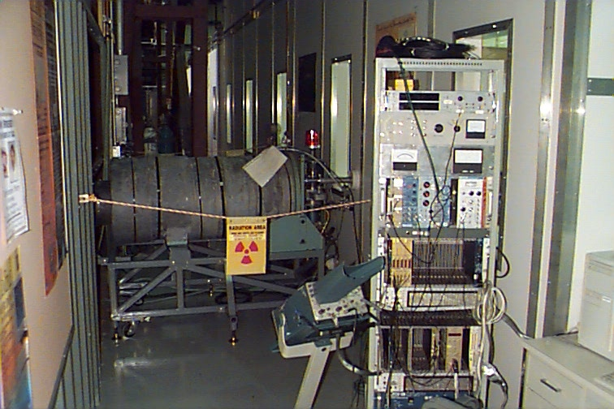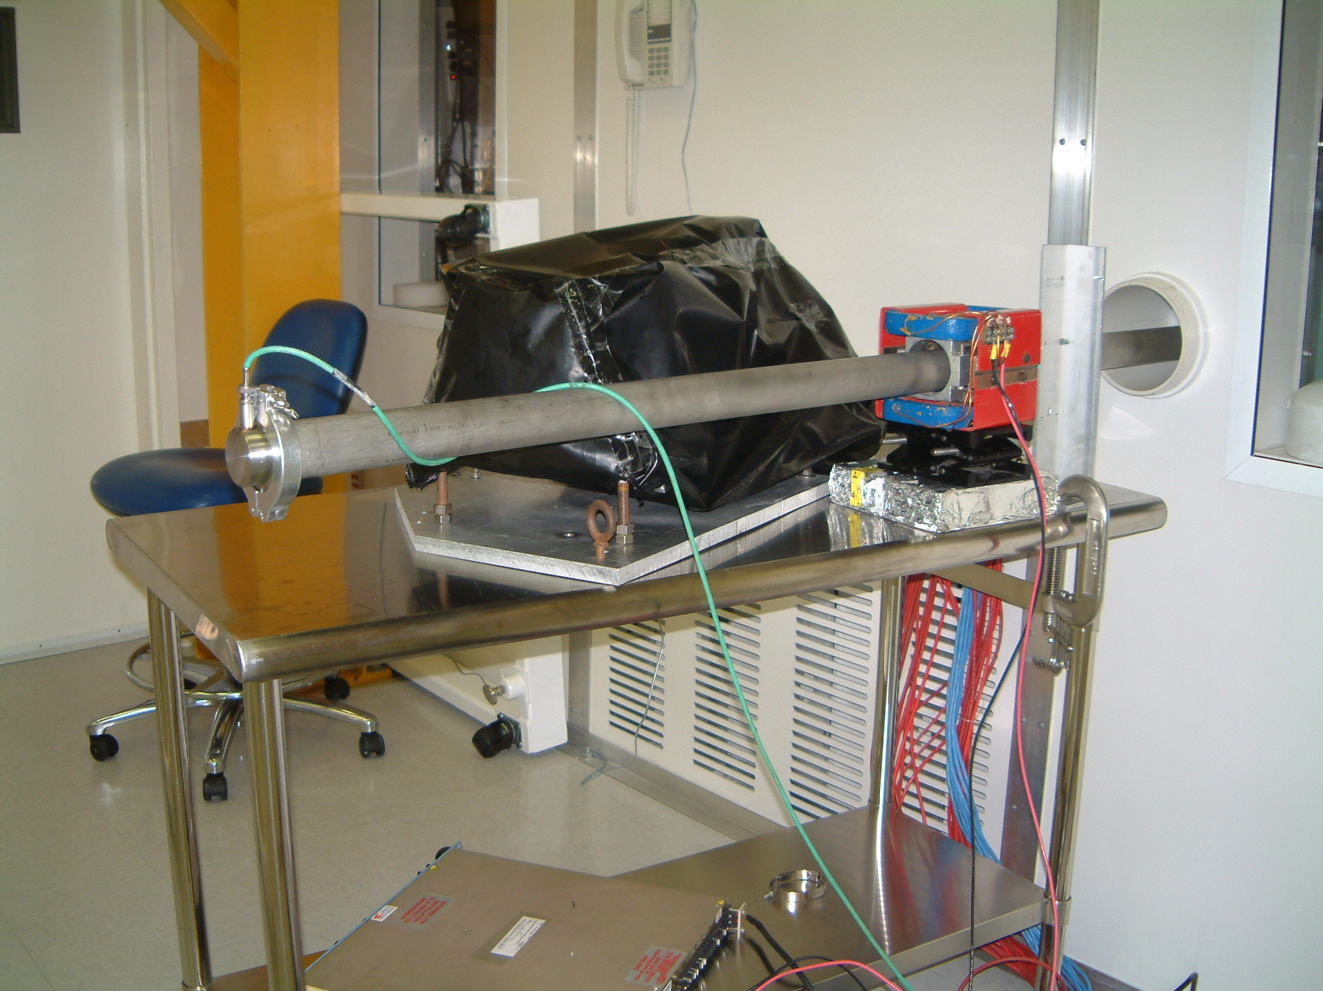

Figure 1. a) The Van de Graaff accelerator in Bldg 33 adjacent to the clean room at SLAC and a rack containing the accelerator control panel, BGO DAQ, and HV supplies are shown. The accelerator beam pipe penetrates the clean room wall on the right in the photo. b) Within the Bldg 33 clean room, the Van de Graaff beam pipe enters through the wall. The BGO calorimeter (wrapped in black) sits out of the way in the backward direction to monitor the integrated flux of gammas that emerge from the target which is at the end of the beam pipe.
  - Van de Graaff Accelerator
The Van de Graaff is a small electrostatic accelerator that produces a <400 Kev proton beam. The proton beam strikes either a Li⁷ target or a LiF target that terminates the end of the vacuum pipe and produces monoenergetic gammas via the reactions:
2 : 1
P (440 Kev) + Li⁷ → Be⁸(1+)* → Be⁸ + γ (17.6 Mev and 14.6 Mev)

P (340 Kev) + F¹⁹ → O¹⁶(1+)* + α → O¹⁶ + γ (6.1 Mev )

The Van de Graaff (Figure 1a) is operational and installed outside the clean room in the GLAST Assembly Bldg. 033.

Figure 2 shows Li and LiF spectra taken with the Van de Graaff and the BGO calorimeter. The Van de Graaff photon flux will be calibrated using the BGO calorimeter as described in LAT-TD-01396. The photons emerge isotropically from the Li target. As shown in Figure 1b, the BGO is placed toward the back of the target to count the number of photons that enter the solid angle of the BGO’s 6 cm x 6 cm fiducial area during each data taking run with the EM, EM2, TOWER, LAT, and CU. Simultaneous BGO and LAT runs will be taken as described in LAT-PS-04133.

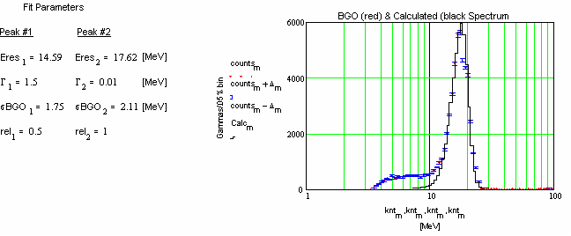
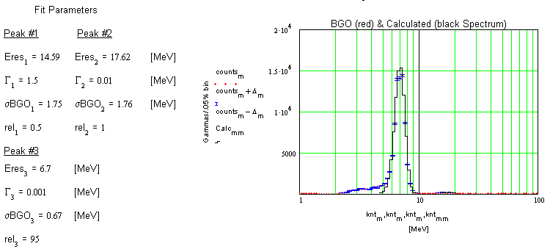

Figure 2. The photon spectrum seen by the BGO from a) Li target, and b) LiF target. For each peak, the fit is a convolution of a Breit-Wigner for the intrinsic line width and a Gaussian for the detector resolution. The fit parameters are shown to the left of the figure.

  - End Station A Beams and Test Station
The SLAC Linac accelerates ~1 mm long bunches of electrons or positrons. The energy of the bunches can be tuned from a few GeV to 50 GeV, and the number of particles in a bunch can be adjusted between 10⁹ and a few 10¹⁰. It is expected that 30 pulses/sec will be available for our experiment. As shown in Figure 3, a secondary beam of positrons or hadrons can be generated before entering the A line. The A line has bend magnets and momentum slits, and acts as an ~±0.5% momentum width spectrometer (±1.0% when slits are wide open) as it transports the beam to End Station A. In End Station A, a radiator may be inserted in the beam to generate photons. The energy of the radiated photons are determined by measuring the energy of the degraded electrons with a Tagger. The Tagger will be a scintillator hodoscope as shown in Figure 3.

The End Station A test station hardware is mostly the same as that used in the single tower BTEM GLAST Beamtest ’99. A gas Cherenkov detector and time of flight are used to cleanly separate protons from kaons, pions, and positrons. A scintillating fiber hodoscope is used for recording the charged beam position and width. There is a back stop BGO (Bismuth Germinate) calorimeter (Figure 4) for measuring leakage from the CU and for verifying the photon tagger energies. A new instrument x,y,Θ translation table will support the CU in a clean, controlled, monitored, and approved environment. Only certified people will work with the flight hardware. The coordinate system for the x,y,Θ translation table is shown in Figure 5.

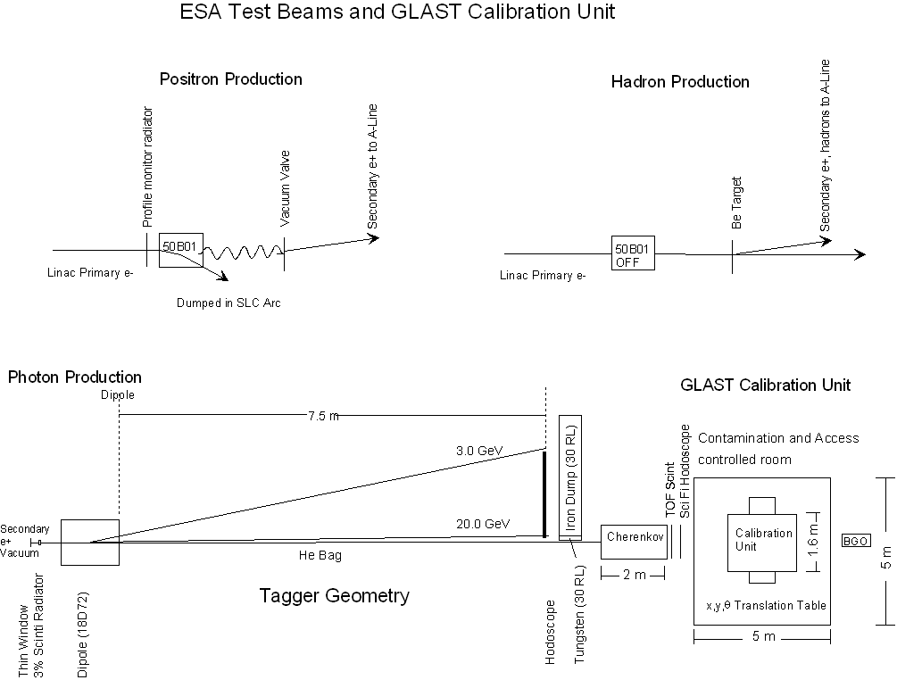
Figure 3. The End Station A test beams and experimental layout is shown for the GLAST CU Beamtest.

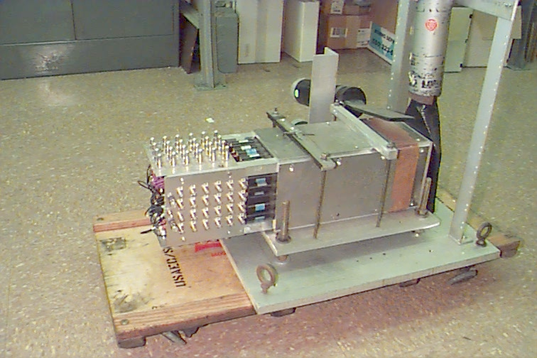
Figure 4. The BGO calorimeter from SLAC E146 that will be used in the GLAST CU Beamtest. It consists of 45 BGO crystals (a 7 x 7 array with the four corners missing), each crystal measuring 2 cm x 2 cm x 20 cm (18 X₀). Each crystal is read out by a 3/4” photomultiplier tube. The PMTs detect ~1 photoelectron per 30 keV of energy deposition in the BGO.
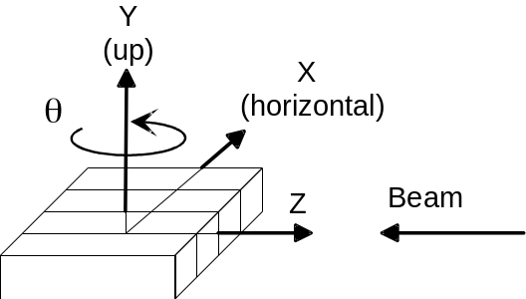
Figure 5. This is the Coordinate system and orientation of the Calibration Unit. The origin of the coordinate system will be translated in Z to be beneath the center of mass of the unit. It is a right handed coordinate system with 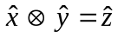.
The Linac and beamline instrument readouts will be put into a reflective memory by the existing End Station A data acquisition system. A companion reflective memory module will sit in the Third Party VME crate. This Third Party crate feeds data to the Event Builder Module just like any other TEM, and the Event Builder Module then packages the Third Party data with the event. The CU will be triggered by an external “beam is here” signal on each Linac pulse (30 Hz). The Third Party crate cpu will wait until End Station A fills the reflective memory before reading it and passing on this event’s Third Party data to the Event Builder.

- Calibration and Validation Methods
  - Types of calibration and validation to be done
    - Low level calibrations
Low level calibration consists of taking data from which parameters are directly calculated. Examples include the ADC chan / MeV response of each CsI crystals and which strips are dead in the tracker. Some of the simpler science requirements, such as time accuracy and dead time, will also be demonstrated directly from the experimental data. These calibrations are described in LAT-MD-00575 “SVAC LAT Plan for LAT Integration at SLAC”.

    - Calibration of the GLAST Monte Carlo Simulation

The particle beam data during the CU test and the Van de Graaff data during the LAT test will be used to verify and, if necessary, adjust parameters in the GLAST Monte Carlo Simulation code. The simulation is absolutely essential for demonstrating compliance with many of the LAT Science Requirements as well as eventually interpreting on orbit data. The LAT response must be known for many particle types (e,p,γ), energies (20 MeV to 300 GeV), angles of incidence (θ,φ), and positions (x,y,z) of entry. We need a library of data taken at very many points in this 7 dimensional “phase space”. Unfortunately, making this library experimentally would take prohibitively long. Instead, experimental data will be taken at only a relatively small number of points. This data will be compared with the simulation output at the same phase space points, and, if necessary, the simulation code calibrated (adjusted) to give agreement. The full library of data will then be generated with the calibrated GLAST Monte Carlo simulation.

    - Verification of the higher level Science Requirements using the Simulation

Compliance with the science requirements will be demonstrated using the output of the calibrated Monte Carlo simulation. For example, the effective area for energy E photons at a particular angle of incidence will come from simulating a large number of energy E photons, thrown uniformly over a large plane. The fraction of these photons that trigger and survive the software cuts multiplied times the area of the large plane is the effective area for energy E photons that will be reported. The number of simulated photons should be sufficiently large so that the error on the effective area is overwhelmingly dominated by systematics rather than statistics.

  - The Strategy for the particle beam measurements on the CU in ESA at SLAC.
    - Calibrate the energy response of the Calibration Unit
Various photons and positrons will be put into the CU at a variety of x, y, θ in order to calibrate the energy response of the CU:
1) mono-energetic photons from the Van de Graaff (17.6 MeV γ)
2) tagged photons (100 MeV to 1000 MeV),
3) single mono-energetic positrons (1 to 40 GeV), and
4) Linac pulses containing multiple positrons (eg: 7 x 40 GeV = 280 GeV)
The energy of the 17.6 MeV Van de Graaff photon is from a well measured nuclear excitation of Be. The energies of the .1-1.0 GeV tagged photons are known from the magnetic field and geometry of the tagger magnet. The energies of the 1-40 GeV positrons are known from the magnetic fields and geometry of the A-line. The number of positrons per bunch is measured by the pulse height in a beamline scintillator and by seeing energy peaks in the CsI calorimeter. As a cross check, the photon tagger energy will be checked by a BGO calorimeter.

    - Record data using the ESA Bremsstrahlung γ beam
A bremsstrahlung γ beam (from 20 GeV positrons) will be used to simultaneously take data at all γ energies from below 50 Mev to 20 GeV. To first approximation, the bremsstrahlung spectrum has equal numbers of γs per percent width energy bin. The already energy calibrated LAT (see 6.2.1) will be used to bin these photons into ±25% energy bins. Possible bin edges are .040, .060, .090, .135, .203, .304, .456, .683, 1.02, 1.54, 2.31, 3.46, 5.19, 7.78, 11.7, 17.5 GeV. The bremsstrahlung beam will be put into the CU at a variety of x, y, θ. The identical analysis of both the experimental data and the simulation output will be compared to verify the simulation. The simulation code will be modified, if necessary, to obtain agreement with the data.
The CU Monte Carlo will include the radiator. We will not Monte Carlo generate monochromatic photons for comparison with the data. Instead, we will Monte Carlo positrons incident on the radiator + CU and compare this to the measured data. Including the radiator in the Monte Carlo will not only provide the correct shape and intensity bremsstrahlung spectrum, but it will also correctly provide multiple photons to the CU when the positron radiates more than once. The Monte Carlo data will be normalized to the beam data by the ratio of the number of Monte Carlo positrons to the actual number of positrons counted by the radiator target scintillator.
A low Z (to minimize the LPM effect) plastic scintillator (CH) will be used as the radiator. The scintillator (with an ADC to determine multiple positrons) will count the incident positrons, thus providing a normalization of the bremsstrahlung spectrum.

The actual bremsstrahlung γ spectrum has been measured in the SLAC E146 experiment by Anthony, etal^{.(1)}. Their results for a carbon radiator are shown in Figure 6. Their 2% carbon radiator with a 25 GeV beam is close to the GLAST beam test configuration. The classic bremsstrahlung spectrum should be flat on this plot. The gradual down slope between 500 MeV and 20 MeV is due to the experimental depletion of lower energy photon bins when the electron radiates more than once in the radiator and the summed photon energies populate a higher energy bin. There is a dipping suppression of the bremsstrahlung spectrum below 20 Mev that is theoretically understood as due to the LPM and dielectric effect. This suppression is due to the electron multiple scattering while traversing the bremsstrahlung formation zone. The bremsstrahlung amplitude from before and after the scattering can interfere thus reducing the amplitude for bremsstrahlung photon emission. This effect is not relevant for E_{γ}>50 MeV.
We will verify that the CU Monte Carlo correctly reproduces the bremsstrahlung spectrum and CsI response, by using the CU CsI alone to measure the bremsstrahlung spectrum above 50 MeV during data taking. The CU will be triggered externally on every beam pulse. Whereas the 3-in-a-row tracker trigger bit and subsequent offline track finding will yield the photon detection efficiency, the CsI (corrected in energy for tracker energy loss when there is a conversion) is a well energy calibrated calorimeter of high efficiency for measuring the spectrum and absolute number of incident photons. A histogram of the number of events versus energy in the CsI, for both the Monte Carlo and real data, will demonstrate how well the Monte Carlo (bremsstrahlung spectrum and CsI) reproduces the data. The photon spectrum seen by the CsI alone also serves as a second means of normalizing the Monte Carlo to the data (the radiator target scintillator is the first).
The demonstration of how well the entire Monte Carlo is calibrated would include the following plots.
- A plot of the number of internally triggered on and reconstructed photons versus CU determined energy in logarithmic energy bins. This plot would be made at each CU rotation and transverse position.
- A plot of the number of photons versus the cosine of the angle between the beam direction and the reconstructed photon direction in d(cos) bins. This plot would be made for each CU ±25% energy bin at each CU position, resulting in (15 energy bins)x(18 positions)=270 plots with 10,000 incident photons contributing to each plot.
Each of these plots would be made for both the real and Monte Carlo data and compared.
As an additional diagnostic for background effects, three differential bremsstrahlung beam analysis can be done. For example, an angular distribution plot can be made with all energy bremsstrahlung photons that come from a 1 GeV e+ beam. Likewise, an angular distribution plot can be made with all photons that come from the same number of 4 Gev e+. Subtracting the 1 GeV angular distribution plot from the 4 GeV angular distribution plot, yields the angular distribution (point spread function) of the CU response for a pseudo 2.5±1.5 GeV photon beam. Notice that this does not depend on the tagger or CU determining the energy of the photons being used in the point spread function. Some normal incidence bremsstrahlung data from a 9 GeV e+ beam will be taken to subtract from the normal incidence 11 GeV e+ data to yield the CU response to a pseudo 10±1 GeV photon beam, and some normal incidence bremsstrahlung data from a 18 GeV e+ beam will taken to subtract from the normal incidence 20 GeV e+ data to yield the CU response to a pseudo 19±1 GeV photon beam.
The magnet must be on for the bremsstrahlung running in order to sweep the positron away. Thus there will be an additional source of tagged photons that are more than 3 GeV less than the positron beam energy. A summary of these energies for bremsstrahlung running is shown in Table 2.

Table 2. Summary of the positron energies for the bremsstrahlung running.

e+ Energy [GeV] | Primary Purpose | # of e+ (=runs) | Tagged γ Energy [GeV] | Min e+ Energy Tagged [GeV] | Tagger Magnet B*L  [kG-m]
1 | CU Energy calibration | 4 | .1 - .25 | .75 | 3.3
4 | CU Energy calibration | 4 | .1 – 1.0 | 3 | 13.3
9 | Differential brems subtraction | 2 | 5-6 | 3 | 13.3
11 | Tagged photons at CU “sweet spot” | 2 | 7-8 | 3 | 13.3
18 | Differential brems subtraction | 2 | 14-15 | 3 | 13.3
20 | .05 – 20 GeV γ for verifying MC | 12 | 16-17 | 3 | 13.3

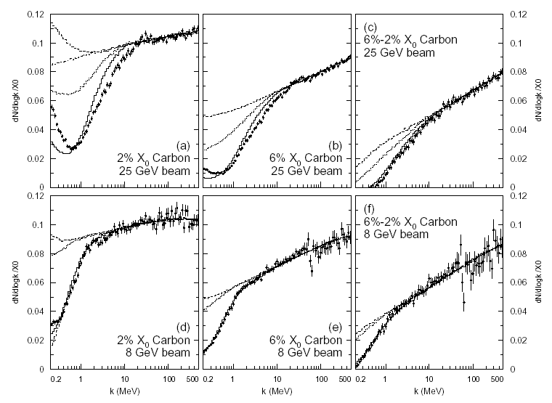
Figure 6. Bremsstrahlung measurements from SLAC E146 (Anthony, etal⁽¹⁾). Measurements with statistical errors only of dN=d(log k) are compared with the LPM (Landau, Pomeranchuk^{[2]}, and Migdal^{[3]}) plus dielectric effect plus transition radiation Monte Carlo curves (solid line), for (a) 2% X₀ carbon and (b) 6% X₀ carbon targets in 25 GeV electron beams, while (d) shows the 2% X₀ carbon and (e) the 6% X₀ carbon target in the 8 GeV beam. The cross sections are given as dN=d(log k)/X₀ where N is the number of events per photon energy bin per incident electron. Panel (c) shows the result of subtracting the data in (b) from that in (a), while (f) is the result of subtracting (e) from (d). Also shown are the Bethe-Heitler plus transition radiation MC (dashed line), LPM suppression only plus transition radiation (dotted line) and, for comparison, Bethe-Heitler without transition radiation (dot-dashed line).

Typically, the simulation normalization had to decreased by a few percent to match the data (-3.0% for (a) Carbon), an amount consistent with the authors’ estimate of a 3.5% systematic error (2% of which came from their knowledge of the target thickness).

    - Record data using the ESA Proton beam
Protons will be put into the CU at a few x, y, θ. As in 6.2.2, the analysis of the experimental data and simulation output will be compared to verify and correct the simulation.

- Description of Tests
  - Cosmic Rays on the ground
Cosmic data runs with the EM, EM2, TOWER, LAT, and CU are described in LAT-TD-04136 “VG and CR Data Runs for LAT Integration”. These runs are derived from LAT-MD-03489 “Ad Hoc Committee on End-to-End Testing”. Additional cosmic runs are described in LAT-MD-00575 “SVAC LAT Plan for LAT Integration at SLAC”.
  - Photons (14.6 and 17.6 MeV) from the Van de Graaff accelerator
The Van de Graff is installed in Bldg 33 with its target pipe inserted through the wall of the Clean Room. Measurements show that the Van de Graaff produces ~500 Hz of isotropic gammas (14.6 and 17.6 MeV) into 4π. When the VG target is placed at the center of a tower’s top layer, the normal 3-in-a-row tracker trigger has an acceptance of ConversionEfficiency*SolidAngle=.3 steradians. Thus there will be ~10 Hz of triggers due to VG photons in the tower in addition to the usual ~20 Hz of cosmics. Energy and direction (the photons point at the VG target) will be used to separate the photons from the cosmics. This method was used successfully to measure the first EM’s energy resolution, efficiency, and point spread function as summarized in LAT-TD-5160 “Van de Graaff EM Data Analysis Progress Report”. For the full LAT, the ACD will also be used to identify the charged cosmics.
The use of the BGO calorimeter to monitor the VG photon flux is described in LAT-TD-01396 “Calibration of the Van de Graaff Photon Flux”. The procedure for taking simultaineous BGO and LAT data is in LAT-PS-04133 “Procedure to Take Simultaineous BGO and LAT Data”. Data runs using the Van de Graaff are listed in LAT-TD-04136 “VG and CR Data Runs for LAT Integration”.
  - Am²⁴¹ Source X-rays
X-rays (60 Kev) from a strong Am²⁴¹ source will be used to generate a high trigger rate of 3-in-a-row triggers by making accidental coincidences between silicon layers in the tracker. Without orbital rate cosmics from an airplane flight of the LAT, the source will provide the most realistic orbital rate data loading. Subtle effects will be looked for by comparing cosmic muons in the high and low trigger rate data. The use of the source is described in LAT-TD-04980 “Use of an Am²⁴¹ Source for High Rate Triger EM, Tower, and LAT Data Runs”. Data runs using the source are listed in LAT-TD-04136 “VG and CR Data Runs for LAT Integration”.
  - Positrons in ESA
A secondary beam of positrons travels down the A-line and arrives in End Station A. The A-line has momentum slits and is therefore a long spectrometer. The positrons have an energy known to ~±0.5% with a spread in energy of ~±0.5% (depending on how open the slits are). The CU energy calibration is referenced to this spectrometer and to the minimum ionizing energy deposition of cosmics crossing the CsI crystals. We will run with an average of 1 positron / pulse to maximize the number of pulses that have exactly one positron. The calculation of runtime for the positron beam is shown in Figure 7. The CU will be triggered externally on each beam pulse.

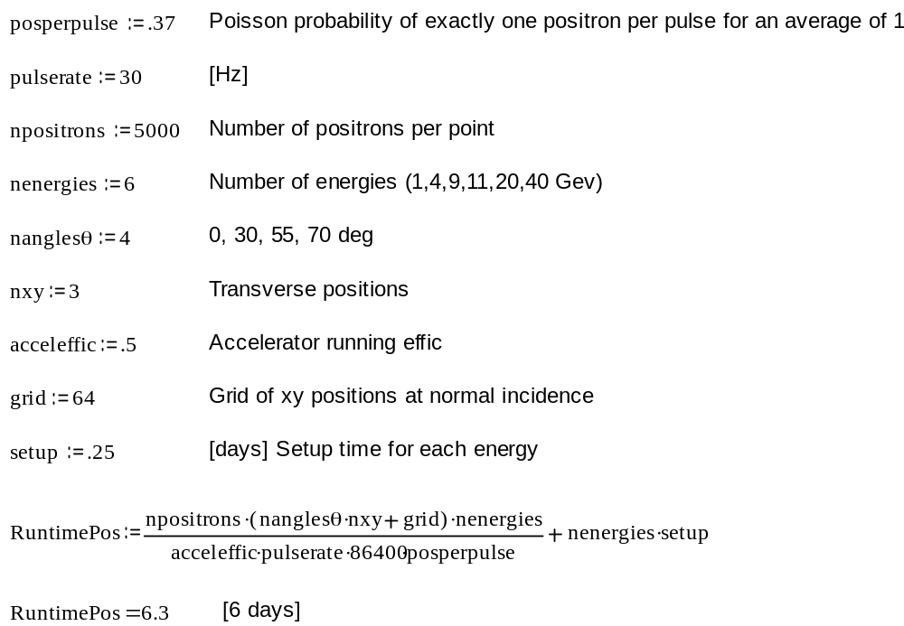

Figure 7. The calculation of runtime is shown for the positron beam.

  - Photons in ESA
    - Bremsstrahlung Beam
The average number of positrons per pulse and the radiator thickness will be adjusted to yield nγavrg photons per pulse. An nγavrg=1 maximizes the Poisson probability (=.37) of exactly 1 photon in the pulse. However, sometimes 2 γ/pulse may come out of the bremsstrahlung target, for example 20 MeV and 980 MeV. The LAT will record the sum energy of 1 GeV, and a track will be seen in the tracker if one of the photons converts. However, it is not known which of the photons converted. When 20 MeV conversions are unknowingly added to the 1 GeV photon bin, wide tails will be put on the 1 GeV SPAR. What will be verified is that the simulation of the LAT + bremsstrahlung radiator agrees with the measured SPAR. The pollution from more than one photon will be kept as small as possible by keeping nγavrg as small as possible, consistent with getting enough photons in our allotted run time. Figure 8 shows the fraction of pulses that have 2 gammas in them for different nγavrg. An nγavrg=.22 will be used which will give approximately the same pollution as in Beamtest ’99. An average of one 20 GeV positron/pulse into a .5 inch thick (=.030 radiation lengths) polystyrene scintillator radiator will produce an average of .22 bremsstrahlung photons per pulse between 50 MeV and 20 GeV. The calculation of the required running time is shown in Figure 9. The CU will be triggered externally on each beam pulse.
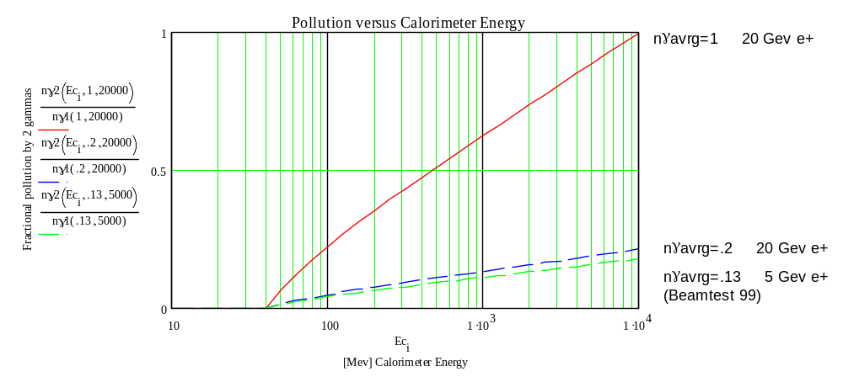
Figure 8. This is the fraction of bremsstrahlung pulses that have 2 gammas adding up to the total energy seen by the calorimeter. We will use nγavrg~.2 which yields the dashed curve in the figure.

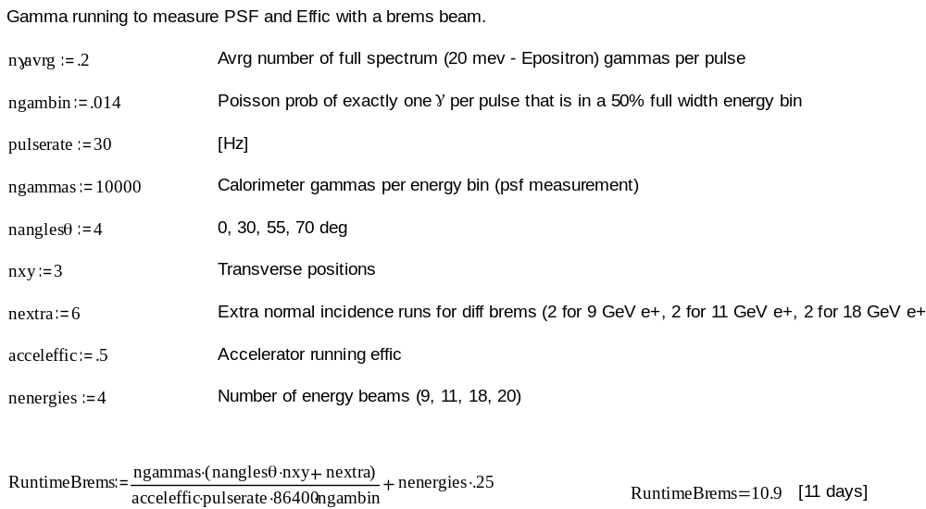

Figure 9. The calculation of runtime is shown for the Bremsstrahlung Beam.

    - Tagged Photons
During all bremsstrahlung running, the momentum of the degraded positron will be measured by a spectrometer consisting of a dipole bend magnet, 7.5 meters of drift space through a He bag to minimize multiple scattering of the positron, and a scintillator hodoscope to measure the position of the positron transverse to the beam axis.. The hodoscope has 100 scintillator fingers, each 1 cm wide. The inside edge of the scintillator array is a few cm from the beam axis so that the radiated photons do not pass through scintillator, and the outer edge is ~100 cm away. This tagger is similar to that used the the 1999 beamtest of the GLAST BTEM. Figure 10 shows the calculated photon fractional energy resolution for the magnet settings and some beam energies of Table 2. The calculation includes the positron beam size, multiple scattering in the radiator, multiple scattering in the 7.5 meter drift, and the size of the hodoscope scintillators. Figure 11 shows a calculation of run time for E_{positron}=1 and 4 GeV tagged photon running.
Downstream of the hodoscope are 30 radiation lengths of shielding to absorb the positrons and prevent any shower products from hitting the CU. Since a 20 GeV positron is deflected only 15 cm from the beam axis for the field and drift in Table 1, the edge of this shielding closest to the beam axis is made of tungsten to minimize transverse shower leakage.

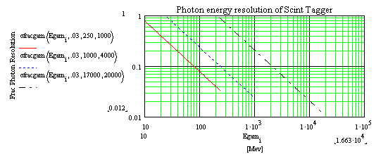

Figure 10. Energy resolution (RMS) of the Photon Tagger as a function of photon energy for 1, 4, and 20 GeV positron beams, with maximum tagged photon energies of .25, 1, and 17 GeV.

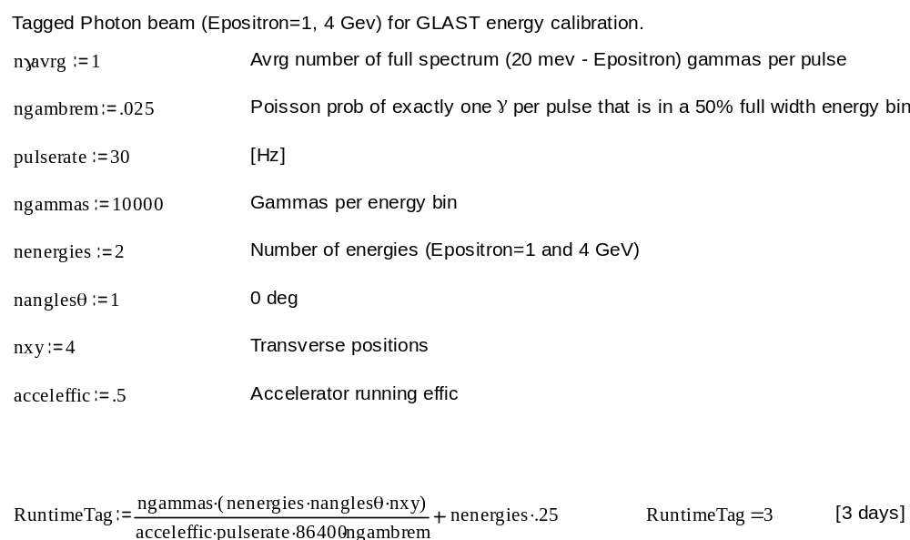

Figure 11. The calculation of runtime for the Tagged Photon beam.

  - Protons in ESA
The A line will be set to deliver 13 GeV/c with an average of 1 particle/pulse. This maximizes the number of pulses which have exactly 1 particle. The beam contains mostly positrons and pions, and we measured .0044 protons/pulse in Beamtest ’99. These protons are very cleanly identified using time-of-flight and a cherenkov counter. In one month with a .58 accelerator efficiency we will get ~200K protons as we did in Beamtest ’99. In the full LAT, proton rejection is a product of the ACD rejection (~10³) times the Pattern Cut rejection (~10²). These ~200K protons will be used to calibrate the simulation at a small number of x, y, θ (TBD). Then the simulation will be used to demonstrate the actual Pattern Cut rejection. The large cosmic ray sample on the full LAT will be used to demonstrate the ACD rejection factor. The CU will be triggered externally on each beam pulse.

A test beam request has been put into SLAC for 21 days of secondary positrons (test beam experiment T-458) and 30 days of secondary hadrons (test beam experiment T-459) in ESA. This time is being made available consistent with the GLAST schedule after delivery of the LAT.
- References
- Anthony, etal.; Phys Rev D56:1373-1390, 1997. (also hep-ex/9703016)
- L. D. Landau and I. J. Pomeranchuk, Dokl. Akad. Nauk. SSSR 92, 535 (1953); 92, 735 (1953). These two papers are available in English in L. Landau, The Collected Papers of L. D. Landau, Pergamon Press, 1965.
- A. B. Migdal, Phys. Rev. 103, 1811 (1956).

