 | Document # | Date Effective
 | LAT-TD-00879 | Draft 8/13/02
 | Author: | Supersedes
 | A. Brez | none
LAT Technical Document
LAT Technical Document | Subsystem/Office
LAT Technical Document | Tracker Subsystem
Document Title
Production and measurements of the mechanical ladders for the GLAST Engineering Model Tower

CHANGE HISTORY LOG
Revision | Effective Date | Description of Changes

1. PURPOSE
This document describes the results of the production of 150 Tracker SSD ladders called “mechanical ladders,” constituted of non-working silicon wafers. The mechanical ladders will be assembled on the trays of the Engineering Model Tracker tower module.

2. SCOPE
The mechanical ladders have been produced following procedure LAT-PS-635. This procedure defines the methods used to assemble, test and qualify the flight ladders starting from four GLAST2000 SSDs. The four SSDs are butt-bonded together edge to edge without any additional mechanical structure, and all the pads are wire-bonded in series to form a unique sensor 358 mm long and 89.5 mm wide. The wire bonds are encapsulated to avoid short circuits from conductive dust or chips. This extensive production test resulted in a large database used to certify the assembly procedure.

3. DEFINITIONS

AC Pad Pad to access the Al metal electrode on the strips
BTEM Beam Test Engineering Model
Dam & Fill Encapsulation technique. A thixotropic dense adhesive is used as a dam to contain a second fluid adhesive that encapsulates the wire bonds.
Encapsulation Adhesive covering of the wire bonds and metallic pads to prevent short circuits or electrical discharges
ESD Electro Static Discharge
Ladder Assembly of 4 SSDs edge bonded in series, with strips connected by wire bonds.
N-sub Substrate contact on the detector front.
Pad Area of the aluminum metal layer accessible through the passivation layer.
The pad area is defined as the wire-bondable area.
Pitch Distance between strip centers (228 μm)
Rms Root mean square
SSD Silicon Strip Detector
Tray Flat composite panel supporting the SSD ladders, readout electronics, and converter foils in the TKR mechanical structure.
Tower Assembly of 19 trays, stacked vertically and held together with sidewalls, to form one TKR detector module.
μm Micrometer (10⁻⁶ meter)

4. REFERENCES
- SLAC Pub 8682 Beam Test NIM Paper
- NIM A 457, 128 Assembly of BTEM Tracker
- LAT-PS-635 Flight ladder assembly procedure

5. The ladders.
The ladders were assembled from wafers that have the dimensions of the GLAST2000 SSDs: 89.5 mm × 89.5 mm × 0.4 mm. The requested tolerance for wafer dicing was ±20 μm. Three kinds of ladders have been produced:
- 100 ladders with one wafer aluminum coated and 3 wafers without any coating. The first wafer can be wire-bonded to the pitch adapter of the mockup electronic board.
- 40 ladders with all 4 wafers aluminum coated, with all the wire bonds made and encapsulated as in a real ladder.
- 10 ladders with real GLAST2000 SSDs, including all the pads and strips, which were rejected after electrical screening by the manufacturer. These ladders are fully wire-bonded and encapsulated.
The assembly, wire bonding, and encapsulation of these ladders followed the LAT-PS-635 procedure.

6. Results
The ladders were produced using a set of 12 ladder assembly jigs (fig. 1) that follow the same concept developed for the BTEM production ([1] and [2]). On each ladder data sheet the serial number and the serial number of the relative jig are reported. The alignment of the wafer is mechanical, made by pushing each ladder against the Teflon coated references of the jig. Using a Computerized Measurement Machine (CMM), with 5 μm maximum error, the alignment of the ladders was measured on the side of the mechanical references (see fig. 2). On each ladder 8 points (2 points per wafer, close to the extremity) were measured and the residuals from the best-fit straight line were calculated. Fig. 3 shows the distribution of the residuals. The 5.5 μm rms error should be compared with the nominal rms resolution produced by the GLAST2000 strips in the measurement of a particle trajectory: 228/2√3 μm=66 μm. One ladder falls outside of this distribution. One wafer in this ladder was out of alignment, and the minimum residual (−32μm) and maximum residual (47 μm) were measured on that ladder. Even these measurements are close to the required tolerance of 40 μm.
Fig. 4 shows the residuals measured on all the ladders produced with the jig #06. The mean of the residuals measured on the 8 points can be considered to be a measurement of the systematic error that can originated from a bad alignment of the mechanical references of the jig. Fig. 5 shows these mean values for the 12 jigs. The maximum systematic error is insignificantly small (6 μm).

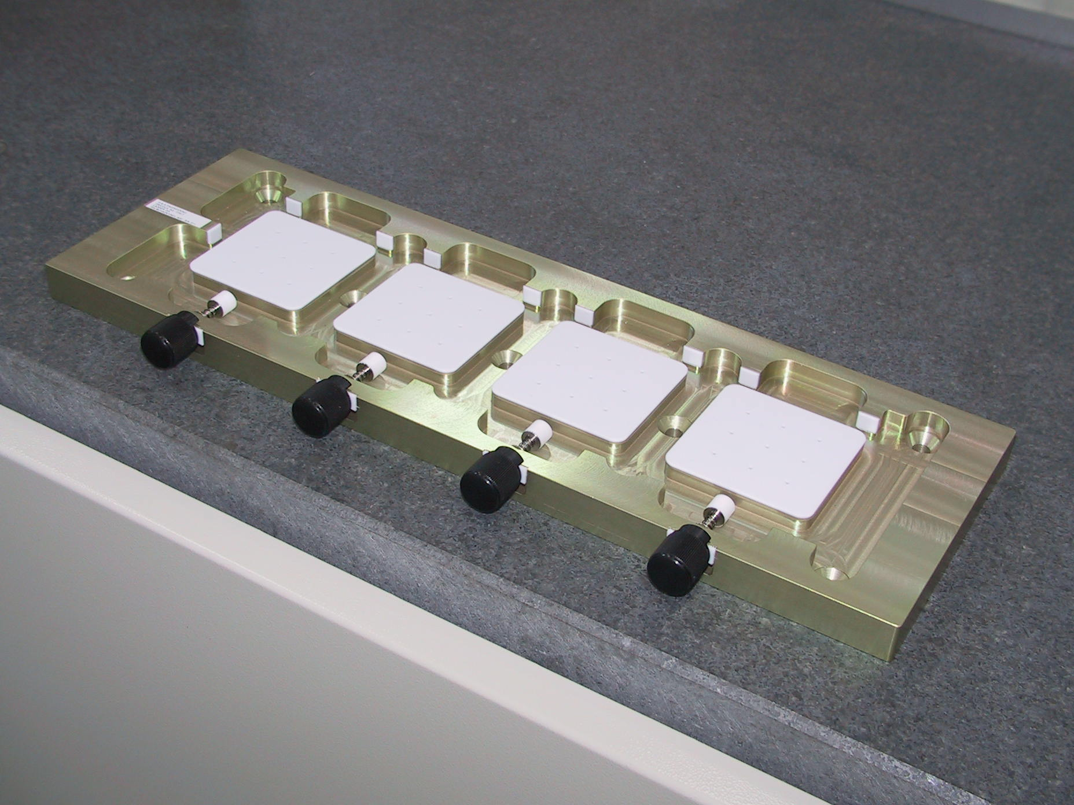
Mechanical references
Pistons
Vacuum chucks
Figure 1. Ladder assembly jig.

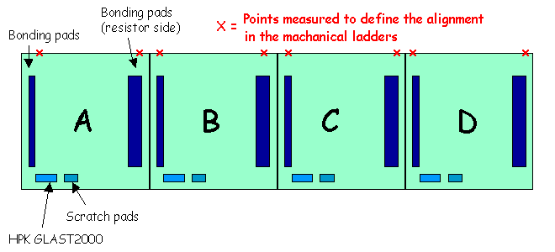
Figure 2. Ladder scheme. The mechanical ladders consist of silicon wafers without lithography. The position, number and length of the wire bonds are identical to those made on real ladders.

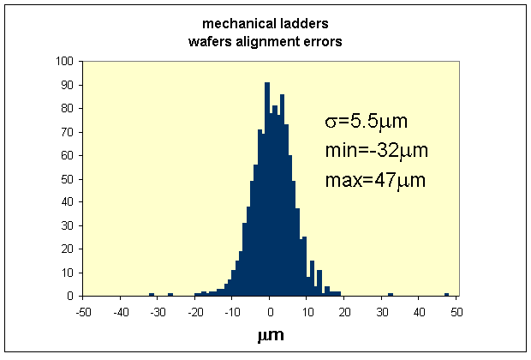
Figure 3. Residuals from the best-fit straight line of the 8 points measured on one edge of the mechanical ladders.

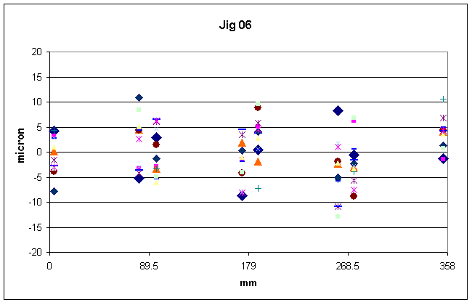
Figure 4. Alignment errors measured on the 12 ladders produced with the ladder assembly jig #06.

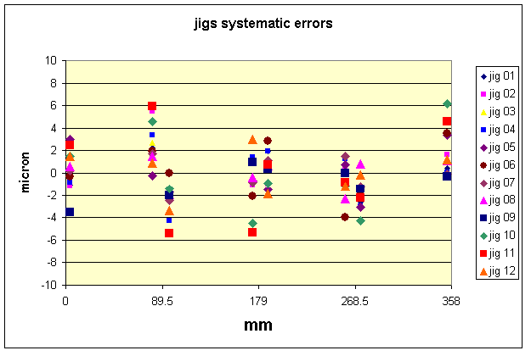
Figure 5. Mean of the residuals measured on the ladders produced with each assembly jig.

7. Wafer bonding and encapsulation
Fifty mechanical ladders were wire bonded following the same pattern of bonding of a real SSD: 384 strip wire bonds at 228 pitch (AC pads) + 2 wire bonds (Bias pads) + 2 wire bonds (Nsub pads). After wire bonding, the ladders were encapsulated. Three encapsulation methods have been considered and tested:
- Whole encapsulation with Scotchweld 2216 A/B only.
- Dam & Fill encapsulation: Scotchweld 2216 A/B (Dam) + GE 615 RTV (Fill).
- Dam & Fill encapsulation: Dow Corning 3145 RTV (Dam) + GE 615 RTV (Fill).
Method 1 was designed to prevent any possibility of adhesive incompatibility (the Scotchweld 2216 A/B adhesive is also used to edge-bond the wafers together). Method 2) is more common and uses the Scotchweld 2216 A/B as a dam to minimize the possibility of the glueadhesive incompatibility.
Method 3 is standard for encapsulation.
Two ladders with workng SSDs were produced using each method. Electrical tests demonstrated that the 3 methods are equally successful. The leakage current increase after encapsulation is less than 25% in all the tests.
Method 1 was abandoned for the following reasons: the Scotchweld 2216 A/B adhesive is quite dense, with a short pot life, particularly when used in a syringe. The deposition of the adhesive in between the wires is very time consuming, and it is difficult to avoid bubbles. The adhesive is opaque, so it is not possible to perform a visual inspection of the wire bonds after encapsulation.
Method 2 is more suitable, but still the Scotchweld 2216 A/B is not optimal for use as dam adhesive. The short curing time and the density make the control of the thickness of the dam problematic. This technique is time consuming for two reasons: the syringe of the dam adhesive must be refilled 3 times for each ladder and before the fill deposition, and the dam must be completely cured at room temperature (7 days).
Method 3 gives the best results in terms of reliability, geometric shape and time. The dam and the fill adhesives are transparent and soft, decreasing the risks connected with a possible contact of the SSDs of two consecutive trays during launch. The leakage-current increase after encapsulation is small (fig.6). During 4 months no significant leakage-current effects have been measured. Fig. 7 shows the detail of the edge of the ladder with the encapsulation. The Scotchweld 2216 A/B adhesive used for SSDs bonding is visible in the Dam-and-Fill area. All of the wire bonds are visible and are covered by soft silicone adhesive.

A

B

C

D
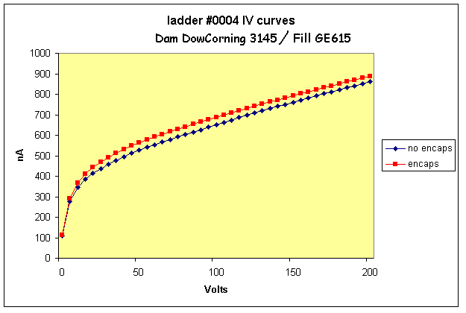
Figure 6 IV curve of the ladder #0004 measured before (blue) and after encapsulation (red)

Joint: ScotchWeld2216

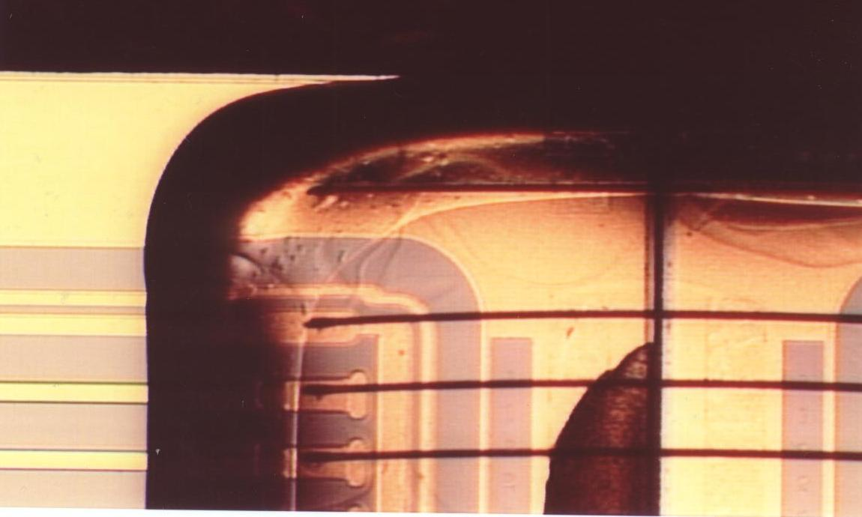
DAM: RTV3145
FILL: RTV615
Nsub bond
Bias bond
Ch 1 bond

Figure 7. Macro-photography of the edge of the ladder with the encapsulated bondings.

6. Conclusions
The production of the ladders needed for the Engineering Model tower has been concluded successfully. 149 ladders were within the required alignment tolerance (40 μm), and only one is just at the limit (47 μm).
The wire-bonding and encapsulation procedure has been fully tested on 50 ladders. The Dam (Dow Corning 3145RTV) & Fill (GE 615 RTV) solution has been chosen for the encapsulation method after comparison with 2 other working solutions.

