LAT CDR RFA #14 Response

Action Requested:
- No concept or treatment of radiator installation was presented. Design and analysis needs to be completed to ensure radiator handling loads are properly addressed and all interface requirements are captured in the S/C-LAT ICD.

- No presentation of ACD installation MGSE.

Supporting Rationale:
a) Necessary for CDR. Analysis of handling load cases must be completed prior to radiator fabrication.

b) Necessary for CDR.

Response:
- The first 3 figures show the concept for radiator installation from the Mechanical Systems Peer review in March 2003; the final 2 figures show the Grid design that was modified in March 2004 to allow the radiators to be installed via a pure lateral translation of the radiator. Previously the radiators had to be tipped and rotated to get the radiator heat pipes into a slot in the Grid wing. The radiator panel has dedicated inserts for GSE attachment. These have been sized for ground handling loads. As shown in Structural Evaluation of GLAST Radiator Sling (GLS0009-04), this design accommodates the ground handling loads with margin. There are no special requirements that need to be captured in the ICD to cover handling loads or radiator installation.

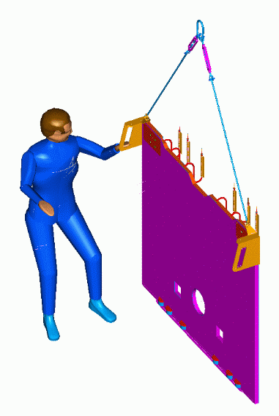
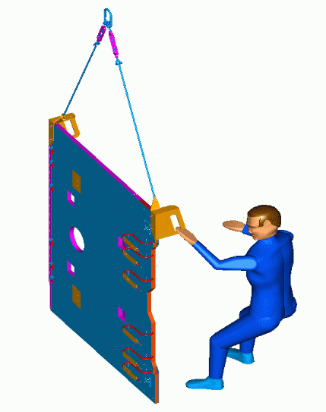
Normal integration is planned for handling with +Z axis up. The handholds are weights which provide CG adjustment of the load as required to offset the pick-up point so the cables clear the instrument grid. The radiator installation and removal can also be performed with the +X axis up. The same sling and sling attaching hardware will be used as for the Z axis up. The radiator interface is 2 inserts per lifting lug attachment.
+Z
+X
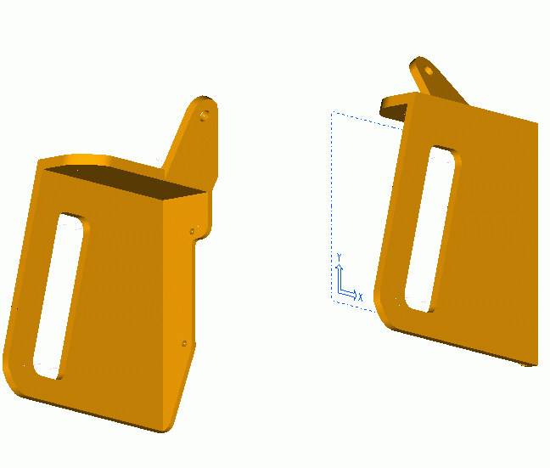
The lifting adapters are made of stainless steel to provide the required ballast characteristics. The lifting adapters are fitted with ¼ inch captive fasteners. There are no loose pieces.

The figures below show the updated grid and radiator configurations to accommodate a radiator installation via a pure lateral translation. In the figure on the left, the grid wing bars, in red, can be removed for the radiator installation. The figure on the right shows the radiator installed on the grid.
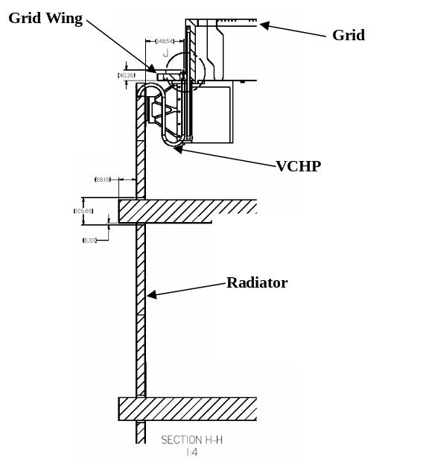
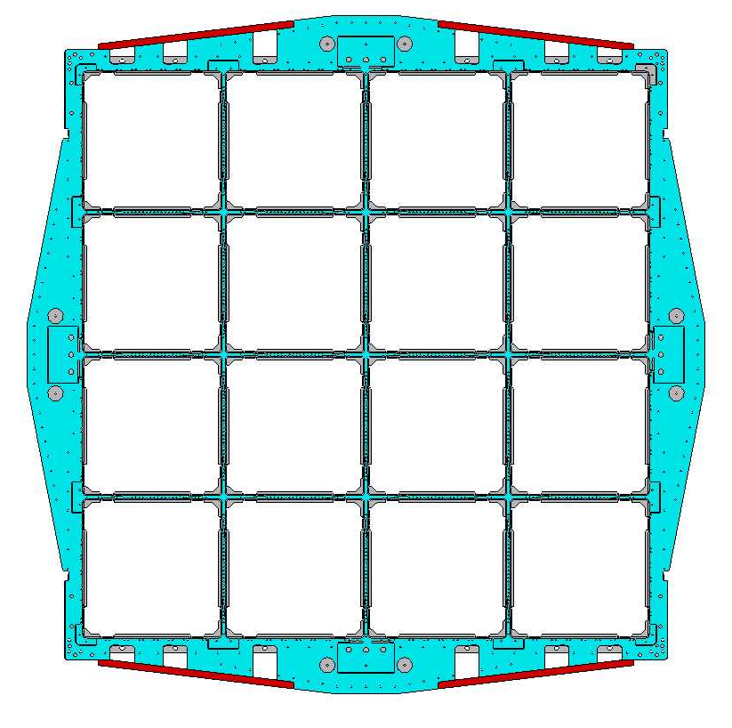
- SLAC will develop a low profile integration stand. When ready for ACD mate operations, the LAT will be lifted from the Rotation / Support Stand and set onto the low profile stand. The crane lift block maximum height is 134 inches [3,403 mm] (Hook removed). The available clearances assume an 8” [203 mm] high spreader (i.e., rectangular structural tubing that is also 6” wide and 0.375” thick). See figures below.

Figure 1: LAT with ACD To/From the Rotation Stand

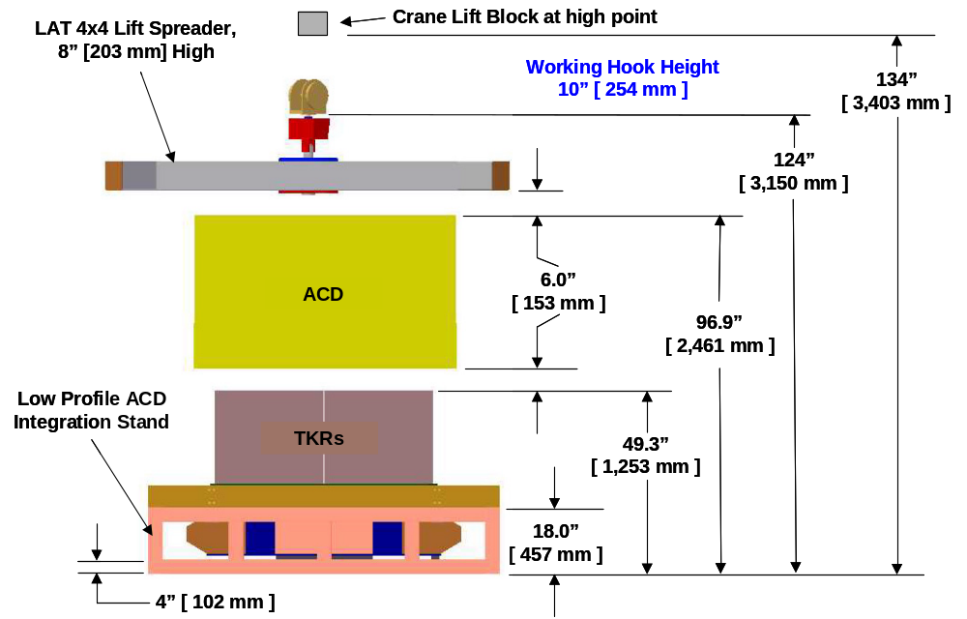

Figure 2: ACD Installation, Low Profile Integration Stand

