Meeting: GLAST Preliminary Design Review, January 8-11, 2002

Subsystem: Mechanical Response Accepted/
RFA Closed:
RFA Number: 48 _________________
(Originator’s initials)
Originator: Jim Ryan, Code 543, 301-286-4975

Specific Request:
Generate a comprehensive strength qualification plan for the LAT instrument.

Supporting Rational:
There is no instrument level strength test planned. A comprehensive document defining the strength qualification plans will ensure that all interfaces and subsystems will be adequately strength qualified.

Response:
Strength qualification plans have been added to the LAT Instrument Performance Verification Plan, LAT-MD-00408. The relative section(s) are presented here for reference.

7.1.1.4 Strength Tests
Strength tests will be conducted on all subsystem mechanical interfaces. A targeted qualification test program will be conducted which will focus on interfaces and specific regions of the Grid Box, and Electronic box interfaces. Preliminary analysis of the design has shown that stresses are very low except in specific discrete areas so qualification testing will be performed on those areas where there are expected to be high stresses. Tests will be conducted as listed in table 7-1.

Table 7-1 Strength Test Qualification Test Matrix
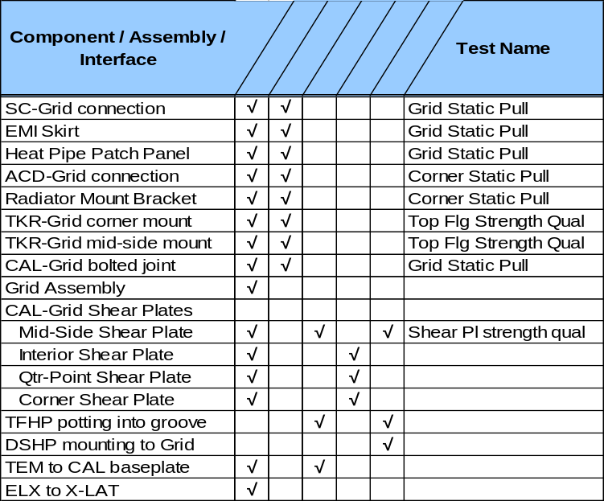

Structural, Mechanical & Alignment Tests
Mechanical tests are performed at successively higher levels of integration to provide the minimum program risk and maximum risk reduction benefit and cost to the program. Tests will be performed to the levels published in the LAT Environmental Specification document, LAT- SS-00778. The diagram in Figure 7-7 shows the flow of the tests during LAT integration onto Observatory testing.
Figure 7-7 LAT Dynamics Tests by Level of Assembly
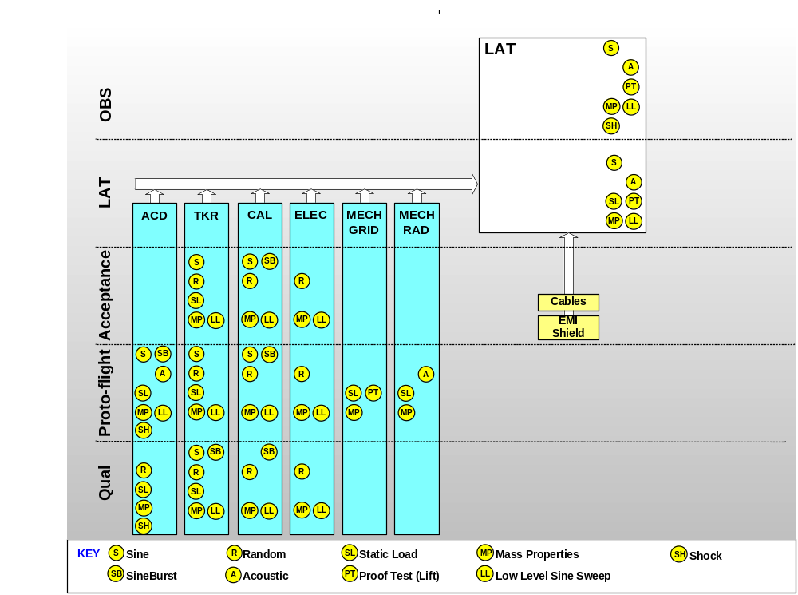

Proof Tests
Proof tests will be conducted on composite materials used on the LAT as called out in 433-MAR-0001 regarding the use of composites on primary and secondary structures. The calorimeter crystal tubes will be proof tested as an assembly via a sine burst test. The tracker bottom tray composite structure interface to the titanium flexures will be proof tested via a static load test.

Static Load Tests
All LAT subsystem mechanical components will be subjected to static load tests. These tests will be conducted on Qualification and proto-flight level components. The X-LAT Plate will be tested to proto flight test levels prior to integration. The Radiators and their associated hardware will be tested and flown, having been tested to qualification levels.

Dynamics Tests
Dynamics tests are to be performed in the mode in which the equipment will observe the environment. The LAT will be launched in a “powered off” mode. All dynamics tests which are for launch environment verification will be performed with the test article powered off.

Sine Burst Vibration
Sine burst vibration testing will be performed prior to integration on some subsystems to reduce design risk.

Tracker
The verification of TKR joint strength is to perform the sine-sweep vibration test with levels increased to envelope worst-case inertial loads. Due to the Tracker's extensive use of composites in the sidewalls and trays, this test will be performed for ALL flight units. Additionally, since the sine vibration test imparts the same inertial load as the sine burst test, the sine-burst test is redundant, and has been eliminated from the TKR test flow.

CAL
The CAL subsystem will conduct a sine-burst test on the first flight unit with the baseplate shear pins installed. In addition, all successive flight Calorimeter composite modules will be sine-burst tested separately (in France) at that lower level of assembly.

ACD
The ACD will conduct a sine burst vibration test on the proto-flight ACD subsystem.

Electronics
The electronics (TEM+TEM-PS, SIU, EPU, GASU, PDU) will be qualified by analysis as defined in GEVS. If any electronics modules do not meet this criteria, the first units shall be subjected to a sine burst vibration test at proto-flight levels.

