Single Event Effect Test Report for GSFC Test Trip to TAMU, 23-24 FEB 2004

Scott Kniffin¹, Jim Howard², Marty Carts³

- Orbital Sciences/NASA GSFC
- Jackson and Tull/NASA GSFC
- Raytheon STX/NASA GSFC

Introduction:
This testing was performed to determine the single event effect (SEE) sensitivity of candidate devices for the Gamma Ray Large Area Space Telescope (GLAST) project. The devices tested were the MAX724 DC/DC Regulator (Maxim) and the AFL2803R3S DC/DC Converter (IR). This testing was performed at the Texas A&M University Cyclotron.

Devices Tested:
The MAX724 is a 5A step-down, PWM, switch-mode DC/DC regulator manufactured by Maxim Integrated Products. These devices are TO-220 packaged. The devices were monitored by a custom test setup built by the GLAST group at Stanford University. The devices were marked: MAXIM MAX724ECK 0342PS.

The AFL2803R3S is a hybrid-packaged 28V input to 3.3V output DC/DC converter manufactured by International Rectifier using the Advanced Analog design. The devices were monitored by a custom test setup built by the NASA GSFC. The devices were marked as shown in Figure 1. The serial numbers of the devices used were: 0348107 and 0348125. Due to the total area of the region of interest within the device, each device was exposed in three areas at each bias/load configuration. These areas are shown below in Figure 2 as Region 1, Region 2 and FETs. The remaining areas on the device contain no components, active or otherwise, that are single event sensitive.

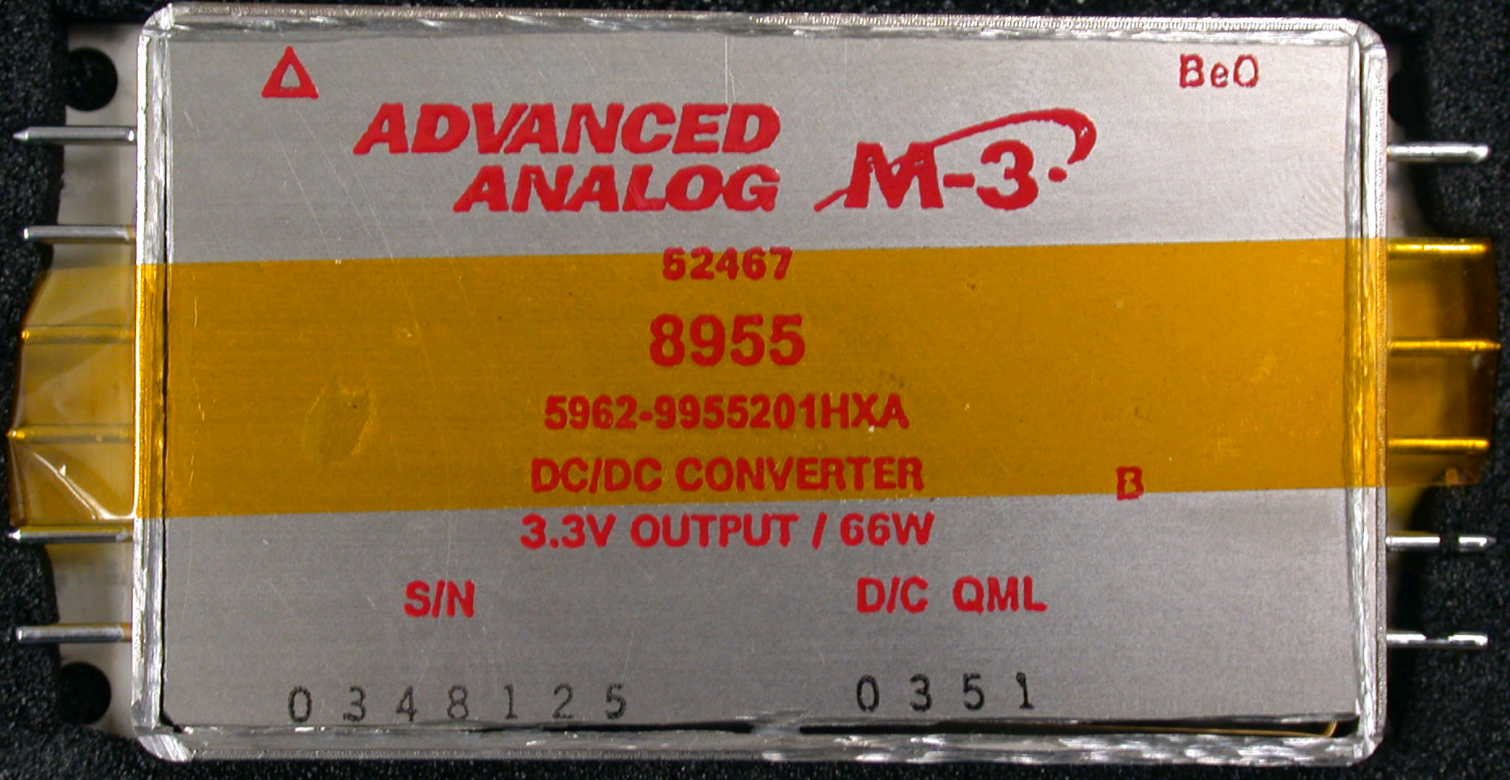
Figure 1: Device case and markings.

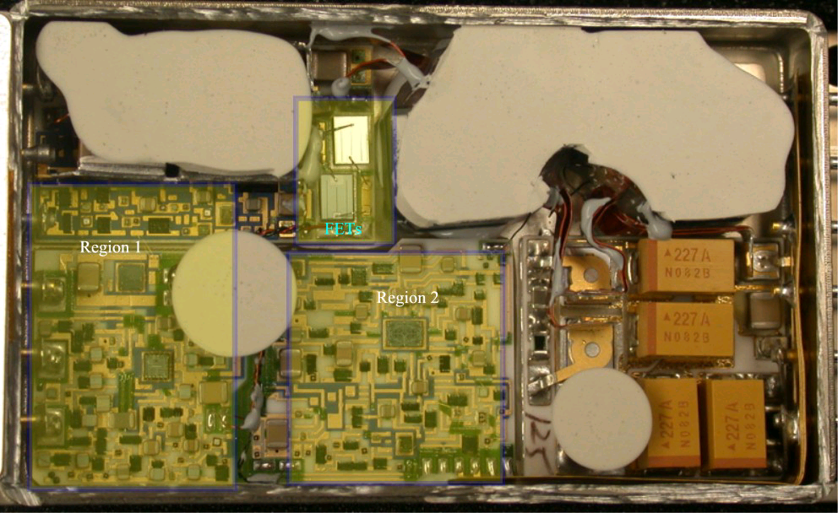
Figure 2: Interior of device and regions of heavy ion exposure.

Test Facility Information:
The devices were tested at the Texas A&M University Cyclotron Facility (TAMU). The cyclotron was tuned to 15MeV/amu for the copper, krypton and xenon used in testing. The MAX724 was screened for SET (single event transients) and SEL (single event latchup), the AFL2803R3S was screened for SET, SEU (single event upset) and SEGR (single event gate rupture). The LET for each ion varied slightly because of a slight change in the distance of the devices from the beam window. For the MAX724, the Xe beam had an initial LET of 53.8 MeV•cm²/mg. For the AFL2803R3S, the Cu beam had an LET of 20.7 MeV•cm²/mg, the Kr beam had an LET of 29.3 MeV•cm²/mg and the Xe beam had an LET of 53.9 MeV•cm²/mg. The full listing is given below in Table 1.

Table 1: Ion Beam Information
Ion | Angle of Incidence | LET or LET_{eff} (MeV•cm²/mg) | Range in Silicon (μm)
Copper | 0 | 20.7 | 117
Krypton | 0, 32, 38, 45 | 29.3, 34.6, 37.2, 41.4 | 116, 98, 91, 82
Xenon | 0 | 53.9 | 102

Test Setup:
The devices were mounted in air at the end of the Radiation Effects Facility line off of the K500 cyclotron. For the MAX724, the output was monitored for SET and SEL. To minimize thermal issues, the devices were screwed down to a sheet of metal sufficient to draw away the heat generated by the device during normal operations. The bias board used was the circuit evaluation card developed by the project to mimic the application circuit.

AFL2803R3S DC/DC converters were mounted to a water-cooled heat sink to draw away the heat dissipated by the device. Due to the limitations of the beam size at TAMU, the devices were irradiated in three separate regions with minimal overlap. The regions are shown in Figure 2 above. The active components were divided into two regions and the power MOSFETs were irradiated separately in order to better observe potential SEGR in the MOSFETs. The devices were also tested at three application voltages and three loads. Based on inputs from the project, the input to the device was determined to be 28V ±1V. Thus the devices were tested at 27V, 28V and 29V at three load conditions: 0A, 4A and 8A. The 8A load is the maximum load specified by the project, the other loads are used to look for different power condition vulnerabilities based on prior experience with DC/DC converters.

Each device was biased according to the application conditions. See the test schematics below. The output of each device was monitored via computer through a GPIB driven test set, operated by LABVIEW software. All devices were delidded for testing.

Results:
MAX724: Three devices of were irradiated to determine the SEL sensitivity of the devices. DUT 2 exhibited a destructive failure that was later attributed to bond wires damaged by the delidding process. As such, this does not constitute a failure. DUTs 1 and 3 were irradiated to a fluence of 1x10⁸ ions/cm² at normal incidence (LET of 53.8 MeV•cm²/mg) and at an angle of 45° (effective LET of 76.1 MeV•cm²/mg). The devices exhibited no evidence of SET or SEL to the highest fluence tested. The cross section is less than 1.0x10⁻⁸ cm² per device.

AFL2803R3S: The complete series of runs is given below. It should be noted that for runs conducted at an angle (to change the effective LET) Region 1 and Region 2 were simultaneously exposed as noted in the table below by “1&2”.

Table 2: Run Log for AFL2803R3
Run # | DUT # | Region Exposed | V | Load (A) | LET |  | Run # | DUT # | Region Exposed | V | Load (A) | LET
1 | 125 | 1 | 27 | 0 | 20.7 |  | 37 | 125 | 2 | 27 | 8 | 29.3
2 | 125 | 1 | 27 | 4 | 20.7 |  | 38 | 125 | 2 | 27 | 4 | 29.3
3 | 125 | 1 | 27 | 8 | 20.7 |  | 39 | 125 | 2 | 27 | 0 | 29.3
4 | 125 | 1 | 28 | 8 | 20.7 |  | 40 | 125 | 2 | 28 | 0 | 29.3
5 | 125 | 1 | 28 | 4 | 20.7 |  | 41 | 125 | 2 | 28 | 4 | 29.3
6 | 125 | 1 | 28 | 0 | 20.7 |  | 42 | 125 | 2 | 28 | 8 | 29.3
7 | 125 | 1 | 29 | 0 | 20.7 |  | 43 | 125 | 2 | 29 | 8 | 29.3
8 | 125 | 1 | 29 | 4 | 20.7 |  | 44 | 125 | 2 | 29 | 4 | 29.3
9 | 125 | 1 | 29 | 8 | 20.7 |  | 45 | 125 | 2 | 29 | 0 | 29.3
10 | 125 | 2 | 27 | 8 | 20.7 |  | 46 | 125 | FETs | 27 | 0 | 29.3
11 | 125 | 2 | 27 | 4 | 20.7 |  | 47 | 125 | FETs | 27 | 4 | 29.3
12 | 125 | 2 | 27 | 0 | 20.7 |  | 48 | 125 | FETs | 27 | 8 | 29.3
13 | 125 | 2 | 28 | 0 | 20.7 |  | 49 | 125 | FETs | 28 | 8 | 29.3
14 | 125 | 2 | 28 | 4 | 20.7 |  | 50 | 125 | FETs | 28 | 4 | 29.3
15 | 125 | 2 | 28 | 8 | 20.7 |  | 51 | 125 | FETs | 28 | 0 | 29.3
16 | 125 | 2 | 29 | 8 | 20.7 |  | 52 | 125 | FETs | 29 | 0 | 29.3
17 | 125 | 2 | 29 | 4 | 20.7 |  | 53 | 125 | FETs | 29 | 4 | 29.3
18 | 125 | 2 | 29 | 0 | 20.7 |  | 54 | 125 | FETs | 29 | 8 | 29.3
19 | 125 | FETs | 27 | 0 | 20.7 |  | 55 | 125 | 1&2 | 28 | 8 | 41.4
20 | 125 | FETs | 27 | 4 | 20.7 |  | 56 | 125 | 1&2 | 28 | 8 | 41.4
21 | 125 | FETs | 27 | 8 | 20.7 |  | 57 | 125 | 1&2 | 28 | 4 | 41.4
22 | 125 | FETs | 28 | 8 | 20.7 |  | 58 | 125 | 1&2 | 28 | 0 | 41.4
23 | 125 | FETs | 28 | 4 | 20.7 |  | 59 | 125 | 1&2 | 28 | 8 | 37.2
24 | 125 | FETs | 28 | 0 | 20.7 |  | 60 | 125 | 1&2 | 28 | 8 | 34.5
25 | 125 | FETs | 29 | 0 | 20.7 |  | 61 | 107 | 1 | 28 | 8 | 29.3
26 | 125 | FETs | 29 | 4 | 20.7 |  | 62 | 107 | 2 | 28 | 8 | 29.3
27 | 125 | FETs | 29 | 8 | 20.7 |  | 63 | 107 | FETs | 28 | 8 | 29.3
28 | 125 | 1 | 27 | 0 | 29.3 |  | 64 | 107 | 1&2 | 28 | 8 | 41.4
29 | 125 | 1 | 27 | 4 | 29.3 |  | 65 | 107 | 1&2 | 28 | 8 | 37.2
30 | 125 | 1 | 27 | 8 | 29.3 |  | 66 | 107 | FETs | 28 | 8 | 53.9
31 | 125 | 1 | 28 | 8 | 29.3 |  | 67 | 107 | 1 | 28 | 8 | 53.9
32 | 125 | 1 | 28 | 4 | 29.3 |  | 68 | 107 | 2 | 28 | 8 | 53.9
33 | 125 | 1 | 28 | 0 | 29.3 |  | 69 | 125 | 1 | 28 | 8 | 53.9
34 | 125 | 1 | 29 | 0 | 29.3 |  | 70 | 125 | 2 | 28 | 8 | 53.9
35 | 125 | 1 | 29 | 4 | 29.3 |  | 71 | 125 | FETs | 28 | 8 | 53.9
36 | 125 | 1 | 29 | 8 | 29.3

Two devices were irradiated to determine the SET, SEU and SEGR sensitivity of these devices. Neither device exhibited SEGR to an LET of 53.9 MeV•cm²/mg (Xe at normal incidence). The SEGR cross section is less than 1x10⁻⁷ cm² for the two power MOSFETs in each converter. Both DUTs exhibited a full power dropout SEUs (output drops to 0V). The dropouts are >1ms in length. The data suggests that the cause of the SETs is in Region 2. The Xe data suggests that the cause of the dropout is in region 1. The threshold for the SETs was not determined due to a lack of total time at the facility. The maximum SET cross section is >2.65x10⁻⁵ cm². The threshold for the SEUs is described as 34.55<SEU_{TH}<37.2 MeV•cm²/mg. The SEU limiting cross-section is >1.86x10⁻⁵ cm². Both DUTs also exhibited transients that are very uniform and all are ~70μs in duration. This would indicate that there is only one specific component that is responsible for the SETs. There was no appreciable difference in the results due to changes in the input voltage. For differing loads, the most sensitive condition was at the full application load of 8A. The following cross-section graphs are for the 28V input, 8A load (nominal) conditions. During testing, there was no significant variation in results between 27V, 28V and 29V. The 8A (full load) condition was the most sensitive for transients and dropouts. Scope captures of the dropouts and transients are given below.

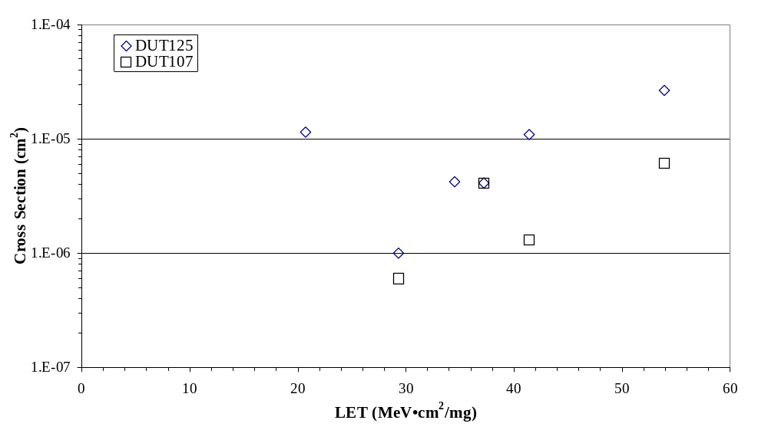
Figure 3: SET cross sections at 28V and 8A.

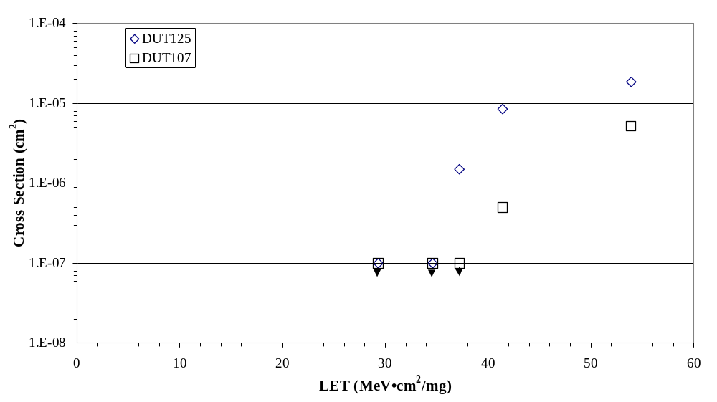
Figure 4: SEU (dropout) cross-sections at 28V and 8A.

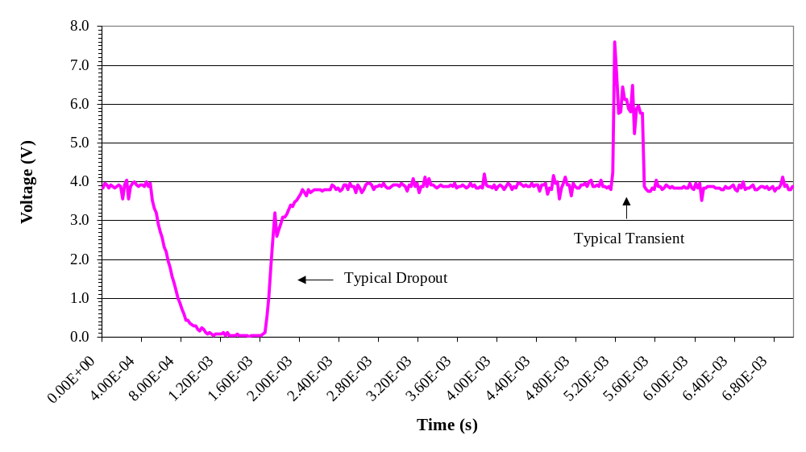
Figure 5: Typical dropout and transient events.

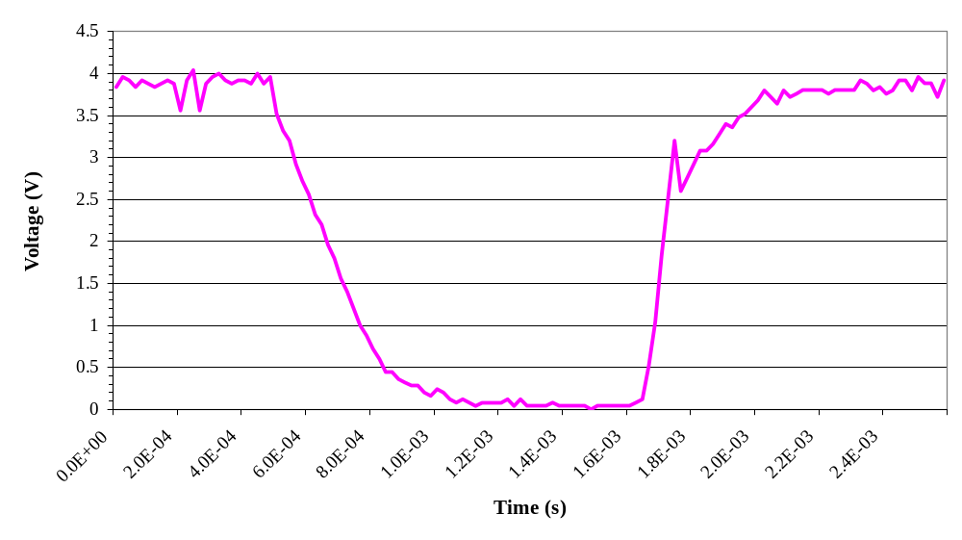
Figure 6: Detail of a dropout event. The time to full recovery is ~2ms. All dropouts are uniform in appearance.

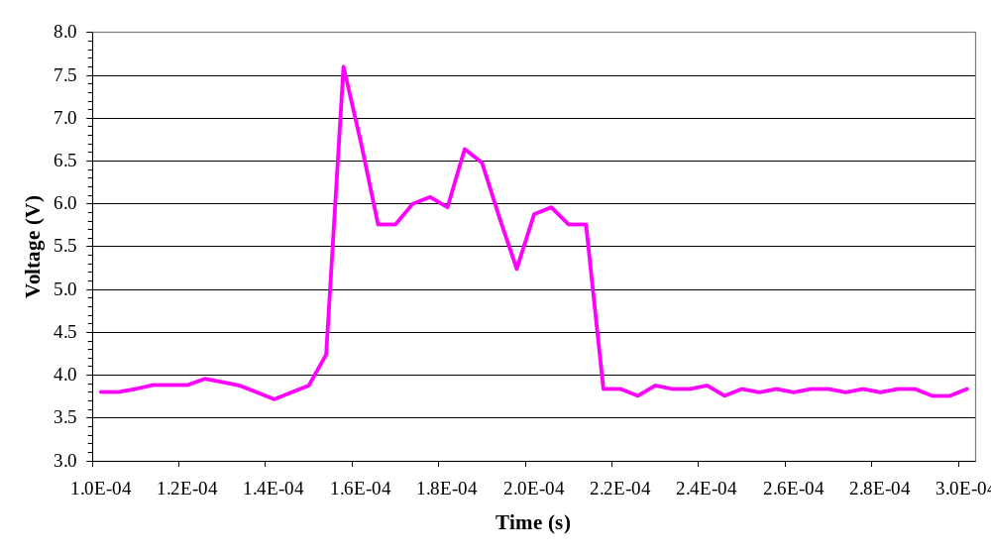
Figure 7: Detail of a transient event. All transients appear uniform and are ~70μs long.

