 | Document # | Date
 | LAT-TD-00550-02 | 3 December 2002
 | Author(s)
 | Gary Godfrey
GLAST LAT System Specification
GLAST LAT System Specification | Subsystem/Office
GLAST LAT System Specification | Integration and Test
Document Title
LAT Test Plan for Airplane

Gamma-ray Large Area Space Telescope (GLAST)

Large Area Telescope (LAT)

Integration & Test Subsystem

LAT Test Plan for Airplane

Preliminary Draft

Change History Log
Revision | Effective Date | Description of Changes
-01 | 1/28/02 | Initial release. Preliminary draft.
-02 | 3/12/02 | Aircraft and truck crash statistics added. Power on acceleration survival limit set.

Contents

1. Purpose 4
2. Scope 4
2.1. Items to be tested 4
3. Definitions 4
3.1. Acronyms 4
4. Applicable Documents 4
5. Expected Cosmic Ray rates 5
6. Description of the elements of the LAT Airplane Test 5
6.1. LAT Flight Unit Shipping Container 5
6.2. Trucking from SLAC to the departure Airport 6
6.3. Airplane Flight 6
6.3.1. Power required from aircraft 6
6.3.2. People required to accompany and operate the LAT on the aircraft 6
6.3.3. LAT tests to be performed on the airplane 6
6.4. Trucking from the arrival Airport to the Thermal-Vac facility 7
6.5. Airplane Accelerations 8
7. Airplane Cost Estimates 8
8. Risk for Trucking versus Flying of the LAT 9
8.1. Trucking risk and expected cost 9
8.2. Flying risk and expected cost 9
9. Airplane Acceleration Environment 12
10. Impact on Other Subsystems 15
11. Environmental and Power Requirements for LAT Operation in the Aircraft 16

- Purpose
The LAT Airplane Test program will be a demonstration of system functionality. As an end-to-end functionality test, the LAT Airplane Test program is designed to ensure the DAQ performance of the LAT. In particular, it will be demonstrated, before launch into orbit, that the LAT DAQ is able to handle the orbital cosmic ray trigger rates with the L1T deadtime and with the software filtered data rate to disk as expected from simulation.
The Airborne Cosmic Ray test may be found in the Table 12 (Science Verification) of the LAT Program Instrument Performance Verification Plan LAT-MD-00408 where it is one of the particle test verifications of the LAT.
- Scope
  - Items to be tested
The LAT Airplane Plan describes the planned test of the sixteen-tower fully instrumented LAT flight hardware. It includes the fully instrumented ACD.
- Definitions
  - Acronyms
ACD Anti-Coincidence Detector
BFEM Balloon Flight Engineering Module tower
DAQ Data Acquisition system
GLAST Gamma-ray Large Area Space Telescope
EGSE Ground Support Electronics
LAT Large Area Telescope.
NRL Naval Research Lab in Washington, DC
RFI Request For Information
SLAC Stanford Linear Accelerator Center in Menlo Park, California
TBD To Be Determined
TBR To Be Reviewed
- Applicable Documents
[1] LAT-MD-00408 LAT Program Instrument Performance Verification Plan
- Expected Cosmic Ray rates
For the latitude of Palestine, Texas, Figure 5 and Table 2 give the 3-in-a-row tracker L1T trigger rate of the BFEM as a function of altitude. Notice, that at 25,000 feet the L1T rate is the same as it will be in orbit. The in-orbit L1T rate is ~22 higher than the ground L1T rate. This few hour airplane ride will be the only exposure of the flight configuration LAT to the full in-orbit cosmic rate.

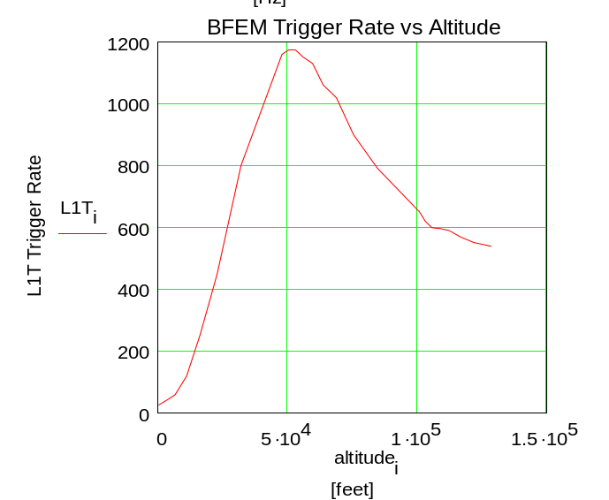
Figure 5. This is the Balloon Flight Engineering Module (BFEM) L1T trigger rate measured over Palestine, Texas in August, 2001. The BFEM front area is 1/25 that of the full LAT.

Table 2. The L1T trigger rate, as read off Figure 5, is shown at some particular altitudes.

Altitude [feet] | L1T [Hz] | Notes
0 | 25 | Ground
25,000 | 540 | Same rate as in orbit
35,000 | 900 | Airplane flight
50,000 | 1175 | Pfotzer max
127,000 | 540 | Approx orbital rate

- Description of the elements of the LAT Airplane Test
  - LAT Flight Unit Shipping Container
The LAT will be packed in a protective shipping container at all times during its transport from SLAC to the Naval Research Lab. This container will include a vibration isolation system to protect against shocks and will provide a thermally controlled, clean , low humidity air (no condensation) environment for the LAT. During takeoffs and landings the LAT power will be off. During the other phases of the airplane flight, the LAT power will be turned on, and the LAT must be able to operate and record data. An acceleration of >.5 gravities in any direction with respect to the long time scale local 1 gravity will automatically initiate the LAT emergency power down sequence.
The design of the shipping container must incorporate several features:
•Mechanical shock and vibration isolation of the LAT from the aircraft.
•Hermetic penetrations of the container for LAT power, LAT data cables, data logger cables, and the cooling needs of the LAT at full power (<650 watts).
•Thermal and acoustic insulation.
•The shipping container must be able to be picked up from below by a fork lift, and from above by a crane.
In addition, peripheral equipment will accompany the shipping container. As currently envisioned, this equipment includes the EGSE, a portable 2 Kw liquid chiller, and a portable air dehumidifier (or dry nitrogen gas bottle).
  - Trucking from SLAC to the departure Airport
The truck interior will be temperature controlled (“refrigerated”) at nominally room temperature (TBD). The truck will also have an air ride suspension that is adjusted to minimize accelerations to the LAT from roadway bumps. The LAT will be powered off during trucking. Since no power will be on inside the shipping container, there will be no need for internal cooling of the shipping container, and the chiller will be turned off. The interior of the shipping container must remain dry. Two battery operated data loggers will redundantly read out acceleration, temperature, pressure, and humidity within the shipping container. A third data logger within the shipping container will provide real time output to a laptop computer being monitored by an I&T team member riding along in the truck.
  - Airplane Flight
    - Power required from aircraft
Power from the aircraft will be required to operate the EGSE (TBD Kw), a portable liquid chiller (~2 Kw), and a portable air dehumidifier (<1.5 Kw) during the entire time of the flight.
    - People required to accompany and operate the LAT on the aircraft
At least four I&T team members (logistics person, LAT DAQ expert, EGSE expert, quality assurance person) will accompany the LAT on the flight. Their tasks will be to protect the health of the LAT, monitor the LAT environment, perform the specified LAT tests and data taking, resolve minor anomalies, and monitor the flight path and altitude of the aircraft.
    - LAT tests to be performed on the airplane
As stated in Section 1., the purpose of the airplane test is to record ~orbital rate cosmic rays with the flight DAQ and onboard software filter. Compared to the orbital DAQ, the only difference will be that the ready-to-be-downlinked data will flow to an EGSE hard disk rather than to the spacecraft solid state recorder.
The aircraft will be in one of three states for data taking:
- Sitting on the ground, climbing, or descending,
- Level flight for ~2 hours at a “middle altitude” of ~25,000 feet (TBD) chosen so that the L1T trigger rate from cosmics is equal to that in orbit,
- Level flight for ~2 hours at a “top altitude” of ~35,000 feet [TBD] where the L1T trigger rate from cosmics is ~2 times greater than in orbit.
The LAT data taking modes will be the same as those available in orbit. These will be:
- Standard Trigger Mode: This is the workhorse 3-in-a-row tracker layers with the standard software filter for gammas. This should include the standard trickle rate of raw events, heavy ion ACD triggers for calibrating the calorimeter, and high energy calorimeter triggers.
- Throttled Trigger Modes: These modes (~2 TBD) are where the event rate to disk has been reduced by more stringent hardware or software requirements. For example, these modes might include:
  - a calorimeter energy requirement in coincidence with 3-in-a-row,
  - a hardware ACD veto of L1T,
- Damaged Trigger Modes: These modes (~2 TBD) test some part of the LAT failing. For example, these modes might include:
- disable signals from one ACD tile
- disable triggers from one tower
- Wide Open Trigger Mode. This is the 3 in-a-row tracker layers with no software filtering.
The total flight time in a passenger jet is 5 hrs between San Jose, CA and Baltimore, MD (2457 miles).
Data taking will be broken up by the EGSE into 10 minute runs (TBD) or 1 Gbyte file length, which ever comes first. Data runs will be recorded continuously (except during takeoffs and landings when the LAT power is off) from 30 minutes before take off until 30 minutes after landing of the aircraft. Only one trigger configuration should be used per run and an attempt should be made to have only one aircraft state (eg: climbing/descending, mid-altitude level, top-altitude level) in each run. All the data taking modes should be cycled through when in level flight. The “Standard Trigger” should be used when changing altitudes. Therefore, during each 2 hours of level flight each of the 6 trigger modes would be run twice.
Sufficient “data quality” information should be displayed by the online EGSE to know that the LAT is functioning and recording data. In particular, the EGSE should display the L1T deadtime, and should display the event rate being recorded to disk from both the software filter and the various trickle sources individually. In addition, there should be an event display that samples the events going to disk.
If the LAT performance fails to meet certain proscribed levels (TBD) during the flight, the onboard I&T personnel will be authorized by the test procedure (TBD) to perform additional tests (TBD) that will aid in understanding and debugging the problem. All such tests will be drawn from a set of previously approved procedures.
  - Trucking from the arrival Airport to the Thermal-Vac facility
The trucking requirements are the same as for trucking to the airport in section 6.2.
  - Airplane Accelerations

- Airplane Cost Estimates
Requests for Information were made to eight airlines regarding the cost of shipping an 8500 lb container with dimensions 90”L x 90”W x 76”H from the San Francisco Bay Area to the Washington, DC area in July, 2004 on a direct non-stop flight. Our requirements for having a gas bottle for dry air flow or electric dehumidifier, airplane power for operating the instrument, and personnel to accompany the instrument and record data were explained.
Table 2. Airlines from which LAT shipping costs were requested.
Airline | Telephone response from airline | Response to RFI
American Airlines | No cargo only aircraft. Our container is too large to fit in bottom cargo compartments. Person can’t be in the cargo compartment when in motion.
Continental Airlines | No cargo only aircraft. Our container is too large to fit in bottom cargo compartments. Person can’t be in the cargo compartment when in motion.
Delta Airlines | No cargo only aircraft. Our container is too large to fit in bottom cargo compartments. Person can’t be in the cargo compartment when in motion.
Emery Worldwide | RFI sent. | No. Emery leases all their aircraft. This use not consistent with their lease agreement, and Emery does not want the hassle of renegotiation.
Federal Express | RFI sent. | Yes. Must charter an entire aircraft.  $82 K Carvair prop plane (~25,000 foot ceiling) (cargo door 64” high)  $100 K Jet. 17,500 lb max, 3 GLAST people max, one fuel stop on the way, 24 VDC 16 kw, 1 month lead time, N2 okay if it is documented to meet IATA rules.
Kitty Hawk Air Cargo | RFI sent. Kitty Hawk in Chapt 11 Bankruptcy (May, 2000). Hopes to emerge from bankruptcy June, 2002.
Leading Edge Air Logistics | RFI sent.
National Air Cargo | RFI sent. Charter broker. | Must charter a 747 for a one way non-stop flight for $150,000.
Northwest Airlines | RFI sent. | No cargo only aircraft. Our container is too large to fit in bottom cargo compartments. Person can’t be in the cargo compartment when in motion. No N₂ bottle.
United Airlines | No cargo only aircraft. Our container is too large to fit in bottom cargo compartments. Person can’t be in the cargo compartment when in motion.
US Airways | RFI sent. | No response.

- Risk for Trucking versus Flying of the LAT
There are different risks of catastrophic damage for the alternatives of trucking or flying the LAT between SLAC and thermal vac testing at NRL.
  - Trucking risk and expected cost
Based on Federal Highway Administration data, statistics on large truck crashes are published yearly by the Analysis Division of the Federal Motor Carrier Safety Administration. Table 3 is from the FMCSA’s Large Truck Crash Facts 2000. It shows a risk of property damage of 164/10⁸ per mile and a risk of injury of 47/10⁸ per mile. Assume that all truck crashes severe enough to produce injury and half the property damage only crashes, will damage the LAT or at least subject it to out of spec accelerations which would require some recertification. Assume that a repair, recertification, and associated delay (1 year?) would cost the project an additional $25M. Shipping 3000 miles by truck then has an expected loss of :
((47+82)/10⁸ per mile) x (3000 miles) x ($25M) = $97K
Shipping by truck would also cost the project 1 week of time (~$200K ?) and ~$30K for the truck, drivers, and pace car. Trucking would therefore have a total expected cost to the project of ~$327K.
  - Flying risk and expected cost
Table 4 is from the U.S. Bureau of Transportation Statistics and shows the risk for all commercial air carrier accidents to be .76/10⁸ per mile. Assume that any airplane accident results in a total loss of the LAT, and that replacing the LAT would cost $100M. Shipping 3000 miles by airplane then has an expected loss of :
(.76/10⁸ per mile) x (3000 miles) x ($100M) = $2K
The project would incur no trucking delay, the airplane would cost ~$100K according to the responses to the RFI shown in section 7, and trucking to and from the plane at both ends would cost <$10K. Flying would therefore have a total expected cost to the project of ~$112K.

On the basis of risk of loss, expected cost to the project, and schedule we should choose to fly the LAT between SLAC and Thermal Vac even if no LAT data taking were done in the plane.

Table 3. Large Truck Crash facts http://ai.volpe.dot.gov/CrashProfile/NationalCrashProfileMain.asp
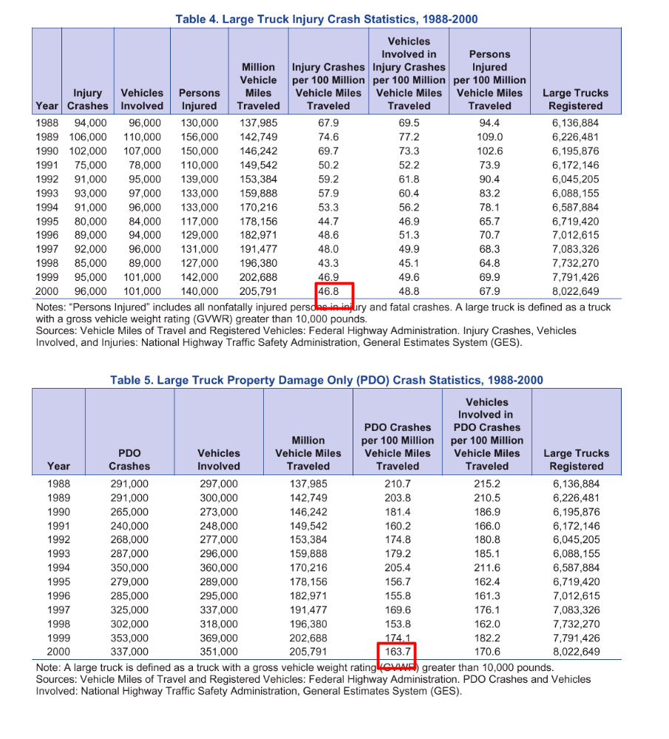

Table 4. U.S. Air Carrier Safety Data from http://www.bts.gov/publications/nts/ .
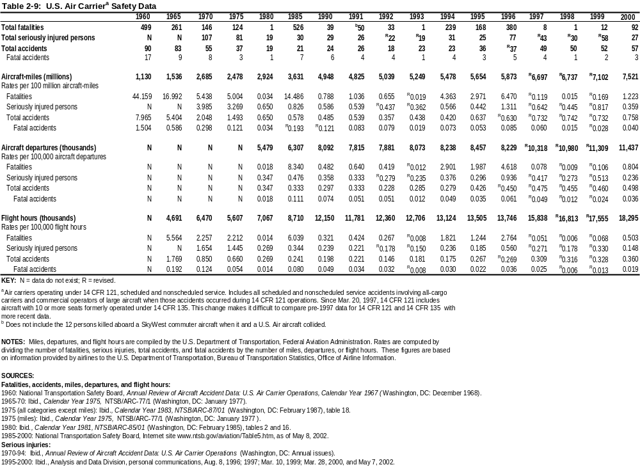
- Airplane Acceleration Environment
During airplane transportation of the turned off LAT, accelerations to the LAT must be less than those specified in LAT-MD-00649 (<6.6 grav vert , <4.0 grav horiz). However, when power is turned on to the LAT, a new acceleration requirement must be met.
The Federal Aviation Administration (FAA) has an ongoing Airborne Data Monitoring Systems Research Program to collect, process, and evaluate statistical flight and ground loads data from transport aircraft used in normal commercial airline operations. The onboard data acquisition systems recorded the vertical acceleration (8 times per second) and the lateral acceleration (4 times per sec). Figures 6 and 7 give the probability per nautical mile of exceeding a particular acceleration during the various flight phases. Assume we are willing to tolerate a 10% chance of exceeding a particular acceleration during 2000 nautical miles (4 hours) of cruise, which is a probability of 5 x 10⁻⁵ per nautical mile (25 per 1000 hours). Figure 6 and 7 show that acceleration to be .5 gravities vertical and .2 gravities lateral. If the LAT electronics is tested to withstand .5 g in all directions, then both the vertical and lateral probabilities will be <10% for the flight. This acceleration is >10 times smaller than acceleration requirements for transportation and rocket flight when the LAT power is Off.
Since the vertical accelertion was measured 8 times per sec, these measurements only reflect the acceleration spectrum up to the Nyquist frequency of 4 Hz.
If the LAT is mounted on a simple damped spring suspension system within the Transport Box, accelerations above the resonant frequency of the spring will be attenuated. The lowest possible resonant frequency of the mounting spring that is consistent with the available of spring travel is ~1 Hz. The top curve in Figure 8 shows the LAT acceleration spectrum assuming a flat airplane acceleration of .5 g at all frequencies, and a spring of resonant frequency 1 Hz with Q=.1 . The bottom curve in Figure 8 shows the LAT acceleration spectrum for an acoustic 100 db pressure wave (flat in frequency) driving one wall of the Transport Box. Notice that LAT accelerations are dominated by airplane motion, even for this excessive estimate of airplane noise.
Figure 9 shows the LAT displacement with respect to the aircraft for both the airplane motion and acoustic drives.

Figure 6. Acceleration data for 17 Boeing 737-400 aircraft over 11,721 flights and 19,105 hours of airline operations from DOT/FAA/AR-98/28 at
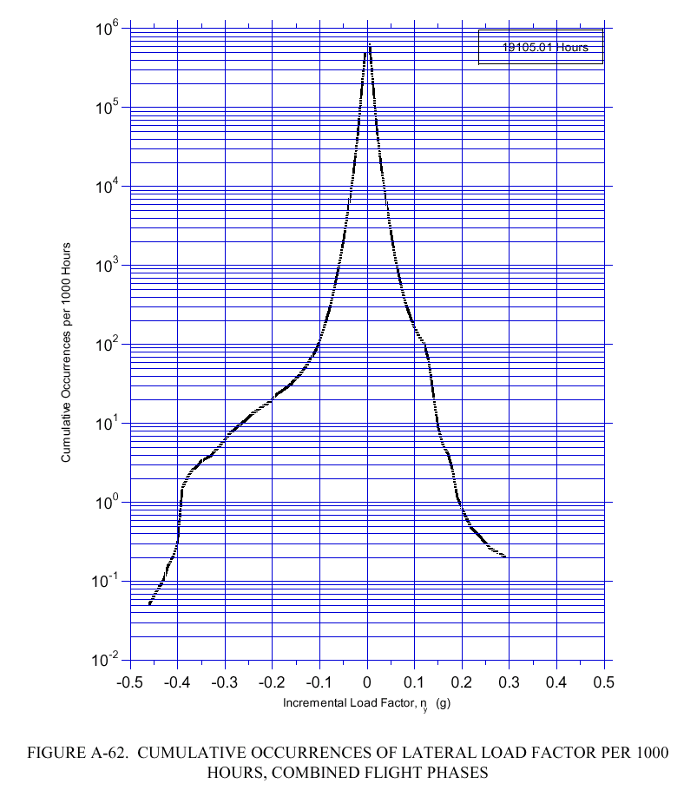
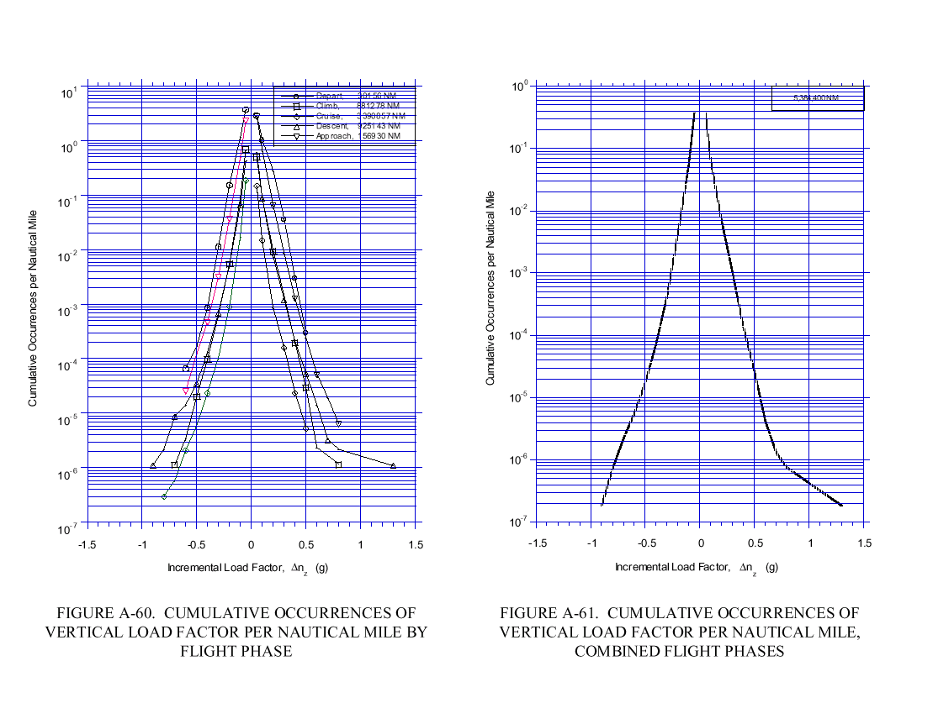http://www.tc.faa.gov/its/worldpac/techrpt/ar98-28.pdf .

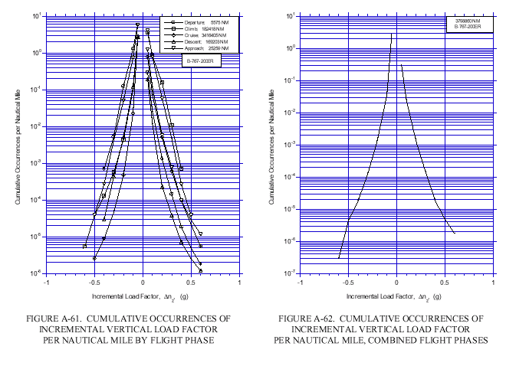Figure 7. Acceleration data for 10 Boeing 767-200ER aircraft over 1285 flights and 9164 hours of airline operations from DOT/FAA/AR-00/10 at http://research.faa.gov/aar/tech/docs/techreport/00_10.pdf .

Figure 8. LAT acceleration spectrum due to aircraft motion and estimated acoustic noise after filtering by the Transport Box spring mount.
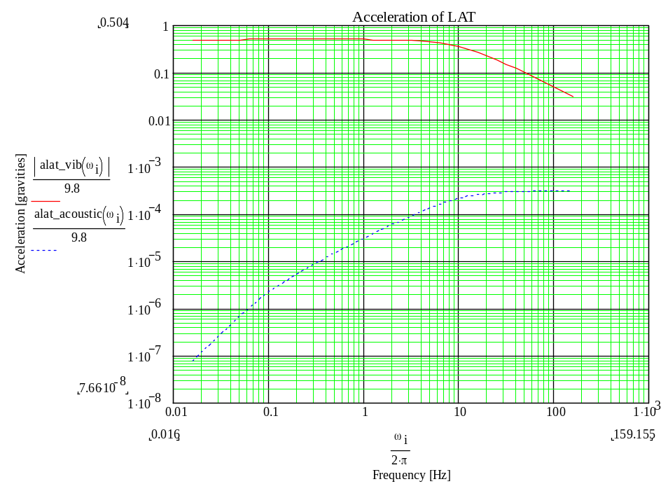

Figure 9. LAT displacement spectrum due airplane movement and estimated acoustic noise after filtering by the Transport Box spring mount.
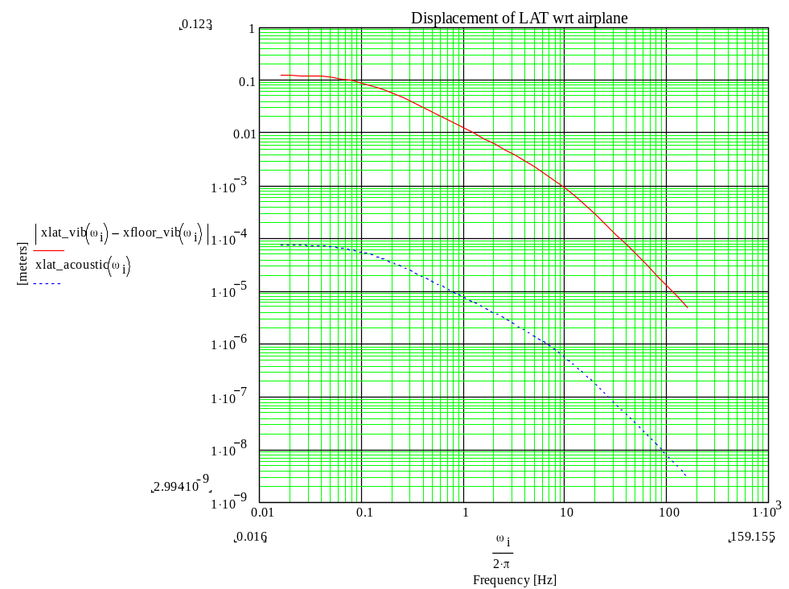

- Impact on Other Subsystems
The primary impact on other subsystems (Electronics, Tracker, Calorimeter, ACD) will be the need for the subsystems to verify that no damage is done when power is on and the subsystem is shaken with .5 g acceleration. In addition, the Electronics Subsystem will have to supply power conversion from the aircraft power to the power required by the EGSE, liquid chiller, air dehumidifier, and the 28 VDC required by the LAT. This may be as simple as a commercial 24 VDC to 110 VAC inverter that would power the existing EGSE power supplies.

The remaining impacts are internal to the Integrate and Test subsystem. The LAT airplane test has an impact on the maximum data rate that the EGSE is required to record. The LAT has already been designed to handle in-orbit cosmic ray rates. Event data is designed to flow from the LAT via a 30 Mbit/sec cable to the satellite’s solid state recorder. For ground testing, the Flight Software Subsystem will receive this 30 Mbit/sec cable into a card in a crate external to the LAT. A CPU in this crate may write the events to disk or send them out on an Ethernet cable. Before the LAT airplane test, the EGSE only had to handle the ground cosmic ray rate (~300 Hz for accumulating 10⁸ cosmics for the LAT survey of detector locations). Now, for the “Wide Open Trigger Mode”, the EGSE should be able to record the maximum data rate that the LAT is capable of sending over the 30 Mbit/sec cable. Most of the time during the flight the other trigger modes will be used for which the data rate will be much less.

The EGSE must also be packaged to be mounted and used while in flight on the aircraft. The EGSE will probably be fixed to the outside of the LAT Transport Box.

If there were no SLAC thermal test, there would be an additional impact on the Integrate and Test MGSE since the LAT must be operated while inside the Transport Box. However, it is planned to take data while thermal cycling the LAT within the Transport Box at SLAC. Thus, the additional MGSE of the liquid chiller, power penetrations, and data line penetrations of the Transport Box will already have been provided.

Integrate and Test also plans to do a microphonics test on the EM (LAT-TD-01137 Engineering Model System Level Test Plan). If the levels of acoustic vibration that are expected on the airplane cause the EM data or Trigger to be corrupted because of design features that are also built into the LAT, then further work on the airplane test would be a waste of effort, and the airplane test should not be done. Likewise, the airplane test may be terminated if the LAT is found to be too sensitive to microphonics during ground testing.

An additional effort from Integrate and Test will be necessary to analyze the airplane cosmic data and quantify the LAT’s performance at the high cosmic rates.

- Environmental and Power Requirements for LAT Operation in the Aircraft

The LAT will remain in its sealed Transport Box at all times during its shipment. Any operation of the LAT during the aircraft flight will be via prewired cable penetrations through the sealed Transport Box. Operation of the LAT within the Transport Box shall meet the requirements of Table 5.
Table 5. Requirements during operation of the LAT on the airplane flight.
Number | Requirement | Value | Source of Requirement
1 | Temperature of the glycol chiller plate on the grid | 17ºC ± TBD ºC | LAT-TD-00997 LAT Instrument I&T Thermal Requirements
2 | Temperature of the LAT Transport Box interior air | 17ºC ± TBD ºC | LAT-MD-00649 LAT Transportation and Handling Plan  (18-25 degC must be fixed !!)
3 | Humidity of the LAT Transport Box interior air | 30% to 45% relative humidity at 17ºC  (dewpoint 8-?ºC) | LAT-MD-00649
4 | Particulate count of the LAT Transport Box interior air | Class 100,000 | LAT-MD-00649
5 | Power to the LAT | 28 ±6 VDC with < TBD p-p ripple  TBD Amps | LAT-SS-00183 GLAST Power Supply Specification
6 | Acceleration of the LAT  (LAT power Off) | <6.6 grav vert  <4.0 grav horiz | LAT-MD-00649
7 | Acceleration of the LAT  (LAT power On) | <.5 grav (any direction) | This airplane test document  LAT-TD-00550

Notice that the dew point of the Transport Box air is well below the chiller plate temperature.

