 | Document # | Date
 | LAT-TD-04419-03 | 13-Jan-2005
 | Author(s)
 | Gary Godfrey
GLAST LAT System Specification
GLAST LAT System Specification | Subsystem/Office
GLAST LAT System Specification | Integration and Test
Document Title
Muon Telescope

Gamma-ray Large Area Space Telescope (GLAST)

Large Area Telescope (LAT)

Integration & Test Subsystem

Muon Telescope

Change History Log
Revision | Effective Date | Description of Changes
-01 | 7/14/03 | Original
-02 | 10/25/04 | Added Pb and more scintillators to give an external trigger only when a single muon (not electron, not multiparticles hitting the telescope) passes through a GLAST tower.
-03 | 1/13/05 | Clarified procedure and validation steps in 6.1 and 7.

Contents

1. Purpose 4
2. Scope 4
3. Definitions 4
3.1. Acronyms 4
3.2. Definitions 4
4. Applicable Documents 4
5. Description of the Equipment 4
5.1. The Muon Telescope 4
5.2. The Muon Telescope Electronics 7
6. Calibration 7
6.1. Procedure to Turn on the Muon Telescope 8
7. Test Setup Validation 8

- Purpose
The purpose of this document is to describe the Muon Telescope.
- Scope
- Definitions
  - Acronyms
EM Engineering Model tower.
GLAST Gamma-ray Large Area Space Telescope
GLT Global Trigger module
EGSE Ground Support Electronics
LAT Large Area Telescope.
SLAC Stanford Linear Accelerator Center in Menlo Park, California
TBD To Be Determined
TBR To Be Reviewed
  - Definitions
- Applicable Documents

[1] LAT-MD-03489 Ad Hoc Committee on End-to-End Testing
[2] LAT-TD-04134 How to Set the LAT Timing Registers
[3] LAT-TD-04135 How to Measure the LAT Trigger Jitter Timing Distributions Using the Muon Telescope
- Description of the Equipment
  - The Muon Telescope

The old muon telescope which was used in testing the EM is shown in Figure 1a. It consists of two 24”x 24” x 1” scintillators spaced 72” apart, and 20” of lead (not shown in photo). This telescope triggers on cosmics at ~4 Hz. The GLAST requirement for this telescope was to provide cosmic triggers to the EM and a zero time for trigger timing studies. Not all tracks passing through the scintillators also pass through the tower. This old telescope is being upgraded to increase the probability that a telescope trigger means a single muon passed through the GLAST tower. The goal is to accurately measure tower trigger efficiency and layer hit multiplicity. In addition, all strips should have hits on them so strip hit efficiencies can be compared.
The new muon telescope in shown in Figure 2 and consists of three levels of scintillators and 10” of lead. Let XOR be an exclusive OR. The top layer S1 = S1a XOR S1b where S1a=S1b=7.75” x 15.5” x 1”. The middle layer S2 = S2a XOR S2b where S2a=S2b=7.75” x 15.5” x 1”. The bottom layer S3 is a single scintillator 24” x 24” x 1” and is the good (clear) scintillator from the old muon telescope. S1 and S3 are 75” apart which provides room for a single tower and clearance to rotate it.
The silicon on a GLAST tray covers an area 15” x 15”. Thus S1 and S2 are slightly larger than the top of a tower and provide muons to all strips. The geometry is such that <.5% (a calculable correction) of the straight tracks that pass through S1*S2*S3 will not pass through a GLAST tower that is placed between them. The scintillators are mounted on a stand that can be moved to position the scintillator array above and below the device being tested. The lead is stacked on a platform immediately above S3. The lead (45 radiation lengths) eliminates electron triggers and guarantees >460 Mev/c muons. The coincidence S1*S2*S3 guarantees that a muon has passed through the tower in order to measure the tower trigger efficiency. The lead eliminates electrons from the coincidence, and the XOR of side by side scintillators will eliminate some of the multiple track events. A single photomultiplier views each scintillator. The Monte Carlo expected coincidence rate from cosmics is .9 Hz. Figure 3 shows the Monte Carlo distribution of telescope muons in the top and bottom layers of the tracker.

(a) (b)
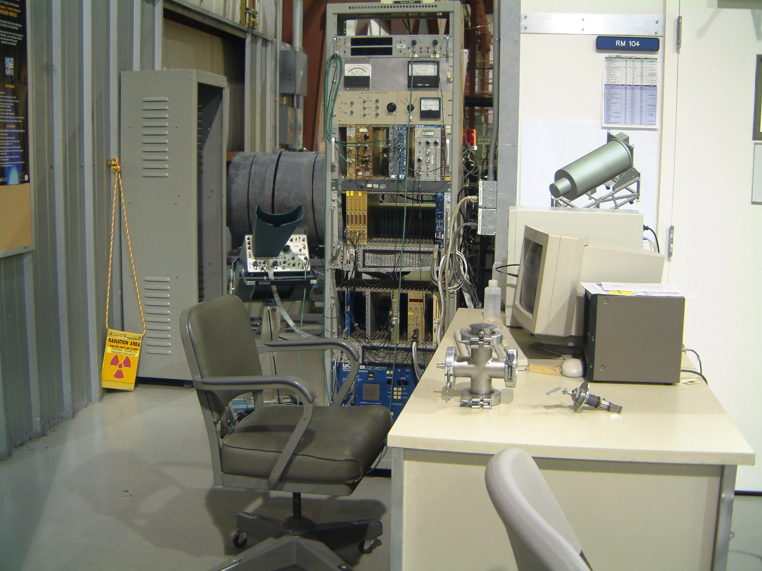
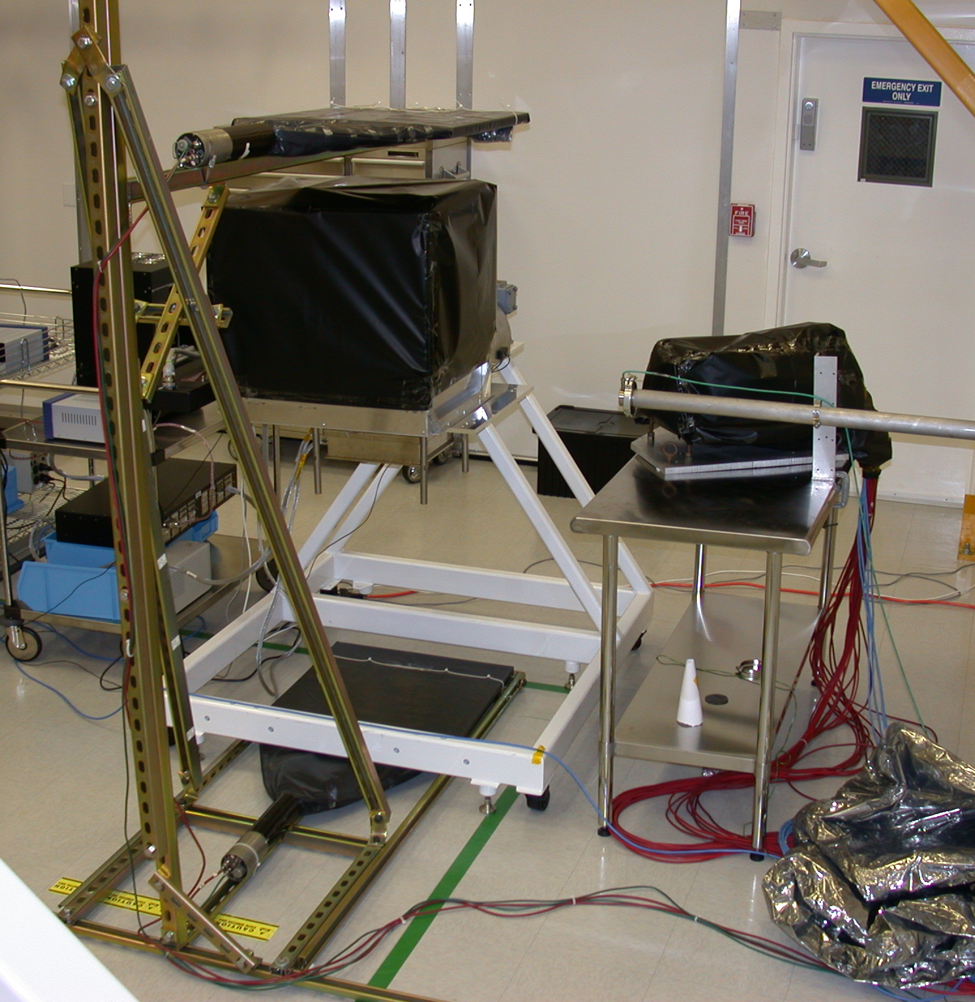
Figure 1. a) The muon telescope is mounted on a stand that supports and inserts the scintillators above and below the device being tested. This picture is of the old muon telescope with EM2 in the middle and 69” between the scintillators. For the new telescope the top scintillator will be replaced with S1a and S1b which will be moved to 75” above S3 to accommodate a full height tower. A new horizontal support will be added for S2a and S2b. b) The muon telescope electronics is in the rack, and the PC is on the desk.

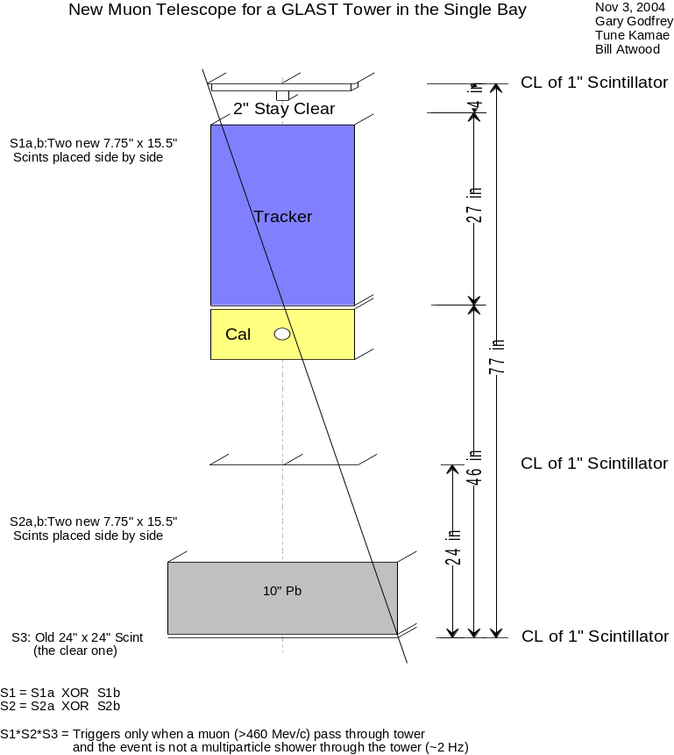
Figure 2. This drawing shows the geometry of the muon telescope with a GLAST tower placed between the scintillators. S2ab is placed so that any ray through S1*S2 will hit S3. The GLAST tower can be rotated (and it will not hit the scintillators) on its rotation stand to obtain other angles and areas of incidence on the tower.

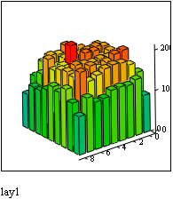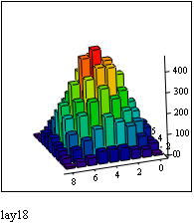
Figure 3. These plots show the Monte Carlo distribution of muon telescope triggers in the top and bottom tracker layers for 400,000 muons distributed as cos²θ_{z} and uniform in area over the S1a,b scintillators .
  - The Muon Telescope Electronics
Figure 4 shows a circuit diagram of the telescope. The electronics consists of:

- Personal computer running DOS 6.20 with a branch driver
- LeCroy HV4032A System with two 4 channel negative HV pods
6 HV cables
6 Signal cables
1 LeCroy 623B Octal Updating Discriminator
1 LeCroy 622 Quad 2-Fold Logic Unit
1 LeCroy 365AL Dual 4-Fold Majority Logic Unit
1 EG&G GG-200 Golden Gate Generator
1 Scalar
1 SLAC built NIM to LVDT Converter

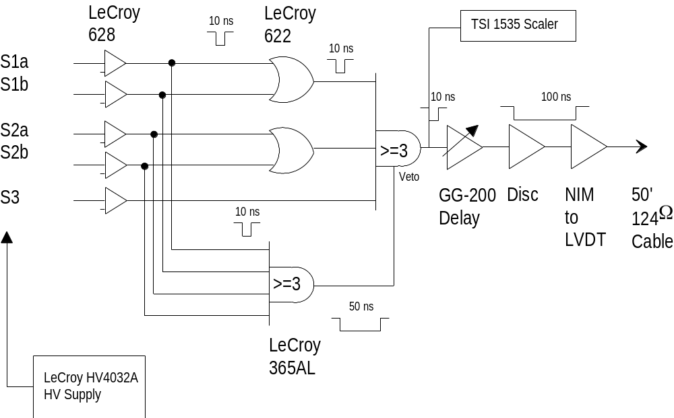
Figure 4. The circuit diagram of the Muon Telescope.

- Calibration

The discriminator levels and PMT HV will be adjusted to plateau the coincidence rate. It is expected that the singles rates will be <1 kHz. The discriminator pulse widths will be <10 ns which lead to a negligible accidental triple coincidence rate of <10⁻⁷ Hz.
The GG-200 delay is set to 200 usec for the trigger jitter measurements (LAT-TD-04135). When the muon telescope is used for externally triggering the LAT to see muons, then the GG-200 delay should be set to the value measure by LAT-TD-04134 which makes all trigger source leading edges arrive simultaneously at the LAT GLT.
  - Procedure to Turn on the Muon Telescope

1) Turn on the power switches of all items in the DAQ rack (scaler, NIM crate, fan, 2 CAMAC crates, 2 LeCroy HV supply key switches).

2) Turn on the plug strip on the desk beside the PC.

3) Be sure that the small slide switch on both LeCroy HV Supplies is set to Remote (not Local).

4) Hit cap lock on the PC keyboard.

5) Type: HV (return)
SET 2 (return)
(wait for display on the bottom most HV supply to finish counting up to 31)
ON 2 (return)
(observe the HV ON red light comes on the bottom most HV supply)
END 2 (return)

- Test Setup Validation

Before using the Muon Telescope with the LAT, it should be verified that the Muon Telescope is providing the correct rate of coincidences. This should be done whenever the Muon Telescope power is turned on.

- Flip the topmost “Gated” switch on the scaler to ON.
- Simultaneously push the Reset button on the scaler and start your wrist watch timer.
- After 300 sec (5 minutes), flip the topmost “Gated” switch on the scaler to OFF.
- Divide the scaler reading by 300 seconds to get the coincidence rate in Hz.
- Fill in one line on the Muon Telescope Validation Data Sheet, including the just measured rate.
- Verify that the just measured rate is the average of previous Validation Data Sheet rate entries to ±20% .

VALIDATION DATA SHEET | LAT-TD-04419  (Paragraph 7.5) | Date:
Title:  Muon Telescope Cosmic Ray Rate | Operator: | QA:
Date | Start Time | Count Time  [sec] | Counts | Rate  [Hz]

